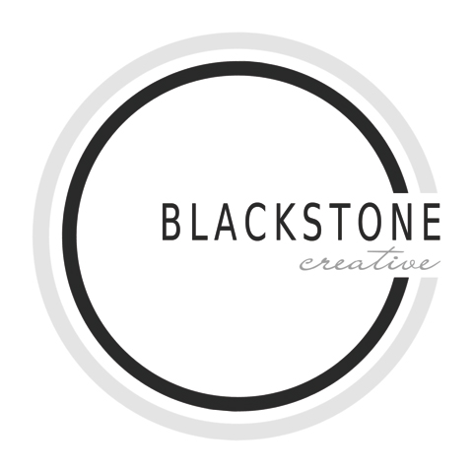
2013 photography collections

all collections include:
One to two hour portrait session with photographer in location of your choice
(unlimited time if necessary!)
Jenny will create a presentation video with hand-selected music and custom editing, which tells your story, highlights the best images, and reveals the connections within your family.
An online gallery for viewing and ordering helps you share your images with family and friends.
Collection 1: 300 €
Your favorite five images from the session will be professionally edited and presented to you on disk as high resolution jpegs

Collection 2: 400 €
Your favorite ten images from the session will be professionally edited and given to you on disk as high resolution jpegs
Your favorite image from the session will be professionally printed for you (20x30cm) on Hahnemühle paper, Jenny’s favorite for portraits.

Collection 3: 500 €
Your favorite fifteen images from the session will be professionally edited and presented to you on disk as high resolution jpegs
Your favorite two images from the session will be professionally printed for you (20x30cm) on Hahnemühle paper, Jenny’s favorite for portraits.

Collection 4: 600 €
ALL presented images from the session will be professionally edited and presented to you on disk as high resolution jpegs (approximately 40+ images)

Your favorite two images from the session will be professionally printed for you (20x30cm) on Hahnemühle paper, Jenny’s favorite for portraits.

a la carte pricing
These products may be purchased separately to complement your collection. A consultation with Jenny will help you decide which products are best for gifts and for your home.

high resolution digital images
Perfect if you just need to add “one more image” to your collection!
High-resolution jpeg file 25 € each
matt prints
20x30 cm and smaller 25 €
Each print is professionally edited, printed on archival photo paper.
Purchase includes the JPEG file for your personal digital use.

hahnemuhle prints
Prints on Hahnemuhle (watercolor) paper are Jenny’s favorite for large format color prints
30x40 cm 45 €
canvas prints
Ready-to-hang, stretched canvas wall art of your favorite images
30x40 cm 100 €
framed + matted prints
Beautiful Hahnemuhle prints finished with wide mats and simple, elegant frames of your choice
30x40 inch 350 €
custom designed albums
Images from your session are selected for the custom design of an album and bound in a book for a modern presentation of your images. There are a number of cover choices for the classic flush-mount and beautifully crafted albums. A great way to display all of your favorite images from your session on your coffee table.
Prices begin at 100 €

