- DAMAGE OF HIGH BLOOD PRESSURE

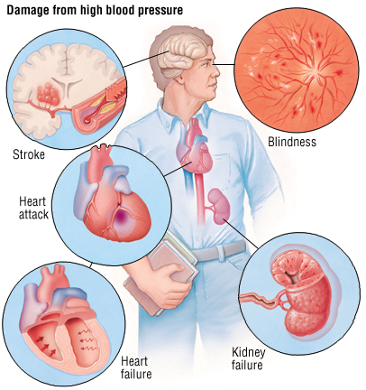

- VASODILATION

