Back
Here are two options for designs for the back of the pouch. The first option is to have a paragraph explaining the product and its benefits. The second option is to high light key benefits of the product. If you can think of a different design for the back of the pouch please feel free to explore different ideas.
Option 1-
Pure nutrition’s natural whey protein is a very high quality 100% natural instant whey protein concentrate impressively providing 80% protein content making this the perfect supplement to aid muscular growth and repair. In addition this all the ingredients are natural but yet still providing a great taste which will make you want more.
Option 2 – (See sketch)

Build, repair and grow
High protein content to maximise strength muscular strength and size gains

Excellent Amino Acid profile
High quality whey protein concentrate with high levels of essential and non essential amino acids vital to muscular repair.
No artificial Flavours
Only the best natural and great taste flavours used

Or combine both options together
Other key information that needs to be on the back -
Ingredients;
Whey protein concentrate 80%, Flavouring, sweetener, colour, sunflower lecithin.
Storage – Store in a cool dry place
Serving suggestions – Mix 25g with 150-250ml of water or milk, consume 1-4 times daily and ideally straight after working out. The less liquid, the thicker the shake.

Also needs to have the Nutritional facts on the back either like in the picture or without the table.
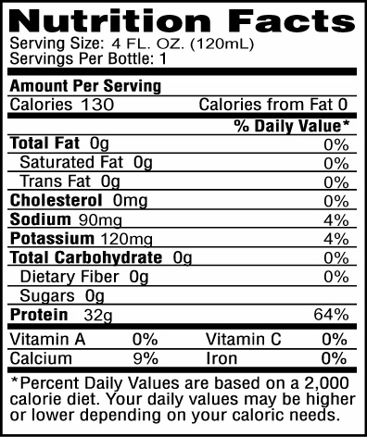
(Smaller text) Do not exceed serving suggestion, and always consult a doctor before use. Natural whey protein should be consumed alongside a well balanced healthy diet and training programme.
For any enquiries to see website.
UK manufactured. Pure Nutrition, unit 2, pure court, Gloucester, GL55 6ZZ, UK
Also needs a retail bar code on the bottom of the back and a smaller batch bar code. As well as a Best before end date.
Bottom – (Stay updated/stay connected)Pure-Nutrition.eu – with social networking logos underneath (Facebook, twitter, instagram, google+ youtube) This ideally should be in black and white to avoid there being too many colours

Front
‘Tear here & Reseal’ in the top right corner
Brand name ‘Pure Nutrition’
Product name ‘Natural Whey Protein’
Key points to go on the front -
- No artificial Flavours
- Excellent Amino acid profile
- 80% high quality protein content
- Soy free

909g 30 servings
Strawberry flavour

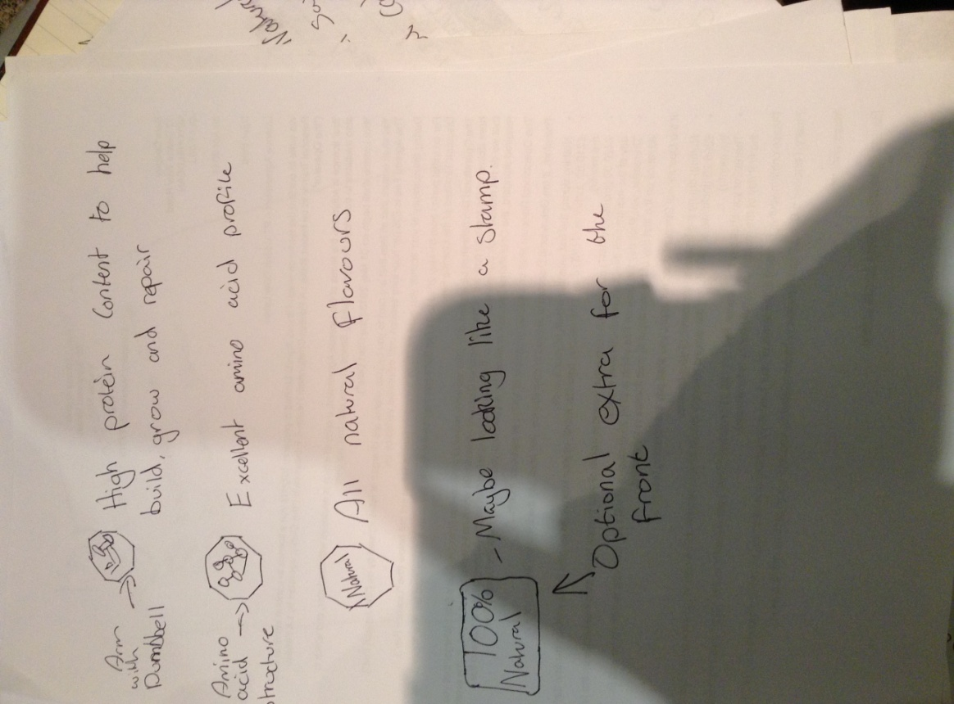

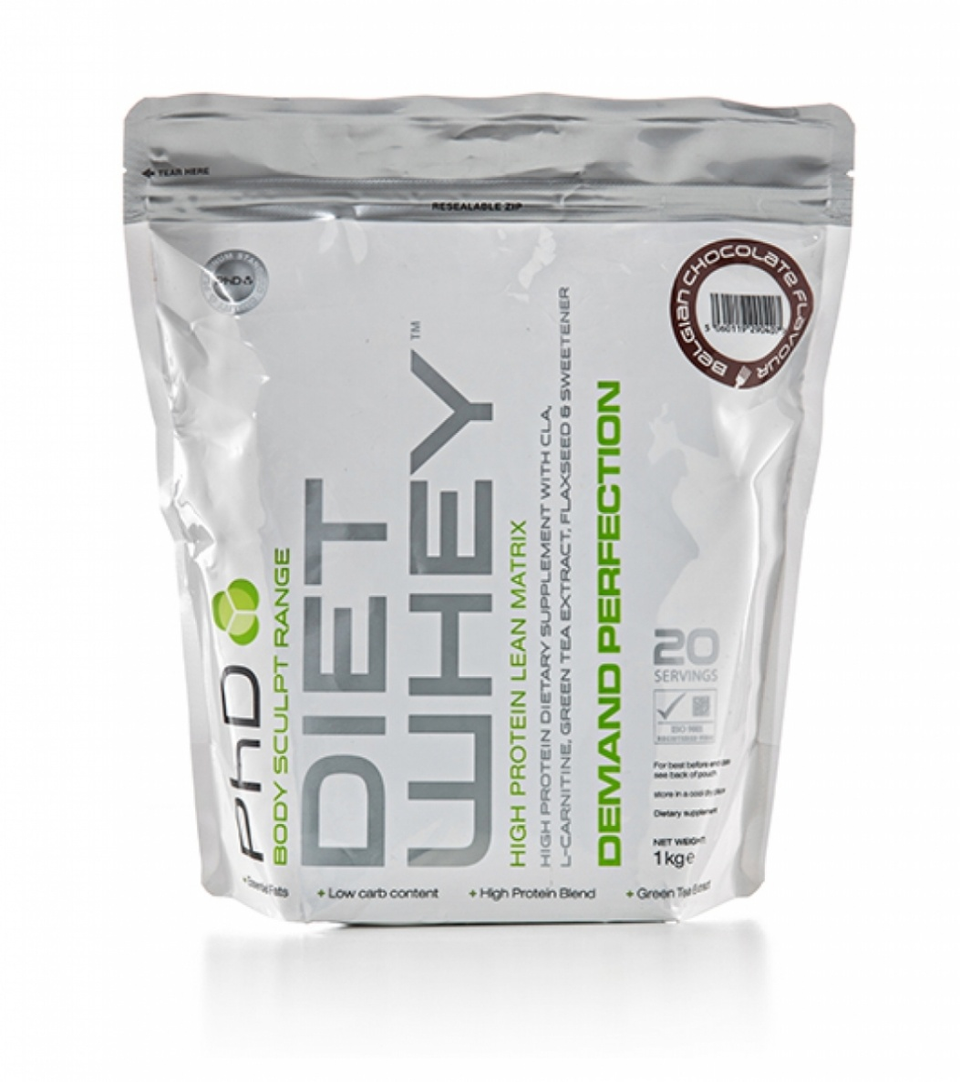
Other product pouch designs;

