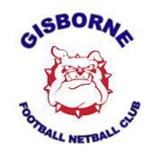
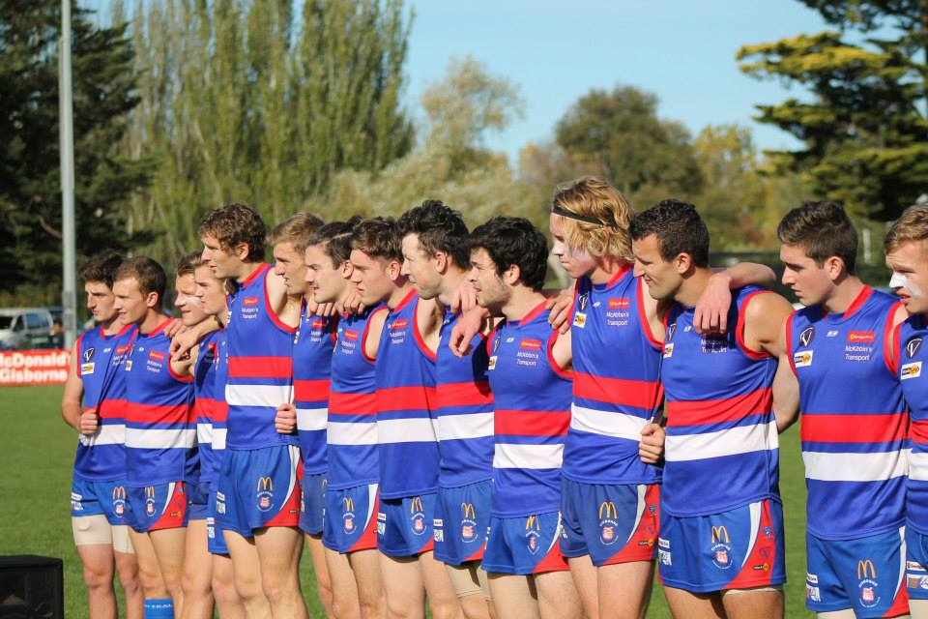
Community - Anzac Day 2014

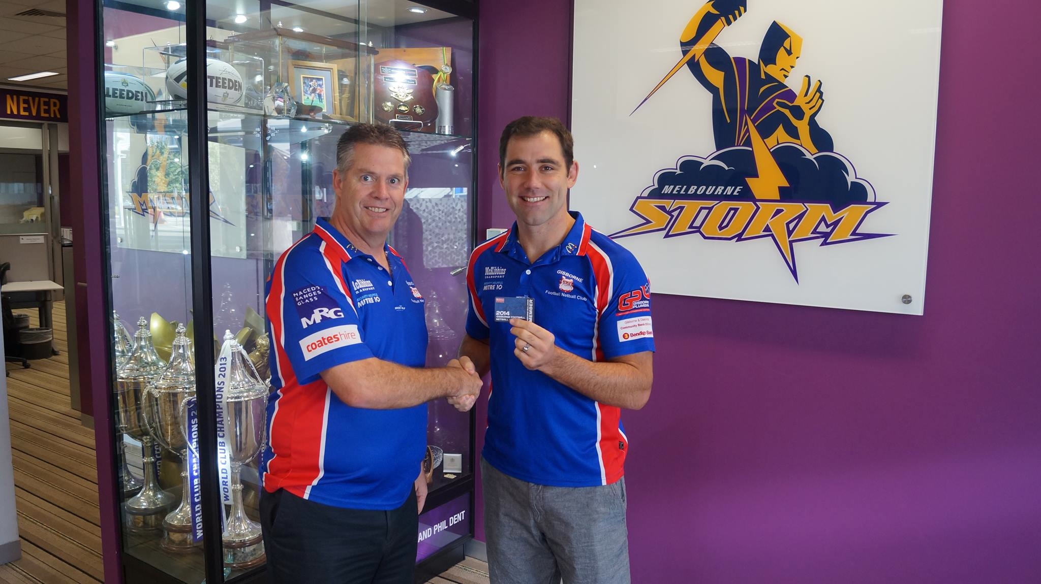
Professional - President Colin Rogers welcomes GFNC No.1 Ticket holder, Melbourne Storm Captain Cameron Smith
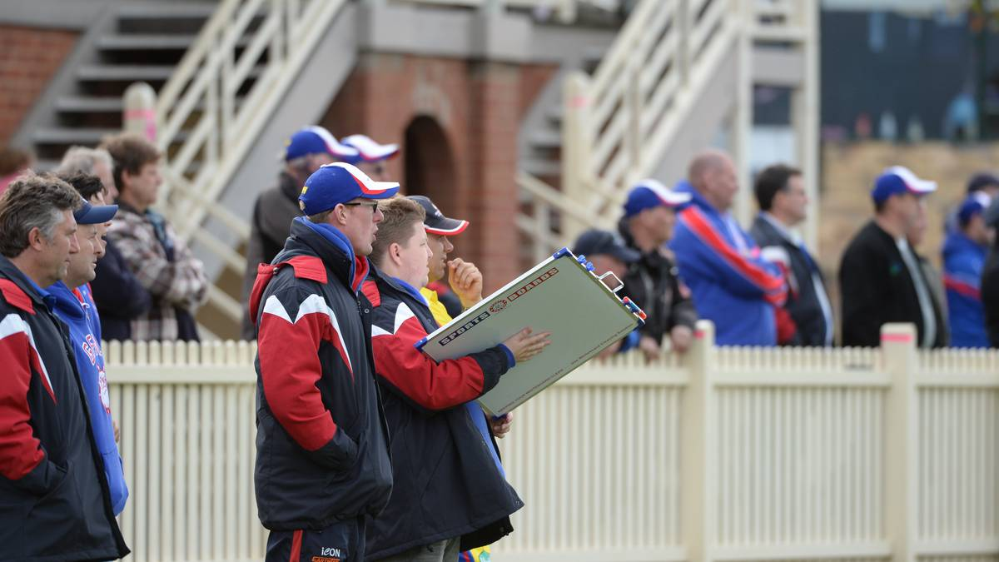
Leadership – Senior Coach Rod Sharp & Support Staff

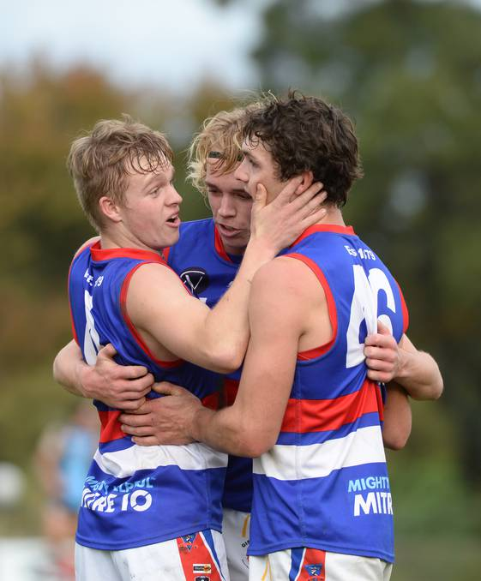
Young & Local
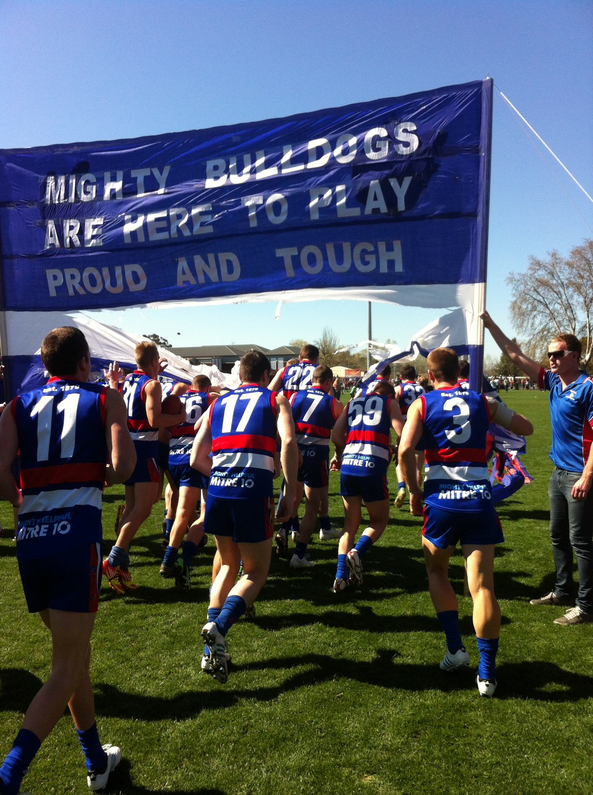

Committed

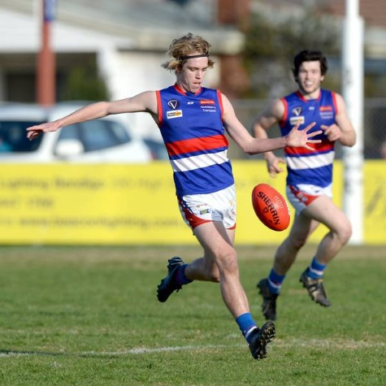
Player Development - Patrick McKenna drafted by AFL club GWS
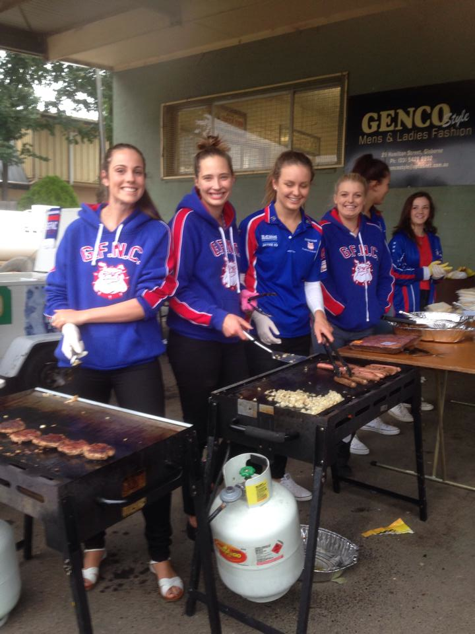
Teamwork
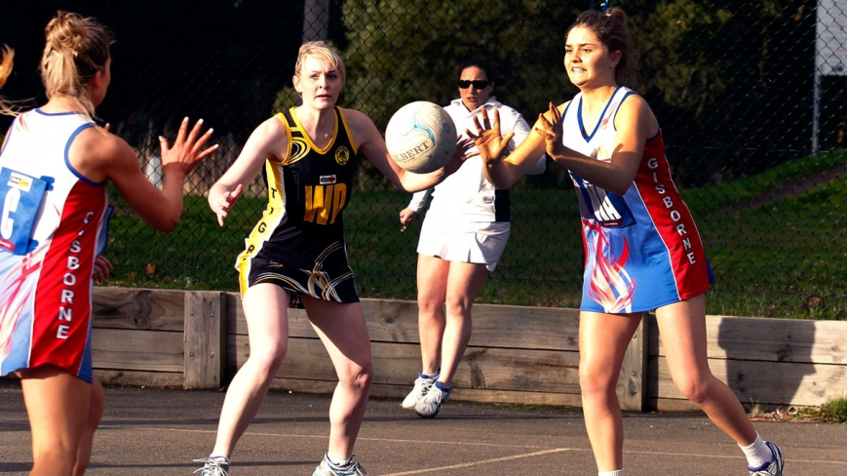
Talented

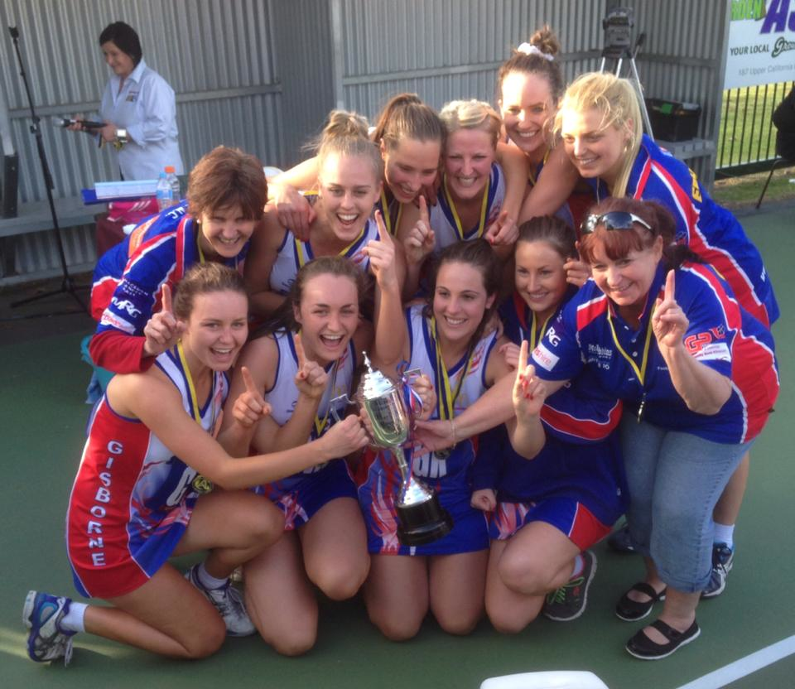

Successful – A Grade Premiers 2013
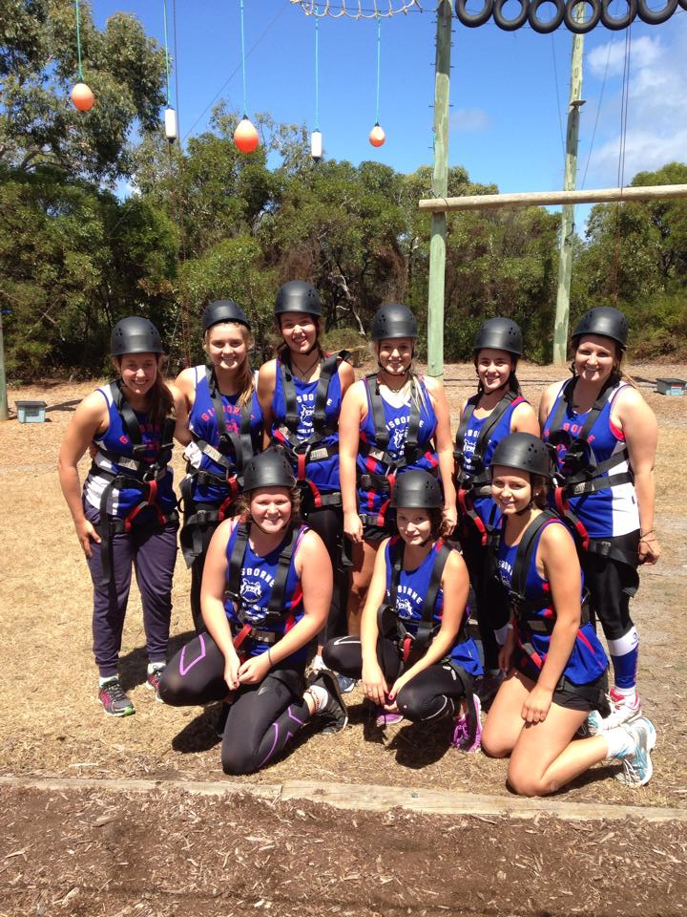

Personal Development - U17 Netballers Anglesea Preseason Camp 2014

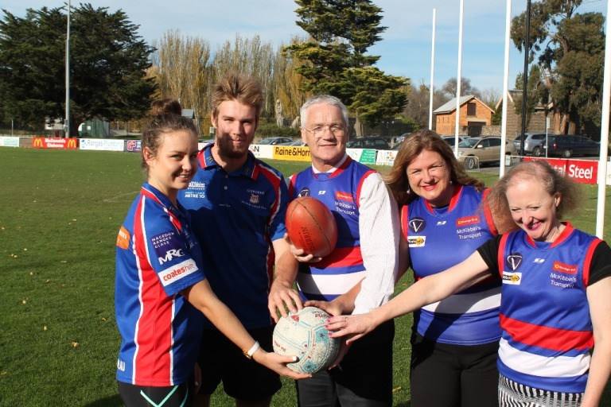

Quality Infrastructure – Gardiner Reserve Community Project Upgrade Announcement

