Thrive Yoga
Creative Brief for Logo Design

- Type of Business

Yoga – predominantly yoga classes and maybe some yoga retail at a later date

- Business Name
Thrive Yoga

- Target Market
Predominantly women that are health conscious, holistic, appreciative of art, have dispensable income

- Selling Point of Thrive
*Thrive is all about loving life – moving from just ‘striving’ to ‘thriving’ in our lives.
*Feeling filled with positivity, trust, excitement.
*It’s about being healthy, feeling great, and connecting with our creativity.
*A sense of union and bliss.

- Design
*Clean, clear, uncluttered
*Pastel shades of pink, purple, blue, tangerine and turquoise (I like the colours in the logos/motifs on last page – not brown though, not so keen on those shades of green but love the rest)
*No hard edges, I like rounded corners and softness
*Font – Vimala alphabet (use second ‘Th’ in Ligatures)
*To be included in ’main’ logo – The name ‘Thrive Yoga’. Included in logo please have a heart ‘bursting’ with stars, hearts, butterflies (ex - logos with peacock in and trees with hearts at end of brief) – a sense of bursting with enthusiasm, being free
*‘second’ logo – design as if a dictionary definition of ‘Thrive Yoga’ – “To flourish and be inspired”, “To trust and have faith”, “To connect with our inner wisdom”, “To live in peace, harmony and bliss”.

- Use
*Business card – on front include logo along with Name – Kate Watkinson, Website – www.thriveyoga.co.nz, Email – kate@thriveyoga.co.nz, Facebook – Thrive Yoga NZ, Mobile – 021 033 7626, on back of card have ‘second logo’ (dictionary definition)
*Website
*Facebook
*t-shirts
*timetable
*posters
*signage (eventually)

*Logo will need to be clear enough to be printed on something small such as business card but also be made large for posters/signage

- Logo only
- Logo with contact detail eg for business card (logo as above with contact details – name, website, email, mobile, facebook
- Thrive Yoga Definition

Example of Vimala Alphabet font to be used -
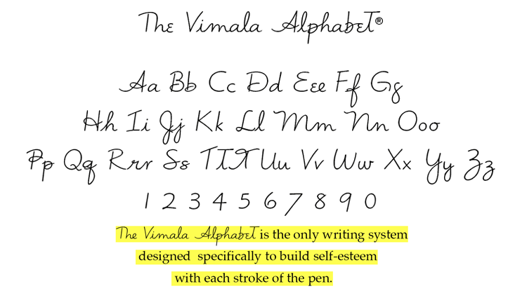
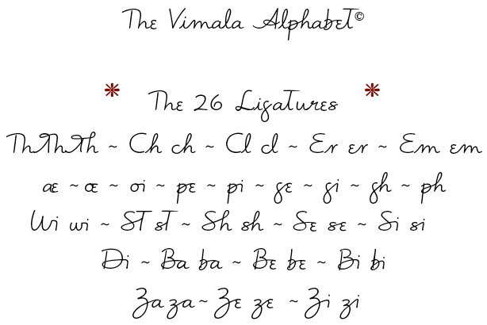

Examples of Logos that I like aspects of -


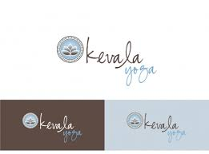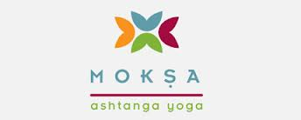


This is an example of the Vimala font being used (uplift, inspire, delight)


