Vignoble Émile-Auguste / Emile-Auguste Winery
- The Emile-Auguste Winery, is a small family owned winery that has been producing wine for little over 3 years. We now want to officially start commercializing our production. To do so we are looking for a label for our wine bottles.

Historical background:
- The winery is named after both of my grandfathers, and so we are looking for a label that would represent the historical connection that the winery has with them. They are the inspiration for the winery and all of the effort that went into setting up the winery.
  - Émile is my French-Canadian grandfather, a family men that lived of the land and was very successful in selling his production in local markets.
  - Auguste is my Italian grandfather, He was a hard working men that lived from farming his land. Every year he would produce a small quantity of wine back home in Italy, he was never able to expand his production but as always been passionate about wine.

What we are looking for:
- A wine label with three variation of colors, we want the same label for all three of the wine we currently produce, but with a different color scheme for:
  - White wine
  - Red wine
  - Rosé wine

- We are looking for a label that will not necessarily be conventional, we are open to creative ideas, as long as our characteristics listed above are met.
- The label will need to be bilingual (French and English), so

What we want the label to communicate:
- We would want the label to have the following characteristics:
  - Modern, yet simple
  - Elegant, yet not tacky
  - Different and unique, yet not absurd
  - Some historical aspect would be interesting so that it reflects the inspiration for the name of the winery

Technical specification:

- Our labelling machine can accommodate the following label dimensions:
  - This means that the label can have a maximum height of 190mm (or 7.5 inch)
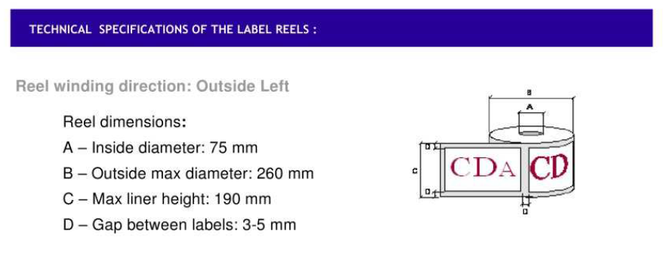

- Our bottles have the following dimensions:
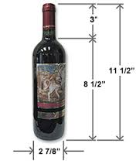

Information required on label (front or back):
- Main information (front):
  - White wine / Vin Blanc or Red wine / Vin rouge or Rosé / Rosé
  - Product of Québec / Produit du Québec
  - 750 ml
  - 11.6% alc./Vol.
  - Winery Émile-Auguste / Vignoble Émile-Auguste

- French description (this is only an example of the description that would be included on the label, separate description will be written for the red and rosé wines):
  - Cultivé et mis en bouteille au Vignoble Émile-Auguste. Ce vin blanc est d’intensité moyenne et légèrement soutenu. Il accompagne très bien les fruits de mer, le poisson et les différents desserts.
  - Contient des sulfites

- English description (this is only an example of the description that would be included on the label, separate description will be written for the red and rosé wines):
  - Grown and bottled at the Emile-Auguste Vineyard. This white wine has a medium intensity and is slightly supported. It accompanies well seafood, fish, sushi, as well as desserts.
  - Contains sulphites

- Address :
  - Vignoble Émile-Auguste senc.
210 Montée Guay
St-Bernard-de-Lacolle Qc
J0J 1V0

