PRISON BREAK HARD CIDER
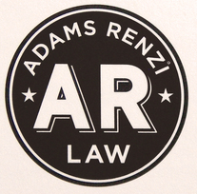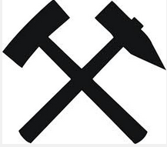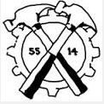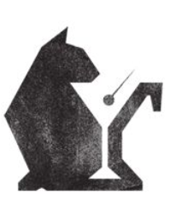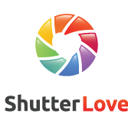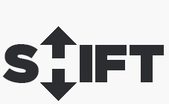
http://blog.spoongraphics.co.uk/freebies/free-wilderness-vector-graphics-logo-template-kit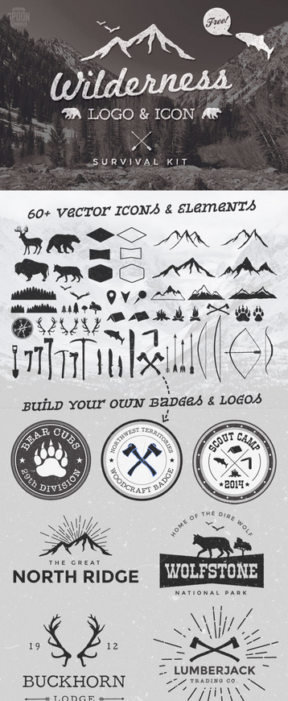

Like This Label Quite a Bit. Would want a less feminine font. Like the white on dark concept.
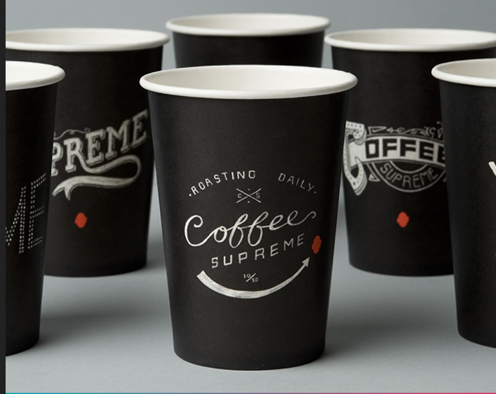

Unisex, but more masculine. Modern, but rustic.
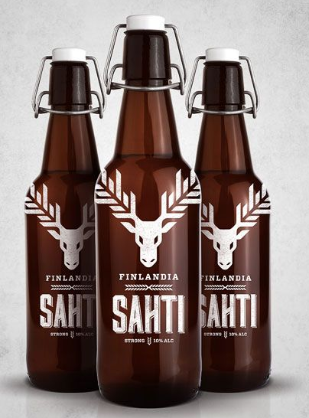

Unisex, but more masculine. Modern, but rustic.
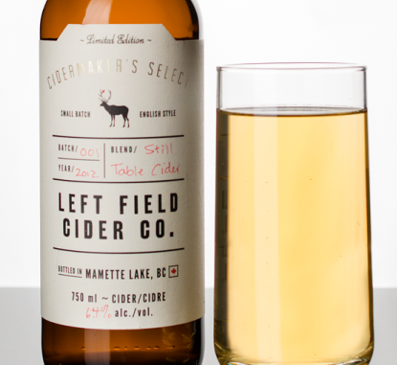

LOVE-LOVE how clean this label is. This is the suite of what I want. A logo that says a little about the brand. Prison tools (a shank, a cats paw, a teaspoon used to dig a tunnel slowly, a pick-axe, an apple tree, a tunnel for escape, drawn plans for escape, barbed wire.)
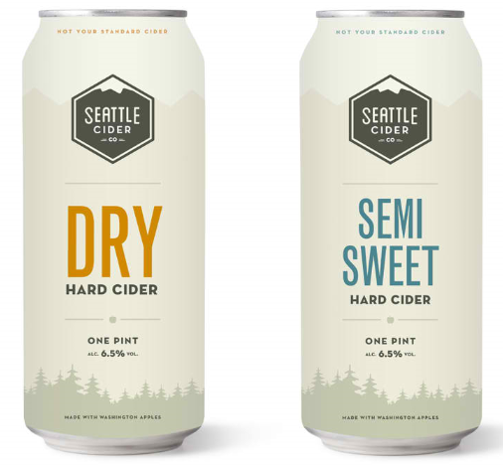
I dig geometric shape stuff.
