DÜO
Cosmetics ∙ London

Company title above and tagline below.

DÜO
Precision for Beauty

My Font inspiration) Chic, luxe, stylish fonts:

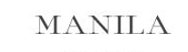

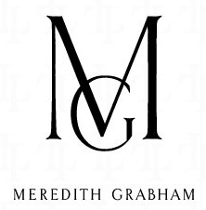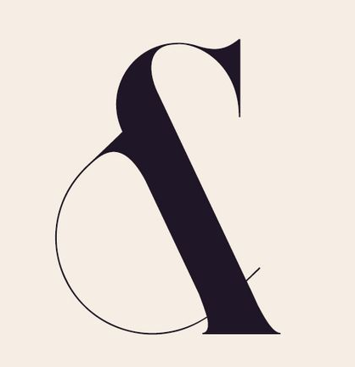
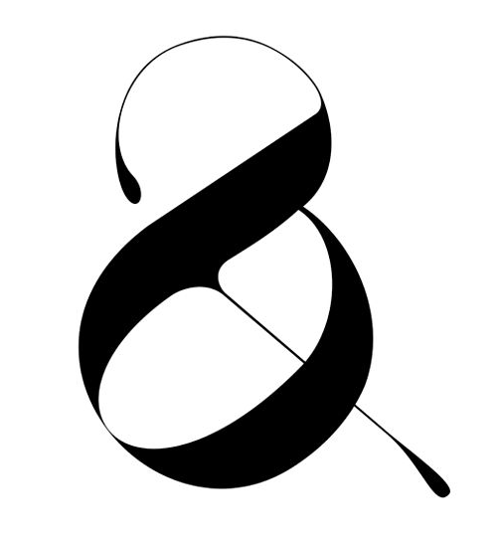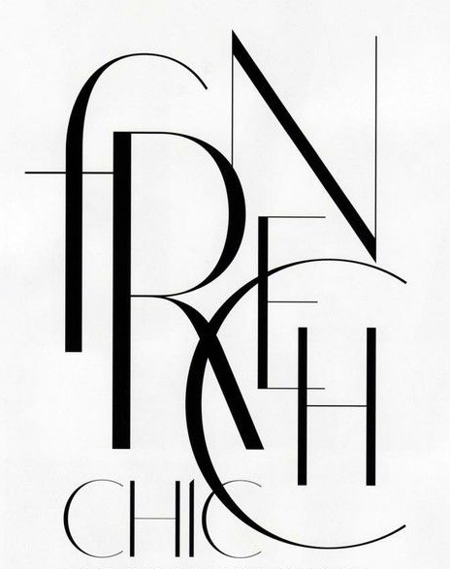

I have not developed the entire brand campaign yet just needed a chic font for DÜO, trying to emulate the MAC, Sephora, or Zoeva (https://www.zoeva-shop.de/) type of luxe style.
This is for a new brand of luxury and chic makeup brushes (and cosmetics organisers) called DÜO. These are intelligently designed professional make up brushes that are designed to reflect a timeless elegance that incorporates chic trends in colours and materials. The cosmetic organizers and makeup brushes are European Chic; always stylish and intelligently designed. DÜO in where form meets function in luxury cosmetics. (Some style inspiration pictures below.)
