- The Disgesten is the existing product in the market with the same ingredient as ours.
- The “Throat Soothers” is a sample of box that we want to put our product into.

Oxifend® Kiwifruit Digestive Complex | Oxifend® Throatsoothers
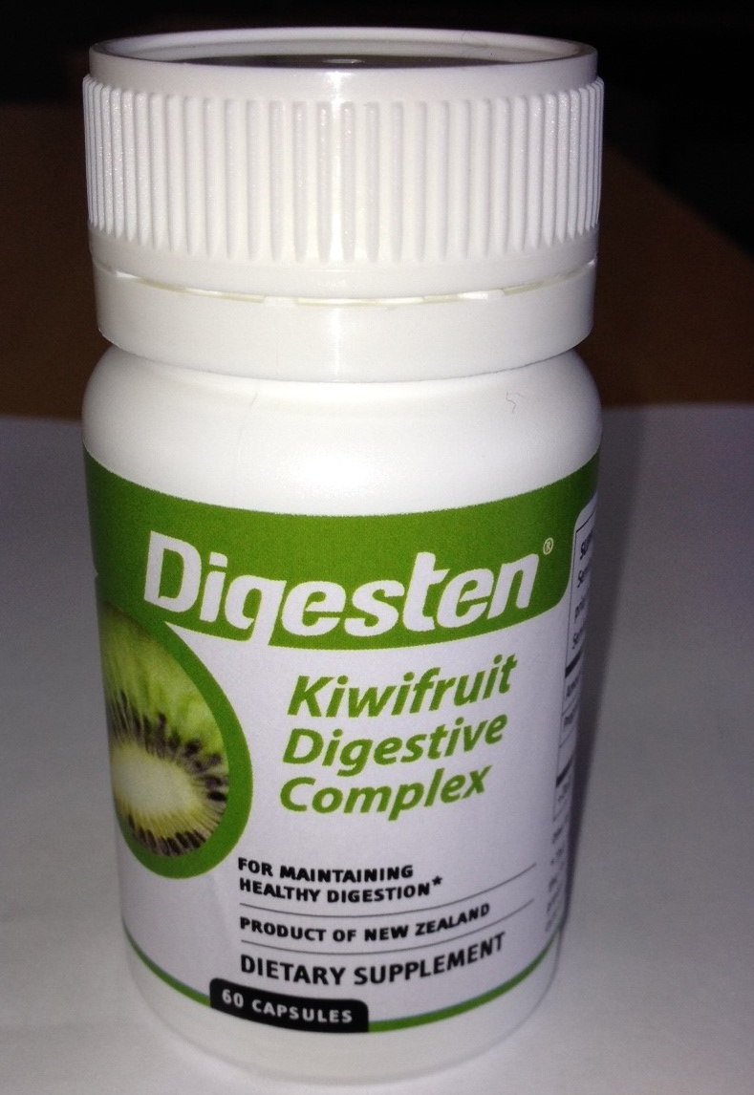 | 

