Creative Brief for PROSOCIAL logo
1) PROSOCIAL is a method for improving the efficacy of groups developed by the Evolution Institute. It will exist in a variety of forms, including books, articles, and an internet platform, that requires a common logo. The method is described in this article published in the online magazine This View of Life, which includes a brief introductory video.
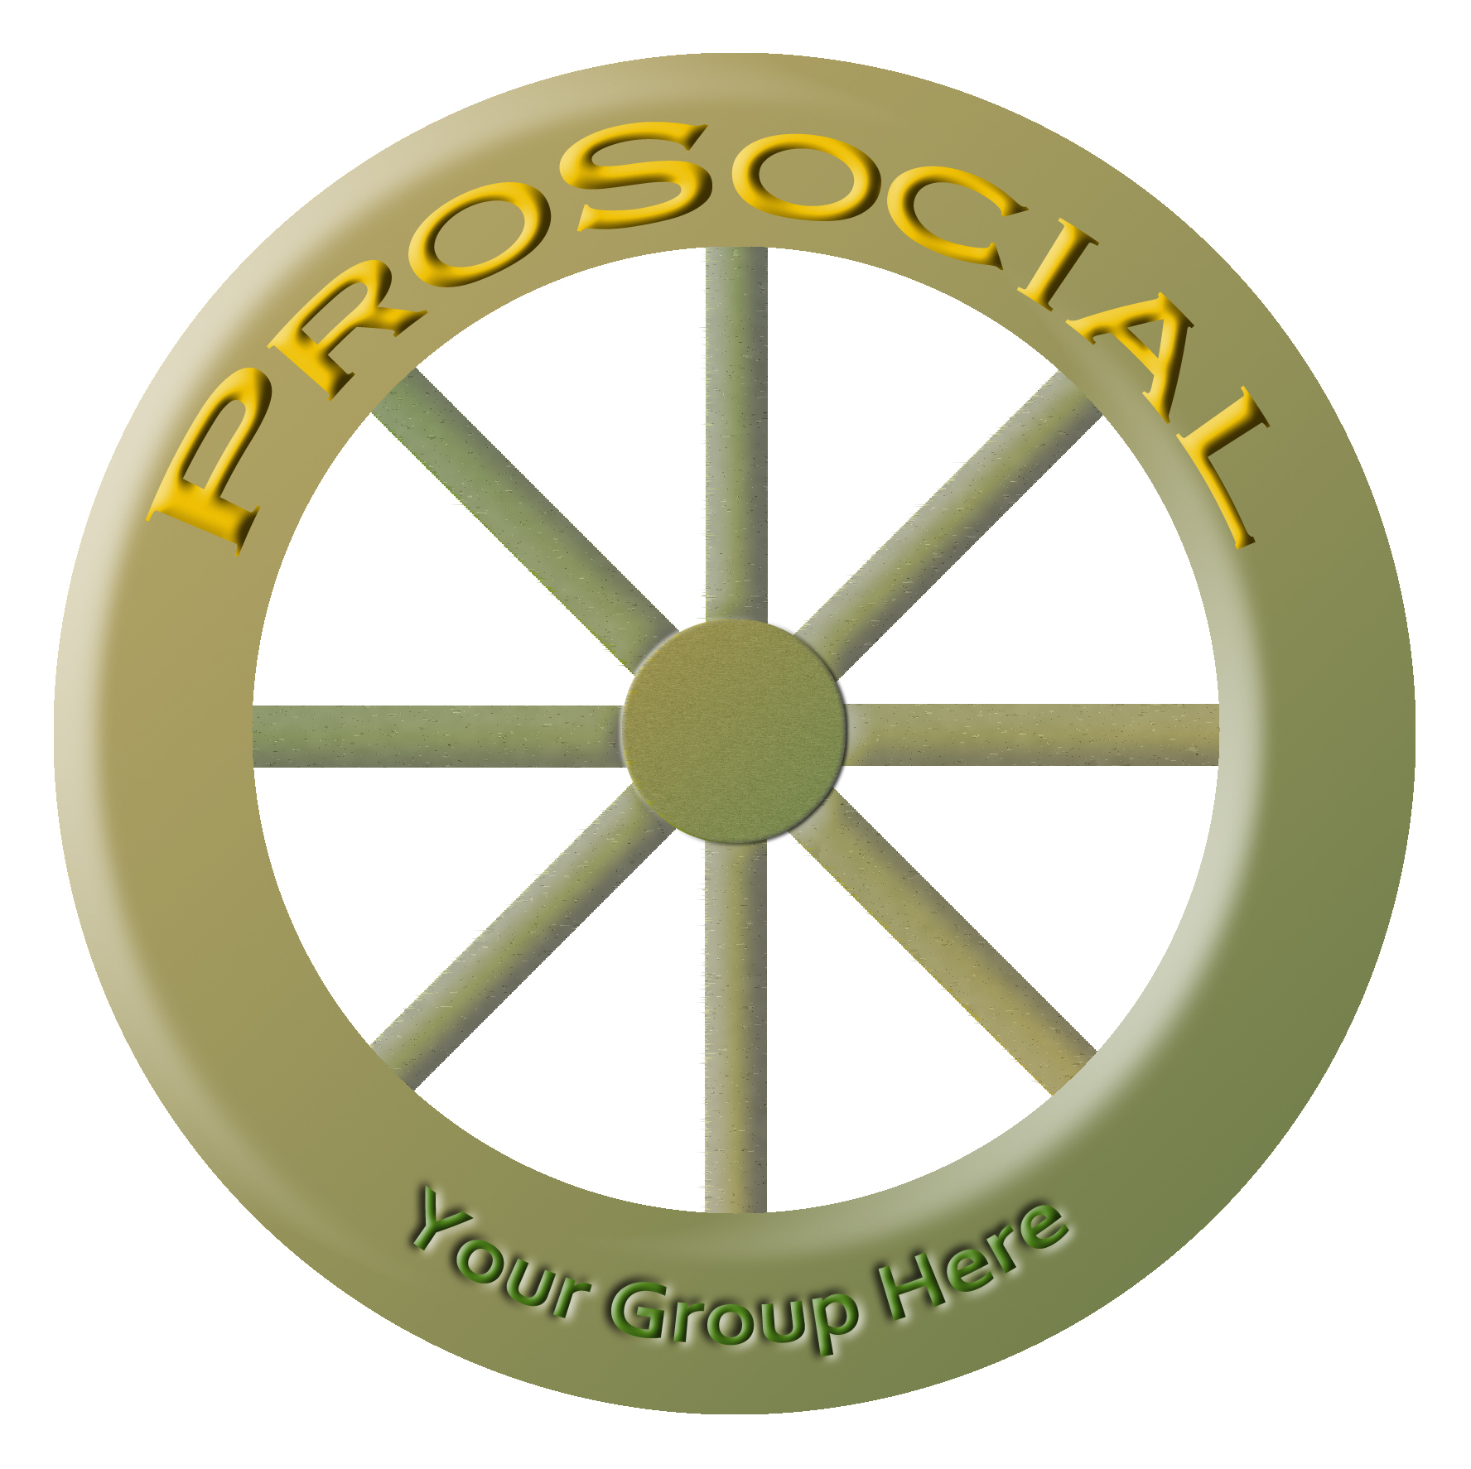
2) A logo that is an image of an eight-spoke wheel has been created, which captures certain features of the method. However, there is a feeling that the logo can be improved. Here are elements of the existing logo that are regarded as positive:
• PROSOCIAL helps groups to function well and a wheel is a functional object.
• PROSOCIAL is based on eight core design principles, so the eight spokes of the wheel have metaphorical significance.
• We want to give groups that use PROSOCIAL their own version of the logo with their own number, similar to what the Rotary Club does for their chapters. We currently intend to do this by displaying PROSOCIAL along the top of the rim, each group’s name along the bottom of the rim, and the group’s number on the center hub.
3) Here are elements of the design that are perceived as negative:
• It appears old-fashioned and possibly won’t appeal to user groups.
• The color scheme can probably be improved.
4) Against this background, we are seeking ideas for a new logo, which can be a modified wheel design or another design that captures some of the positive elements listed above.

