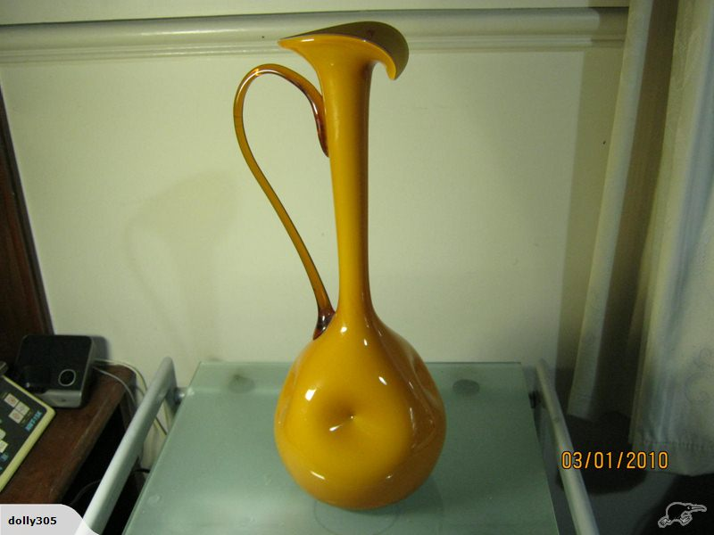

Stunning Retro Yellow Glass Jug

Stunn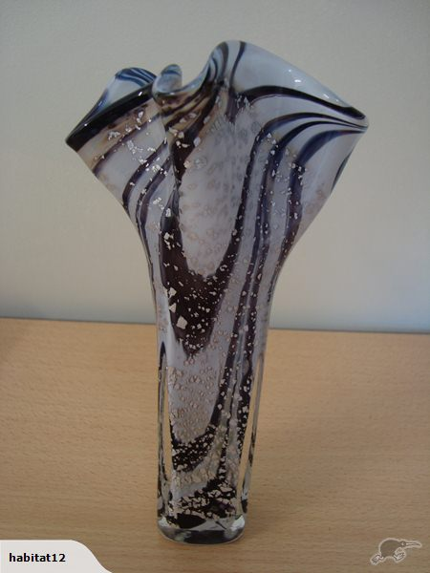

Hand Blown _ vase Georgeous

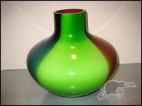

NEW MAKORA KROSNO HANDMADE GLASS VASE
Very good quality, beautiful hand blown glass.
Large and heavy rare shape.
Colour: blue, red, black and lime.
Height: 280mm
Wide: 90mm across top
90mm across base

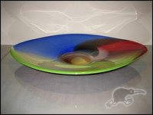
NEW MAKORA KROSNO HANDMADE GLASS PLATER
Very good quality, beautiful hand blown glass.
Colour:
Top: blue, red, black and lime.
Bottom: red
Wide: 460mm x 360mm
Weight: 3.1kg

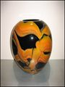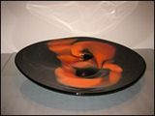
NEW MAKORA KROSNO HANDMADE GLASS PLATER
Very good quality, beautiful hand blown glass.
Colour:
Top: black, brown and orange
Bottom: black
Wide: 460mm x 360mm
Weight: 3.1kg

Purple Glass Bowl and Platter

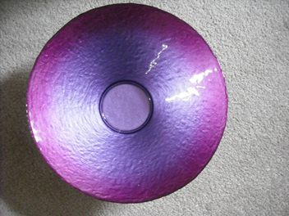

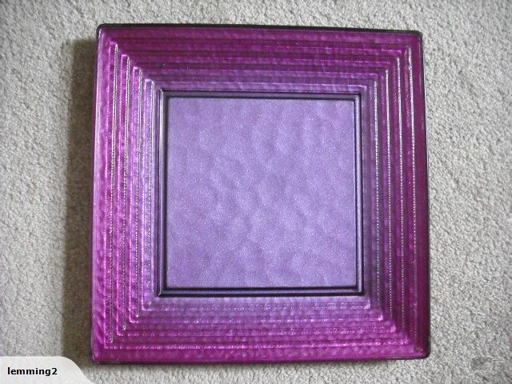

Large retro style vase Op Art vase in excellent condition.
Perfect Christmas gift for the one who appreciates great design and craftsmanship.
Measures 36cm H X 26.5cm W
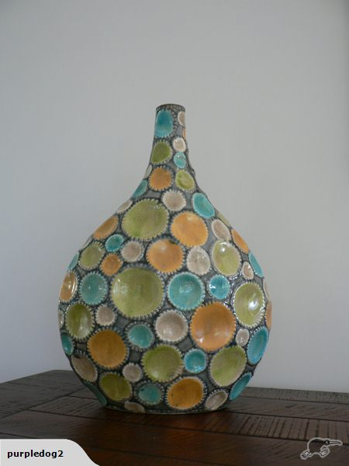

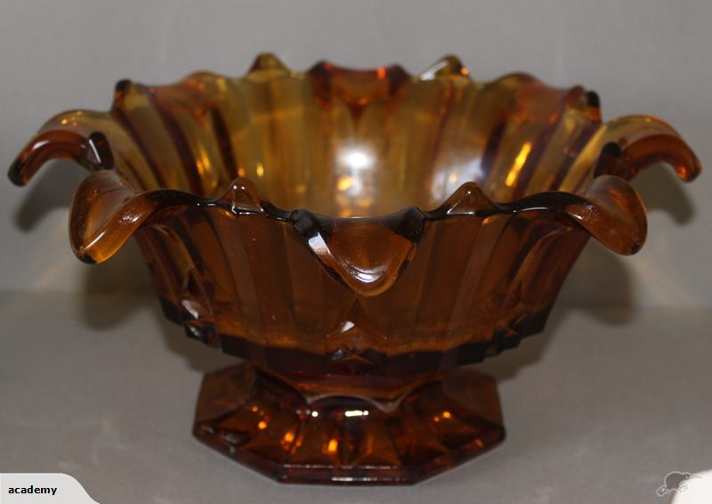

Nice Amber Bowl

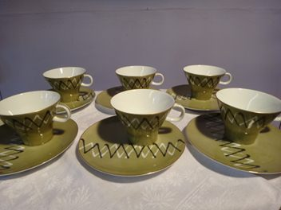

These very Retro looking Cup/Saucers are from the Japan Company "Noritake" –

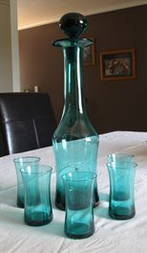
Turquoise Glass Decanter and small turquoise glasses

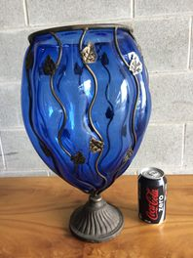
Nice and Large, it looks beautifully Victorian!
It is 45cm tall and has a top opening diametre of 20cm.
The shape reminds me of a large Brandy Balloon.
Its in encased in a metal "cage" adorned with vine leave.

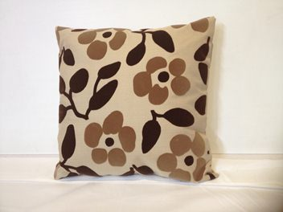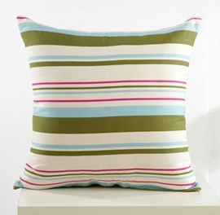

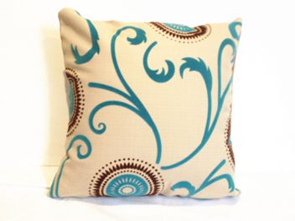
Cushions _ various available new and used
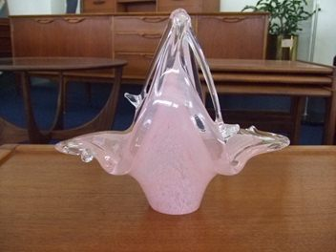
Murano Glass Basket

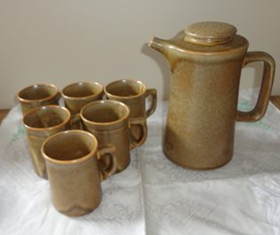
Temuka Riverstone Coffee Set

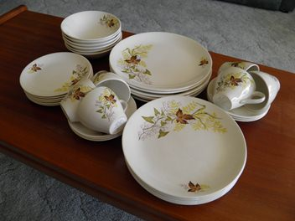
Crown Lynn _ autum Summer Dinner set

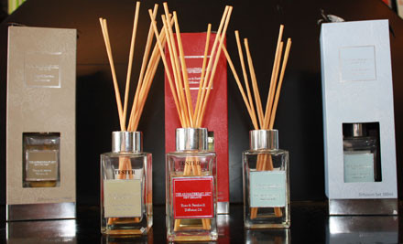
Aurometherapy Diffusers

\

Garden Bits

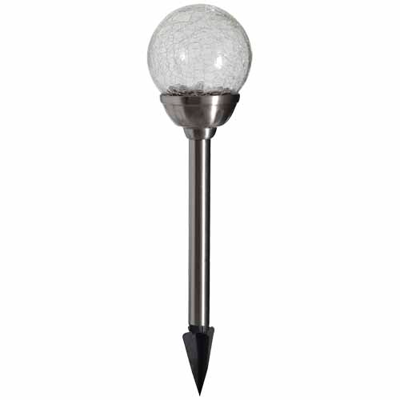
Gardening Solar lights
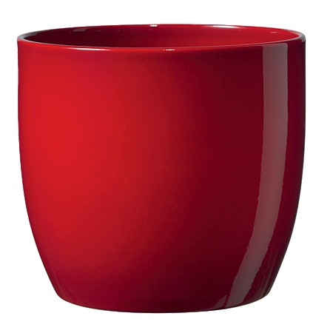
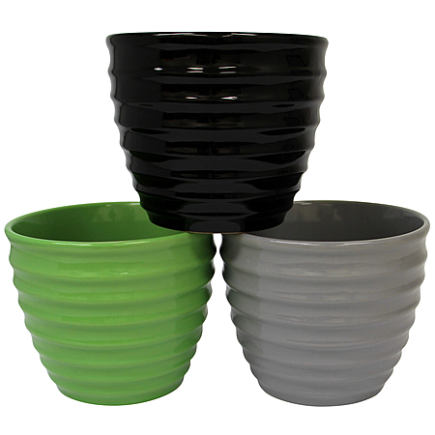
Pots

Wall art
