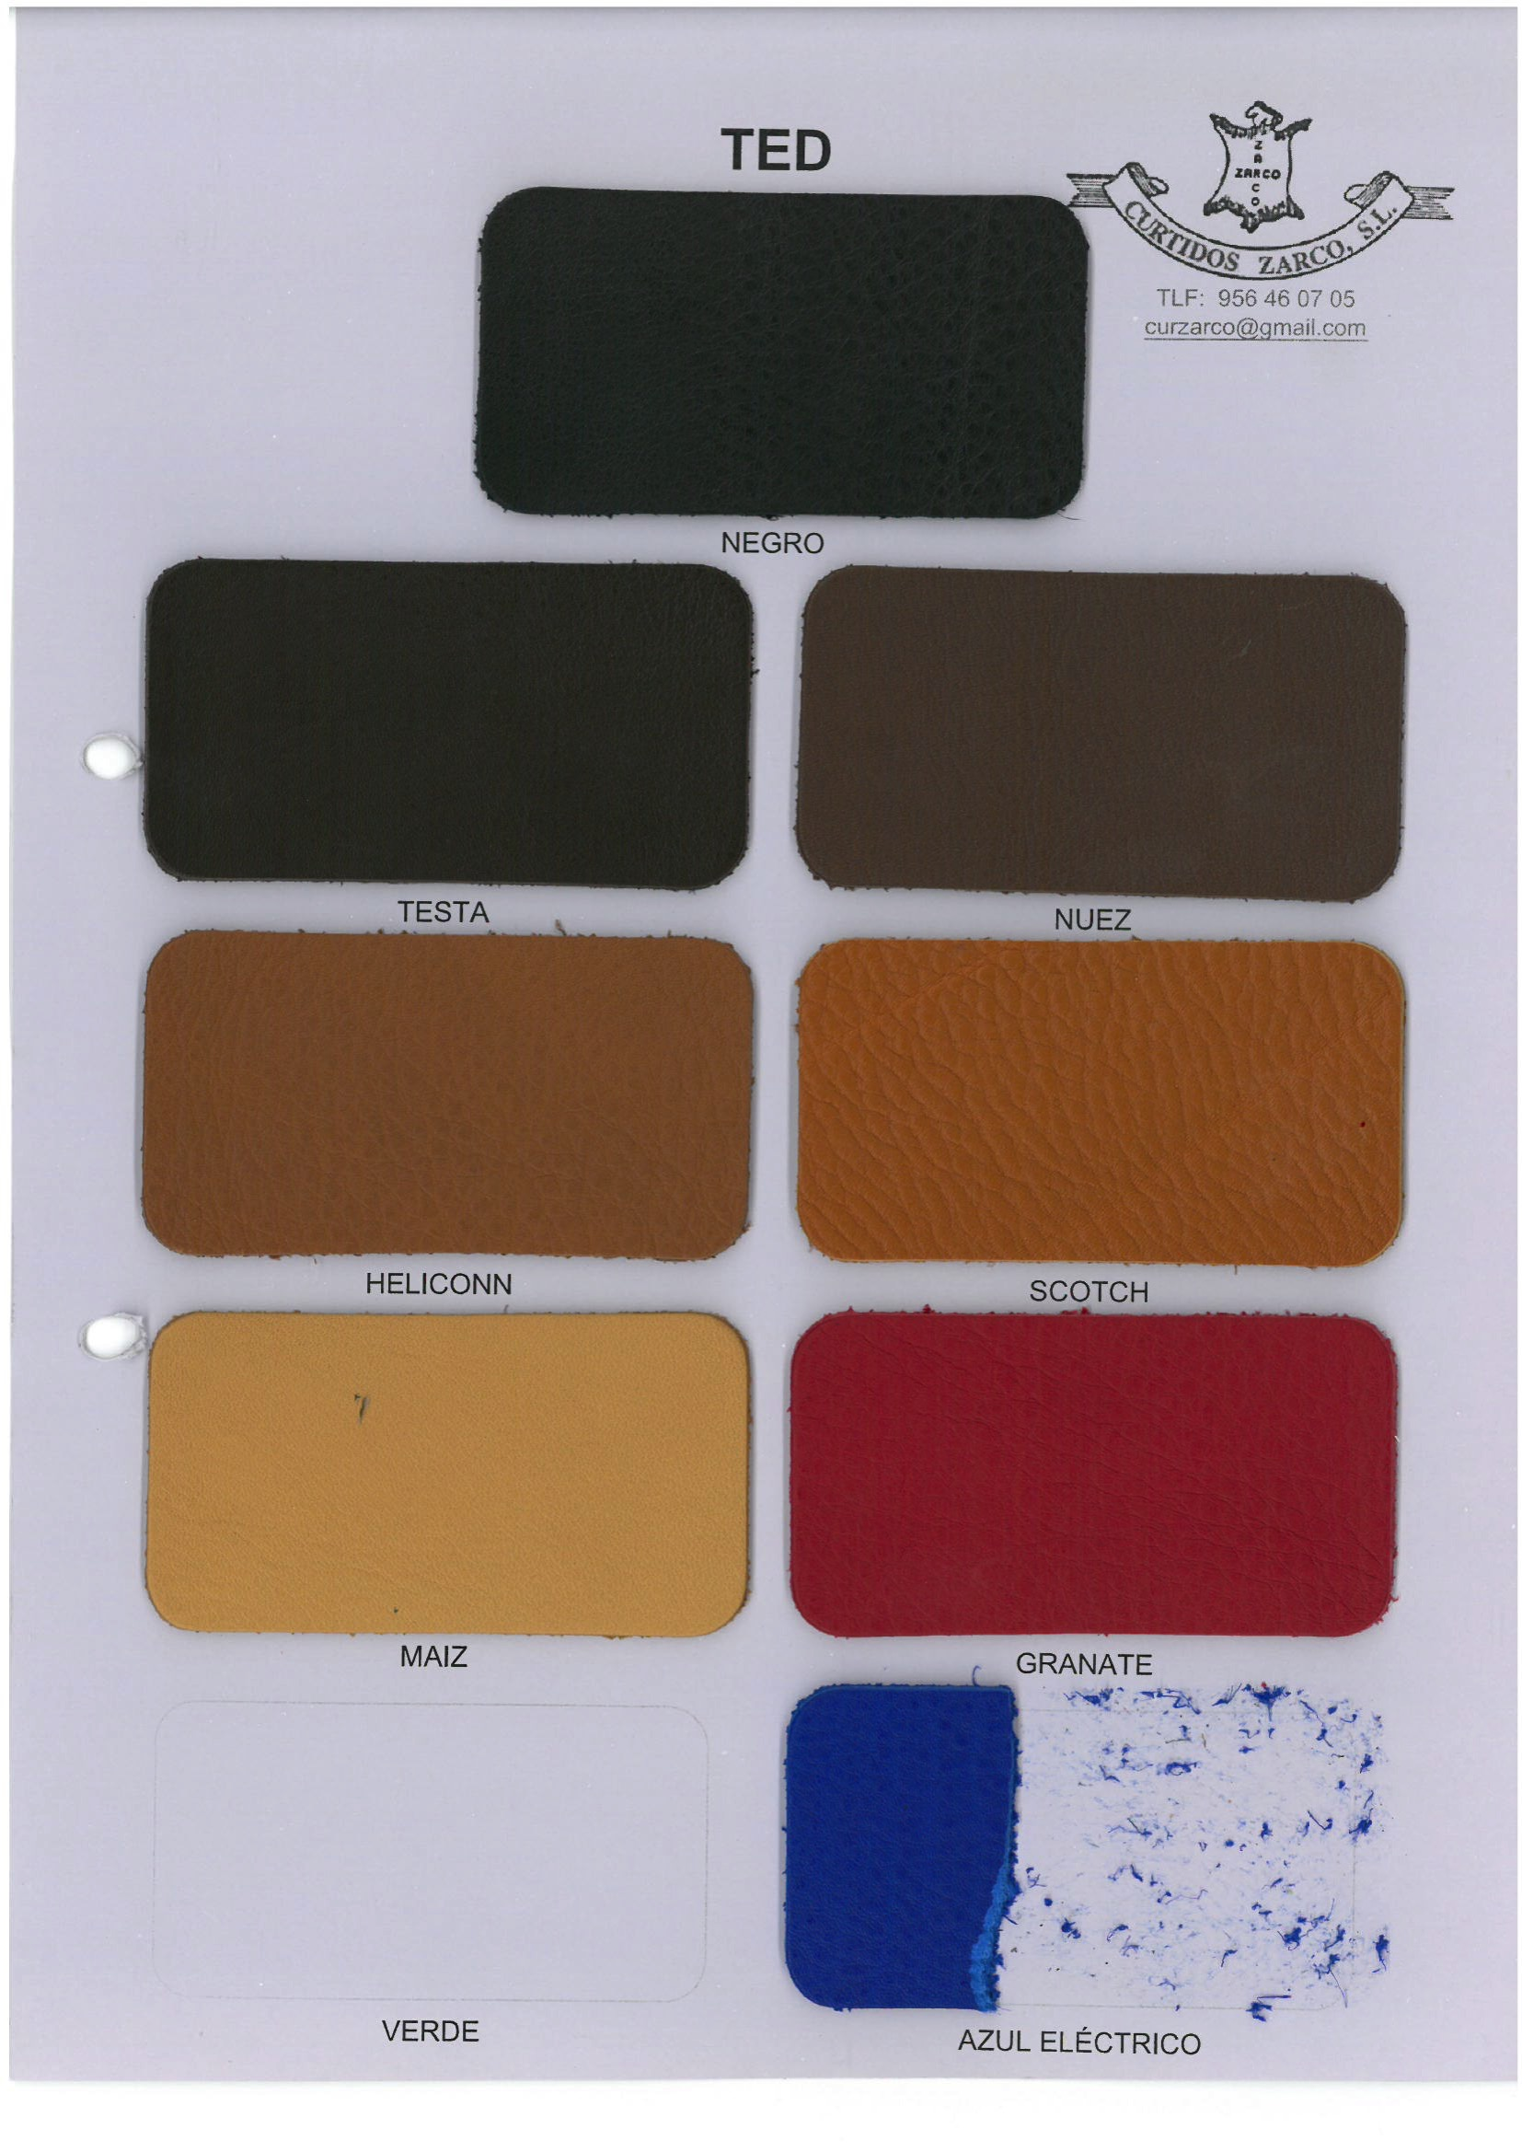
MORE THAN A TREND
COLOR WAYS
A/W 2015
Color 1 – Electric Blue
Color 3 – Bright Red
Color 1 - Black
Color 2 - Caramel

