

Who We are
- The mortgage broker for a modern market. An established brand, that’s helped over 50,000 Australians secure a home loan, since 1998.
- A multi award winning brand that is continually being acknowledged as an industry leader. Our eChoice mortgage brokers have been recognised as one of Australia’s Top 3 Mortgage Brokers in 2013 and 2014.
- We offer expert support for home finance borrowers, whilst providing them with the personalised help they need.

What we do
- We compare hundreds of home loan products from our panel of over 25 lenders including Australia's leading bank and non-bank lenders.
- We help you grow through all stages of life, from buying your first home to investing, we will guide you to use your mortgage as an effective tool to realise your financial goals.
- We save you time and hassle by comparing home loans which could potentially save you thousands!

How We Do It
eChoice mortgage brokers have access to over 25 lenders and 100’s of home loans, and use award winning technology to find a home loan that suits your needs. Your accredited eChoice mortgage broker will make finding the right home loan easier, by helping you understand all the key decisions, while giving you the personalised service you deserve. Best of all our mortgage broker service is cost and obligation free!
The Process
- Simply visit www.echoice.com.au or contact your local eChoice broker directly to get started.
- Your eChoice broker will compare 100’s of home loans from multiple lenders, including Australia’s leading banks to find a product to match your requirements.
- Your eChoice broker will help you understand all the key decisions to get your loan signed, sealed and delivered. They’re with you all the way from start to settlement!
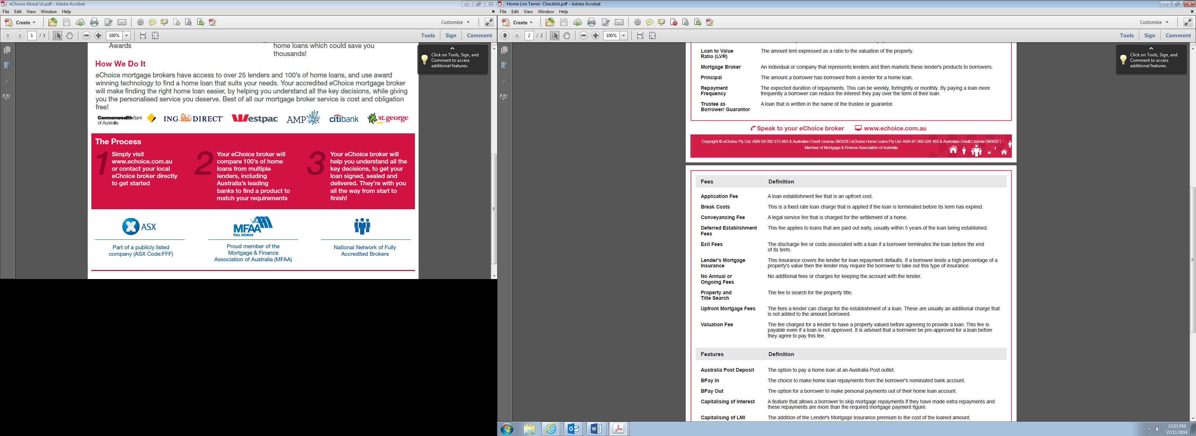
FOOTER:
www.eChoice.com.au
Copyright © eChoice Pty Ltd: ABN 59 082 572 683 & Australian Credit License 390528 | eChoice Home Loans Pty Ltd: ABN 61 069 528 463
& Australian Credit License 390502 | Member of Mortgage & Finance Association of Australia

