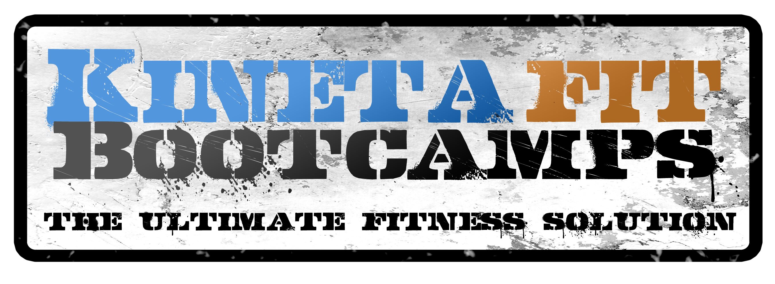

Have you been looking for a good reason to get in the best shape of your life?
KINETAFIT’S FITTEST PAIR CHALLENGE!
If you have been looking for a great reason to get in the best shape of your life, but need some accountability and coaching to get there we have the PERFECT Program for you!
Over the course of 21 days, Kinetafit is holding it’s first ever FITTEST PAIR CHALLENGE!
Our 21 Day Fitness Challenge will give you the world class training and testing to ensure that you are prepared to take on anything that life throws at you be in the best shape of your life at the end of 21 days!
During the FITTEST PAIR CHALLENGE you will be tested on your initial fitness skills, trained in an intense training program for 21 days and re-tested to see which team made the most improvement!
Call 303-503-9344 to reserve your spot today!
The contest will run from January 26th to February 15th. Over $700 in cash prizes are up for grabs for the best Team Scores and Best Improvement!
Male, Female & Co-Ed Divisions!
CALL US FOR MORE INFO
303-503-9344
www.Kinetafit.com

