You are cordially invited to the marriage of synthetic turf and natural grass…
Introducing XtraGrass…
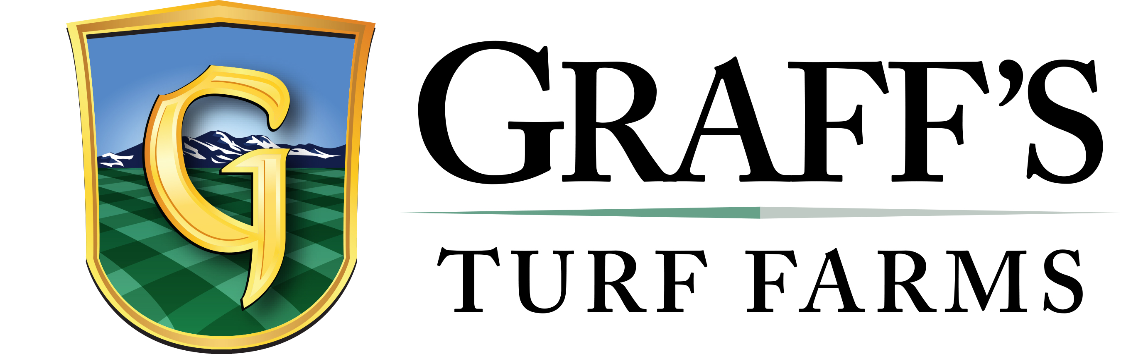The best of both worlds…
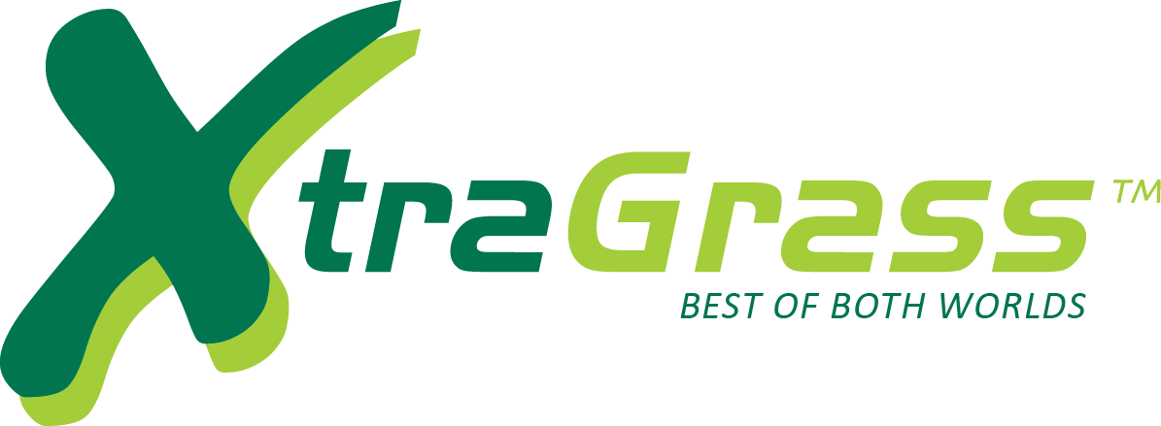
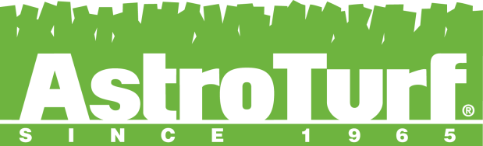

XtraGrass is a unique hybrid system of natural and synthetic turfs. Synthetic fibers augment natural grass, as the natural turf grows through the synthetic matrix.
+ Durability of Synthetic Turf
+ Playability of Natural Grass
+ The first field in the US (Lakewood Memorial Stadium, CO) hosted 60 games in 60 days on a natural surface

www.astroturf.com www.graffsturffarms.com
800-723-TURF 800-280-TURF

