
Creative Brief
We are seeking a wordpress design for a new company called Signal Bay Research (SBR). SBR is a business to business site that provides information, news, and data about the medical marijuana and other emerging industries like cryptocurrency. The site will have a home page/dashboard that highlights the top news, featured companies, featured people, and featured reports. The site will also have profile pages that contain detailed information about companies, people, events, and states (regulations). The site will also have a woo commerce store for reports and data extracts.
The database and website is in development, we need help with the creative design/layout.
We started development using canvas wordpress theme, so it is a plus to base from there. Also we prefer that you use a "child theme" format for wordpress, to keep the CSS consistent.
We will need four page templates, described in the following pages.
Our typical user
- Professional, entrepreneurial men 29-55 years old. They are high net worth investors, lawyers, entrepreneurs and in the financial sector – or they strive to be there. They are also marijuana friendly and web savvy, and “hip” so visual interest is important.
- They read Fast Company, Wall Street Journal, Investors Business Daily, mmjbusinessdaily.com (they wish it were better). They visit the site leafly.com
- they follow us on twitter and facebook.
Our website comparables (functional comparison)
- forrester.com, gartner.com, sugaronline.com, platts.com, juniperresearch.com
. We will compete with Leafly.com , marijuana.com, on some levels.
Website designs we like
- Hbr.org, digiday.com,
1. Home Template
This page has a number of widgets that will contain data about a certain industry. A user may drill down into the data in the widgets to get to profile pages.
In the future, users will have the ability to select other industries (medical marijuana is one, also crypto-currency, 3D-Printing, and renewable energy may come in future)
We would like the page to have a lot more visual interest than the mockup below shows.
Our initial revenue stream will be research reports – so we want to highlight the reports we have for sale. These reports will have images, titles, and subheadlines associated with them. Users can also browse through other data such as companies, regulations, upcoming events. The price widgets on the right will be dynamic, but users do not currently have option to go anywhere.
We may have internal advertisements, such as banners that promote our reports.
Although the mockup shows three columns, two columns may suffice.

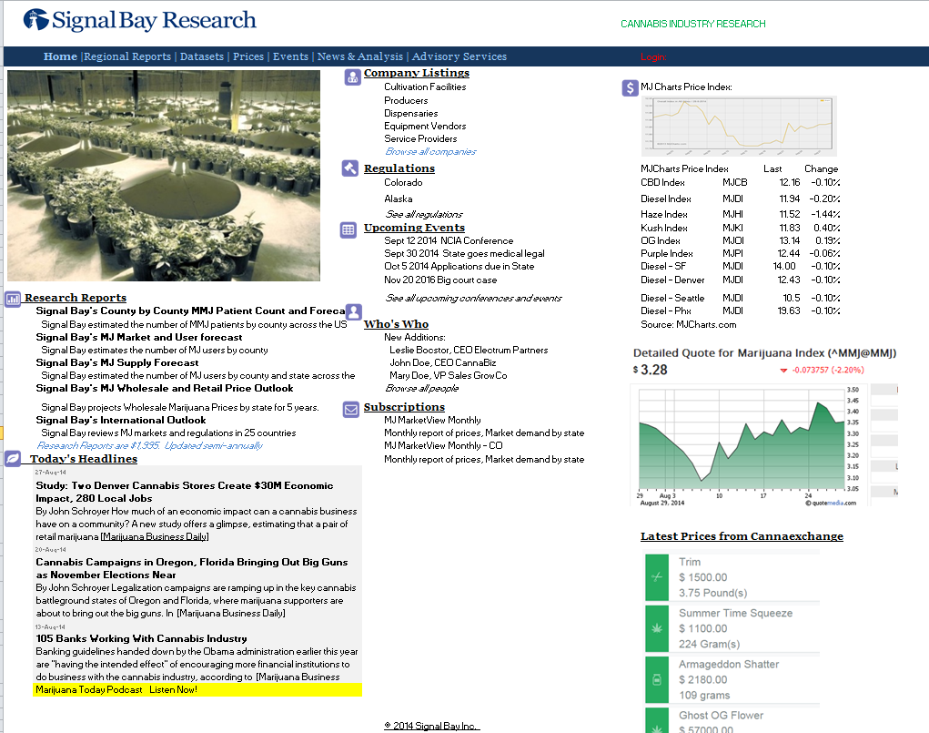

2. Profile Template
Profile template includes profiles of people, companies, states/jurisdictions, and events.
A user will drill down to get to pages that show a profile of a company, a person, a state, or an event.
. We will have long text description of each element plus widgets so the user can navigate to related information. For instance, a company is in a certain state, and a person may be associated with a company and be represented at multiple events. These may include relevant ads that promote our reports. We are seeking a design with visual interest, and ability for users to grasp capture a lot of information/data quickly. We have the capability to include icons/images with each widget or even data element.

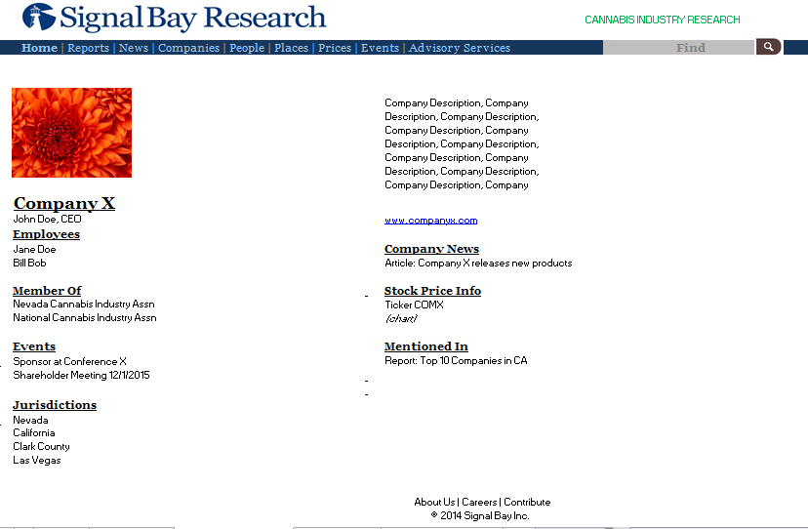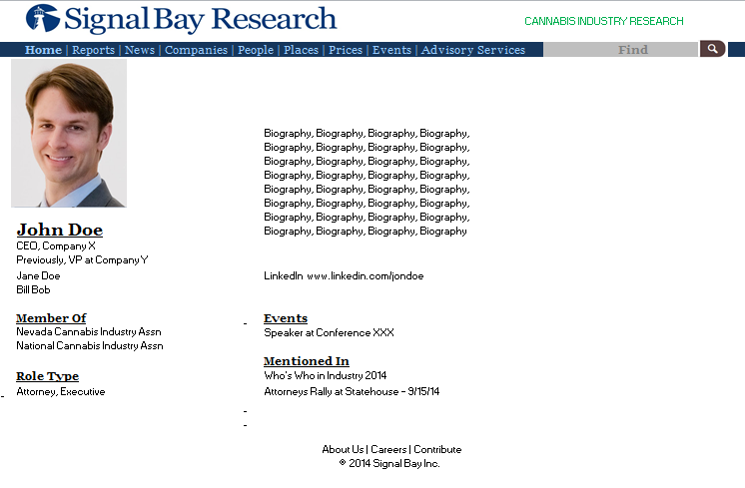

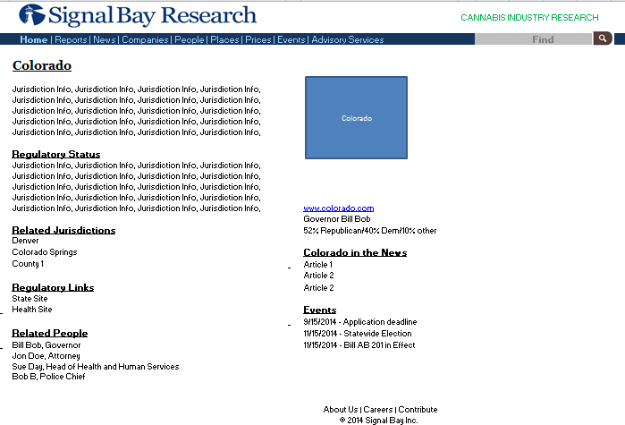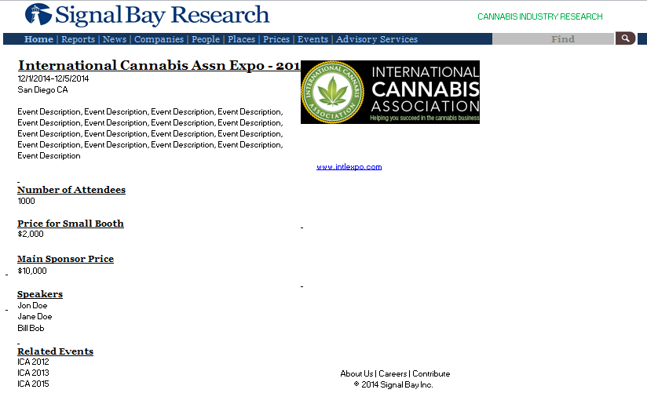

3. Reports store.
We will have digital download products for sale in the reports store. These may include research briefs, books, and data downloads. We are using WP/Woocommerce for this.
We will launch with a small number of reports (fewer than 10), and may build up a library of hundreds of industry-specific reports. Reports for example may be a market outlook for a state, and we may have annual reports. So we may have repeated report themes. For example, Colorado outlook 2015, Arizona Outlook 2015, and Arizona Outlook 2016
Each report will (ideally) have a catchy image or cover art associated with it.

