FONT STYLES: I like clean fonts with some decorative element about them – examples below
PLEASE TAKE THESE AS A GUIDE ONLY


This image has got a clean and clear feel about it through the thickness, boldness of the letters– while is still has something special about it with the slightly decorative font, without being overly feminine

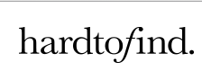
Same as above – simple, clean and clear font with a decorative element though the letter f
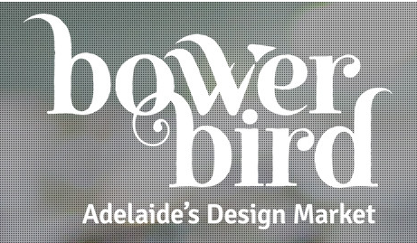


although this logo has a bird device, it is still kept simple without too many elements or being too fussy – another classic example is apple


Simple, effective logo


