Please design a brochure(trifold) like the picture below (MAKE IT UNIQUE AND INTERESTING WITH PICTURES, CARTOONS that can represent our software)
trifold brosur

www.sevenmaps.com

Company moto - “Automate Your Businesses”

There must be amazon.com and verisign trusted logos in the brochure to show that security is our no 1 priority



or



Company profile

Sevenmaps was created ​​to meet the needs of entrepreneurs who want to access their company's finances with ease.

Evolution Technology was established in 2011 in Jakarta, with a mission to make business automation that will enhance the quality and efficiency of businesses.

All of us at Evolution technology aim to provide best user experience to our clients.

Evolution Technology is always innovating and evolving in order to be ready for our clients’ needs.

Advantages of SevenMaps

- The easiest accounting system
Wizard is very user friendly. You can give the authority for each employee and can continue to monitor your company's health online.
- Managing customer and supplier
The complete live data and information of customers and suppliers, including debt and receivables
- Sophisticated Business Dashboard
Important reports at your fingertips
- Real time financial data
You can see all the reports and financial data are accurate and current.
- Access anywhere
Easy to access and control from anywhere in the world
- Security of data
Powered by the famous and the best system in the world, VeriSign SSL and Amazon Web Services
- Free support
Our support team is always ready to help you
- Update new features free
All new features will be automatically ready to be used by you without the need to update the system - free of charge

Contact Us

Ruko Season City blok B no 32
Jl. Latumenten no 33
Tambora, Jakarta Barat 11250
Indonesia

Phone: (021)63859510
Fax: (021)63859511

Email: support@sevenmaps.com

5 Reasons to call Sevenmaps today:
- Free until March 2013
- Take control of your finances today using our modern dashboard
- The easiest accounting system
- Free support
- Security of data

Explanation of the terms

Dashboard
Appearance of financial summary in 1 page summary.

NERACA
Balance sheet is a financial statement that shows the position of resources owned by the cooperative and its infomasi the source of funds. Balance sheet prepared at the beginning of the establishment of a cooperative.

bank dan cash
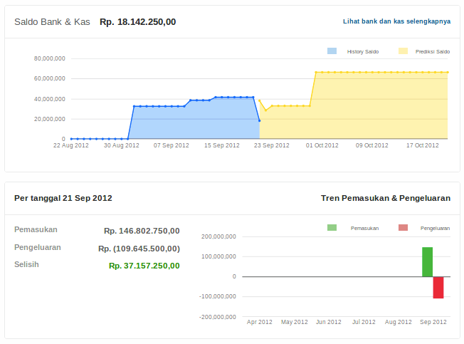
financial overview bank account and capital associated with each account.
Users can see the send, receive funds and check transactions.

Some ideas for pictures/diagram
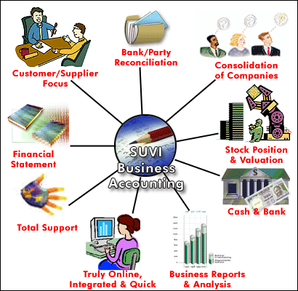
http://www.google.com/imgres?hl=id&client=ubuntu&hs=iaC&tbo=d&channel=fs&biw=1535&bih=810&tbm=isch&tbnid=fTCVRXFeCnSSXM:&imgrefurl=http://principles-of-accounting1.blogspot.com/2011_06_01_archive.html&docid=hS74wI9999wETM&imgurl=http://3.bp.blogspot.com/-5OWiRj7nBgE/Tg1kGHHnzPI/AAAAAAAAAA8/_yrnB5HT-7M/s1600/accounting_diagram.gif&w=410&h=400&ei=xRv-UMyVJ4SGrAf74oHwDw&zoom=1&iact=hc&vpx=1271&vpy=317&dur=7429&hovh=222&hovw=227&tx=193&ty=114&sig=101477332915578223927&page=2&tbnh=149&tbnw=153&start=36&ndsp=36&ved=1t:429,r:49,s:0,i:230

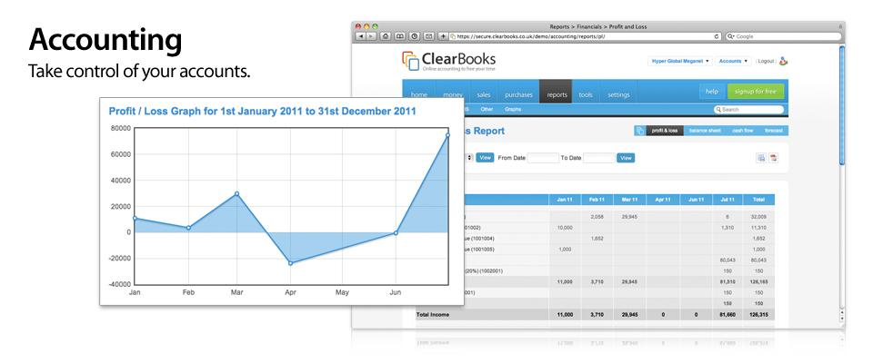
http://www.google.com/imgres?start=115&hl=id&client=ubuntu&hs=Ywr&tbo=d&channel=fs&biw=1535&bih=810&tbm=isch&tbnid=uf0hqFkX-L44_M:&imgrefurl=http://www.clearbooks.co.uk/tour/financial-accounting-reporting/&docid=AJh4ovrllfMWLM&imgurl=http://cdn.clearbooks.co.uk/wp-content/uploads/2009/09/tour_accounting.jpg&w=960&h=400&ei=ERz-UIuwEseGrAf3s4DQDg&zoom=1&iact=hc&vpx=1150&vpy=335&dur=2491&hovh=145&hovw=348&tx=166&ty=95&sig=101477332915578223927&page=4&tbnh=118&tbnw=267&ndsp=37&ved=1t:429,r:35,s:100,i:109


http://www.google.com/imgres?hl=id&client=ubuntu&tbo=d&channel=fs&biw=1535&bih=810&tbm=isch&tbnid=IQuj-tzKQhIdKM:&imgrefurl=http://www.combooksolutions.com/&docid=VCXx53vc5wQ4GM&imgurl=http://www.combooksolutions.com/images/cloud-accounting.jpg&w=960&h=637&ei=Mx3-UKPaK5HKrAf24YCACA&zoom=1&iact=hc&vpx=254&vpy=136&dur=1769&hovh=183&hovw=276&tx=178&ty=118&sig=101477332915578223927&page=1&tbnh=143&tbnw=170&start=0&ndsp=35&ved=1t:429,r:1,s:0,i:81

