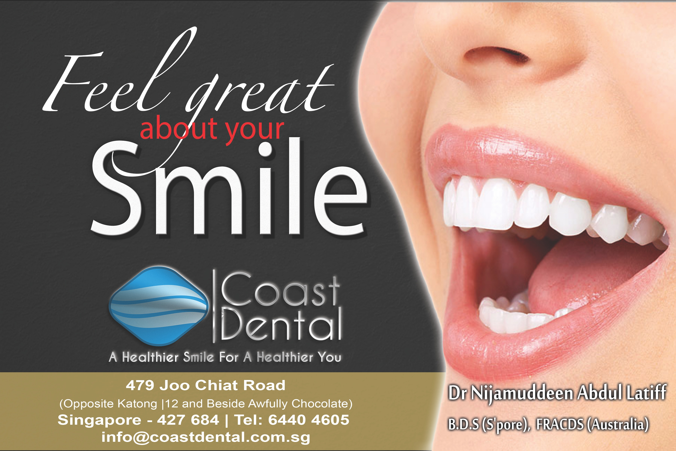
90% of dental diseases have little or no symptoms till advanced stages. When dental diseases reach an advanced stage the pain can be very sudden, intense and often accompanied by facial swelling. At this stage complex dental treatment would be needed to treat the tooth.

Dental problems need not only be related to the teeth and gums. The health of the mouth depends on the harmonious inter-relationship between the teeth, muscles of the jaw and the temporomandibular joint. When an unhealthy relationship exists between these structures an individual can experience excessive tooth wear, shaky loose teeth, cracks or fractures, ear congestion, headaches, facial pain and postural problems.

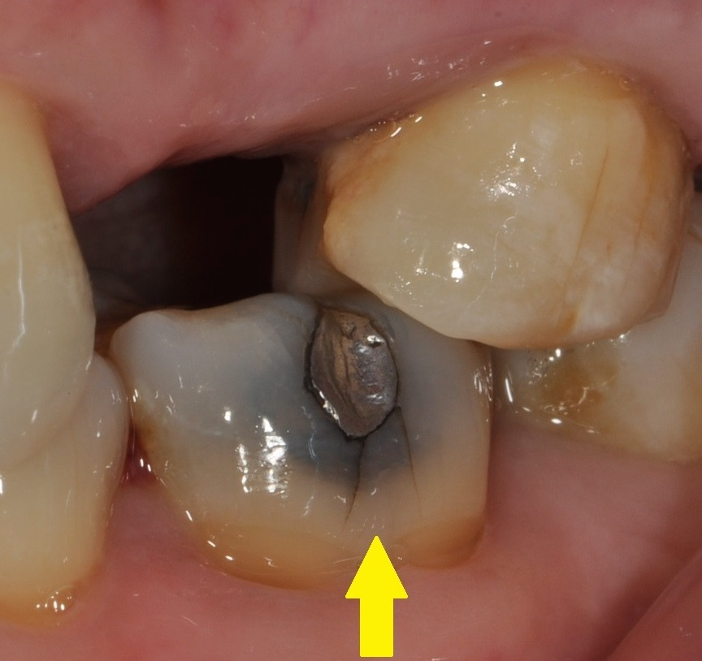

The photo on the left shows a tooth with a mercury filling which has, over time, caused cracks to form along the tooth. These cracks are usually painless until they reach the nerve of the tooth. At this time the cracks can split the tooth and the pain can be sudden and excruciating.

Your smile may be saying more about you than you realise. Studies have shown that an attractive smile gives the perception of an individual to be successful, healthy and sociable. The same studies show that an unattractive smile gives the perception of an individual to be less successful, having a dull social life and even being less trustworthy. Ofcourse these are just perceptions and often can be changed after getting to know a person in due time. However there may be instances where one does not get the benefit of time to make a lasting impression. Studies indicate that lasting impressions are made within the first three seconds of seeing someone. Cosmetic dentistry can greatly improve the attractiveness of a smile and help create a great first impression!

At Coast Dental we believe in comprehensive dentistry. It is our practice philosophy to focus on creating beautiful smiles built on a healthy foundation. We call this functional aesthetics.
Dr Nijamuddeen A. Latiff obtained his BDS from the National University of Singapore. Upon graduation he served in various government institutions such as The National Dental Centre, Health Promotion Board, Singapore Armed Forces and Singhealth Polyclinics.

In 2009 Dr Nijam left the government sector for
private practice. As a firm believer of continual
education he is an alumni member of the Las Vegas Institute of Advanced Dental Studies. At the institute he received training from renowned dentists Dr Ron Jackson and Dr Kit Weathers in the subjects of aesthetic restorative dentistry and root canal treatment.

In 2014 Dr Nijam was admitted as a fellow at the prestigious Royal Australasian College of Dental Surgeons. Dr Nijam has also completed his
part 1 exams for the Diploma of Membership of the Joint Dental Faculties at the Royal College of Surgeons of England (MJDF RCS Eng).

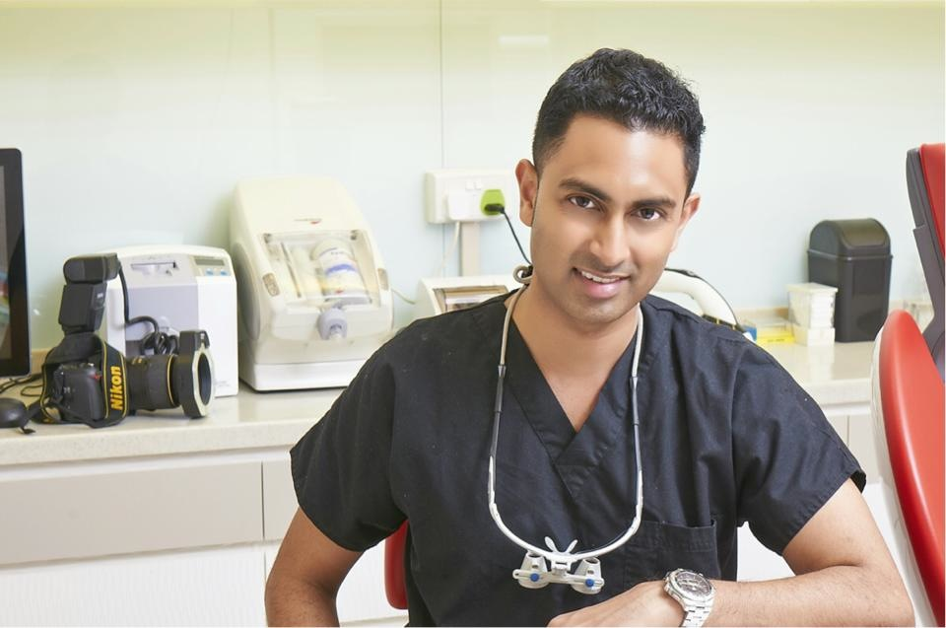

At Coast Dental we believe in investing in state of the art technology to ensure a comfortable dental experience for you.
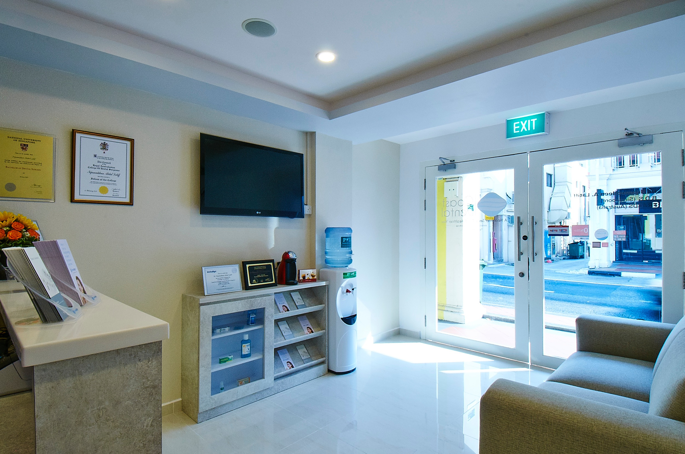
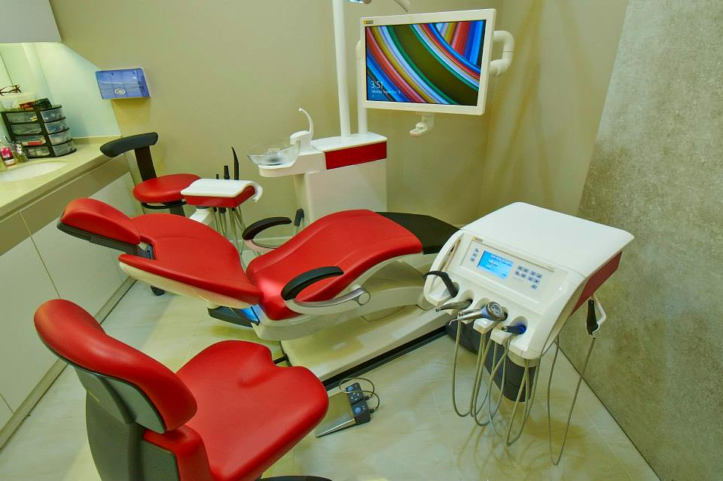
Our Sinius Treatment Centre provides excellent comfort for our patients with its advanced thermo upholstery and lumbar support.
Feel free to relax and ask our friendly staff for some light refreshments before or after your dental treatment
Our Sinius Treatment Centre provides excellent comfort for our patients with its advanced thermo upholstery and lumbar support.

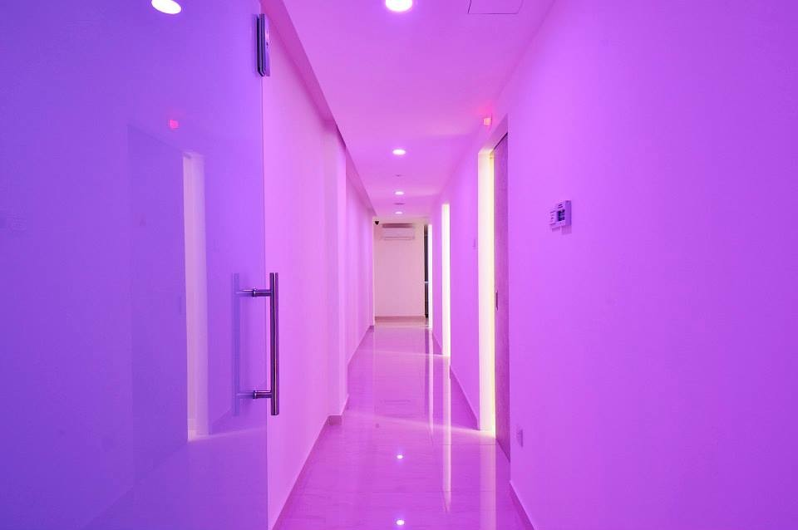
A unique, comfortable and modern dental experience awaits you.
Services Provided

Dental Implants
Invisalign
Smile makeovers
Dental Orthopaedic Treatment
Braces for Children & Adults
Dental fillings & Porcelain restorations
Gum Treatments
Root canal Treatments
Wisdom tooth surgery
Dentures
Children’s dentistry
Digital X-rays

0% interest free instalment plans available.

Call us for an appointment today.

