Brandbook Gidelines
Logo and images

Slogan
We make your dreams achievable
Making your dreams closer

The main colors of the Brand


Additional colors of the Brand
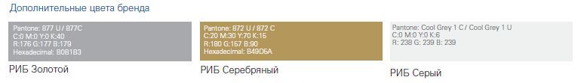
Corporate font
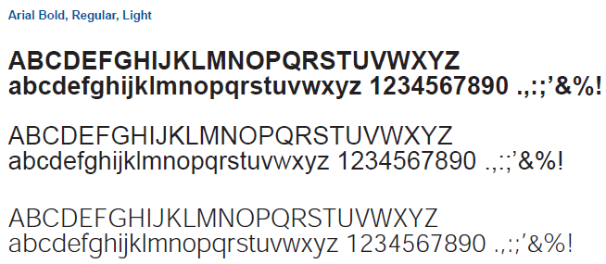
Logo and the original part of logo, use allowed

Logo and the original part of logo, use NOT allowed

