
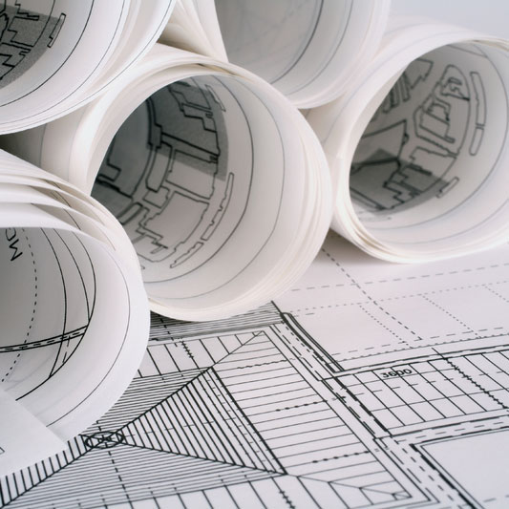
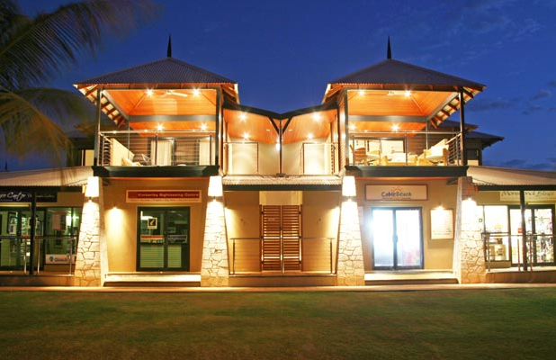
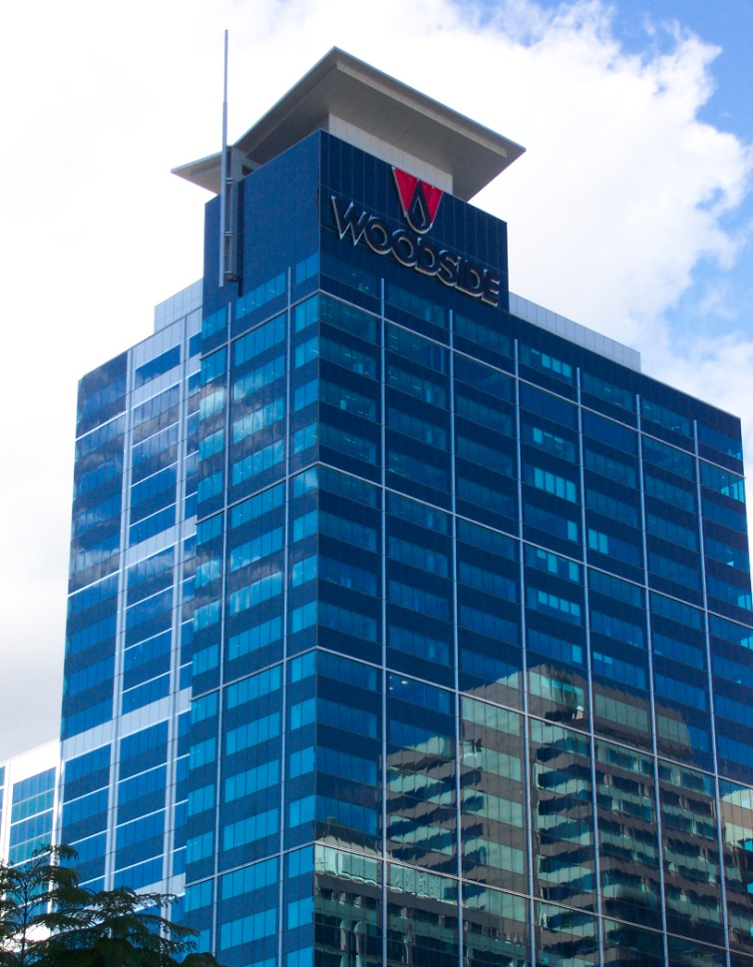
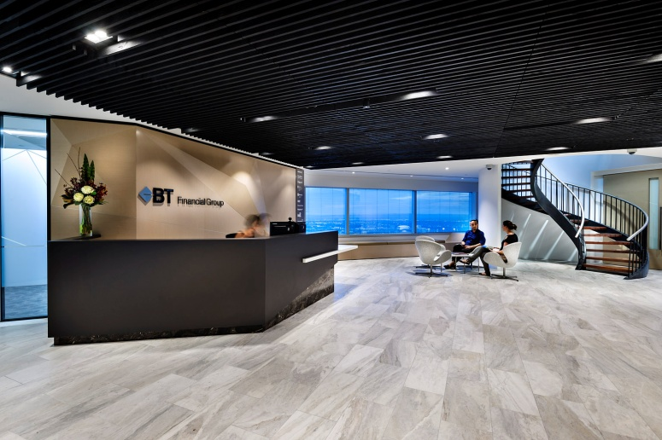
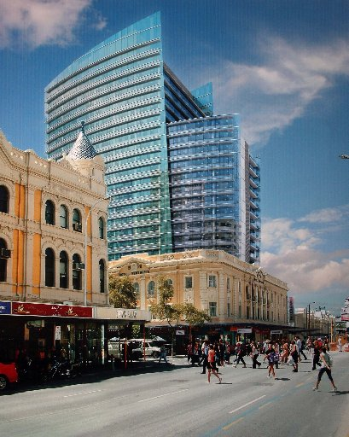
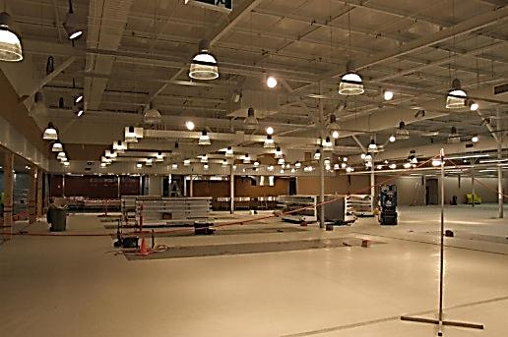
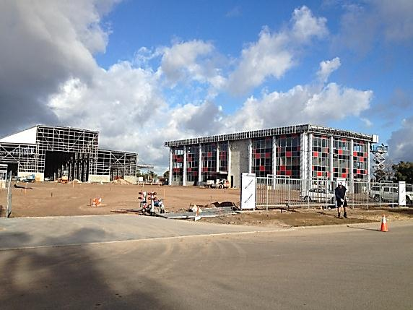

“Every project receives a level of dedication, commitment and service to ensure client expectations are exceeded”

ABOUT US

PGD was formed in November 1998 and has evolved into one of Perth’s leading building services consulting practices.

Our award winning projects cover all states and territories of Australia demonstrating our depth of experience.

We work with all sectors of the property, infrastructure, mining, oil and gas and construction industries delivering, complex, multidiscipline building services engineering solutions.

Our client base includes national, state and local governments, developers, tenants, builders, architects, project managers, interior designers and property/portfolio managers.

PGD provides design, documentation and contract administration services associated with:

- Electrical
- Mechanical
- Communications
- Fire
- Security
- Lighting
- Hydraulics
- Computer Suite
- Building Assessments

OBJECTIVES

To provide the optimum, cost effective, energy efficient design solutions using the latest technological innovations.

Our team at PGD aspires to:-

- Surpass client expectation
- Ensure client understanding of design concepts
- Ensure timely provision of design input allowing ample time for consideration and inclusion

WORK ETHIC

- To protect the engineering interests of our clients from initial involvement to the conclusion of each project
To provide:-
- A level of diligence, based on sound preparation that will ensure client satisfaction
- Innovation in design
- A service orientated and responsive approach
- Continual implementation across all aspects of each project
- A unique, detailed and focused approach to each project

T: 08 9481 7722 W: www.pgdconsulting.com.au E: pgd@pgdconsulting.com.au
BEACHES RESORT BROOME
Mechanical Services
District Cooling System
Air and Water Cooled Chilled Water System
BMS/BAS and DDC Control System
Computer and Data Centre Solutions
DX-Type Water and Air
Cooled System (Single or
Multiple Indoor Units)
VAV and Chilled Beams
Industrial and Commercial
Humidification
Commercial and Industrial Evaporative Cooling Using Air Washers

Building Assessment
Building services condition assessment
Advise relative to available building services (for long or short term purpose)
Trouble Shooting and Investigation
Review of Existing Systems
Upgrade for Current and Future Refurbishment

CAMERON AUSTRALASIA
BT FINANCIAL
Electrical Services
Power distribution
General lighting
Feature lighting for highlight/contrast of client orientated areas
Programmable lighting control
Emergency lighting and exit signs
Electrical consumption management
Lighting control integration with energy management systems
Evacuation warning systems
Power conditioners
Public address installations
Television signal distribution

Critical Use Installations
Layout and space allowance for hardware and equipment
Uninterruptable power supplies and power conditioning
Access control and intruder detection
Fire rating
Anti static solutions
PABX and VOIP integration
Dedicated electrical distribution systems
Stand-by power supplies
High heat rejection cooling solutions

Computer Suite Audits
Comprehensive Computer Suite Audits
Australian Standard Compliance
TIA 942 Tier Rating certification

Hydraulic Services
Water supplies
Waste discharge
Venting
Water heating and cooling
Filtration

Communication Systems
Telephone cabling
Data cabling
Patching philosophies
Fibre optic distribution systems
Integration of voice and
data cabling systems
Hardware housings
Compliance with relevant codes and installation practices
LAN Cable distribution systems

Security Services
Electronic access control
Integration of existing systems with client requirements
Intruder detection
Off site monitoring and alarms
CCTV

Fire Services
Electronic Smoke and Thermal Detection
VESDA Systems
Fire Suppression Systems
Fire Sprinkler Systems

WOODSIDE BUILDING
COLES SHOPPING CENTRE DEVELOPMENT
SQUIRE SANDERS
Recent Projects

