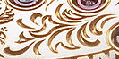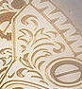

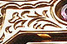
Dear Paria,
I like very much the concept you provided. However, I would like to make the following changes:

1. The coulor of the acanthos leaf and the name should be golden on a white background page
2. I would like the two leaves to form a square shape instead of a rectangula shape
3. I would like the heart to be less evident by not making the two leaves come so close to each other
4. Can you try to make the shape of the leaf look like the images I have sent you below?

