The Scoop on Crumb Rubber and Other Infill Options
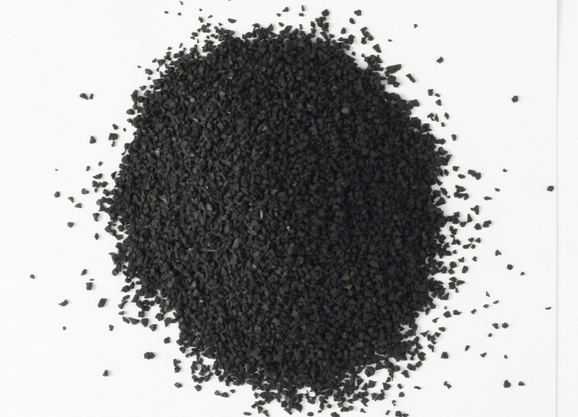
There are lots of infill options. The most commonly used infill used is crumb rubber from recycled tires. You might have heard some rumors floating around about crumb rubber, so we’re here to fill you in on what you need to know. So if you’re curious… here’s the story.

What is the controversy and why are people concerned?
Recently, a soccer coach in Washington State became understandably concerned when two of her goalkeepers were diagnosed with cancer. Through her network of contacts she conducted an informal poll and found more cases of cancer among soccer players – 38 in all, with a dozen in Washington. The coach wondered if the cancer was caused by crumb rubber in synthetic turf. When NBC News picked up the story, a lot of questions arose.

What do I really need to know? Should I be concerned?
- There is NO scientific link between cancer and crumb rubber. No link has ever been made by any study.
- Crumb rubber has been tested extensively. More than 40 studies are freely available for download at www.syntheticturfcouncil.org.
- These studies are not industry-funded. These are independently-funded studies by Federal and State agencies, as well as respected academic institutions.
- While there are very, very minute levels of potentially harmful chemicals in crumb rubber, the quantities are too small to be harmful to human health or the environment.
- We are all exposed on a regular basis to crumb rubber, as rubber particulate is present in the air around roadways.
- Crumb rubber is commonly used in many everyday applications without controversy, including asphalt, running tracks, garden hoses, playground equipment, etc.
- Any suggestion that crumb rubber causes cancer is unfounded.

Are there other infill options?
Yes. There are many other infill options. However, there are drawbacks to everything. And, frankly, nothing has been tested to the extent that crumb rubber has, especially for the price. As a point of comparison SBR sells for around $0.20 per pound.
A few other infill options include:
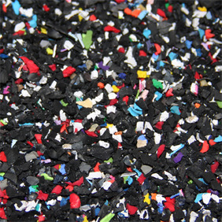
Nike Grind – Of the all of the non-crumb rubber infill options, this is the most attractive. Nike Grind is exclusively available to AstroTurf customers. It is gathered from the waste of Nike’s manufacturing process. While Nike Grind adheres to Nike’s stringent environmental and quality standards, nevertheless it has not been subjected the same degree of scrutiny that crumb rubber has undergone. Cost estimate: $0.56 per pound.

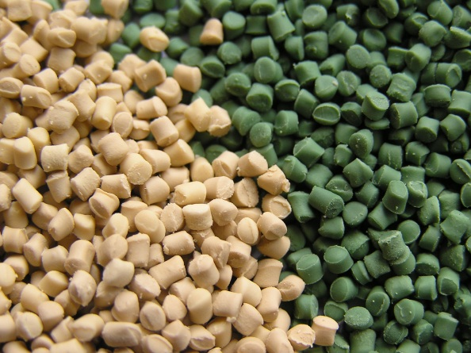
TPE—Thermoplastic Elastomer is a polyolefin infill option. Much (but not all) of the TPE around the world comes from China. One problem associated with TPE is the varying quality from a hodgepodge of suppliers. A particularly worrying trend we have seen in the industry is the low melting point of some TPE formulas, which have caused field failures. Additionally, there have been few if any studies on the human health effects of TPE, and AstroTurf has no information about the dyes used in this infill. Cost estimate: $1.24 per pound.
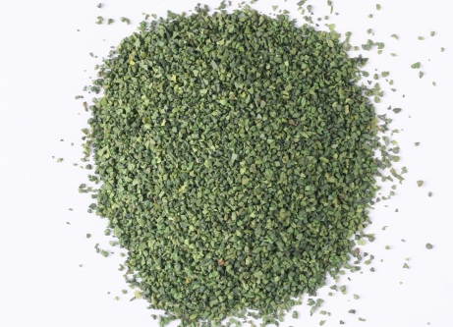
EPDM—EPDM stands for ethylene propylene diene monomer M class. EPDM does not come from car tires but is still a rubber. The cost is very high and, again, has not been studied extensively. Dyes are also used in EPDM. Cost estimate: $1.19 per pound

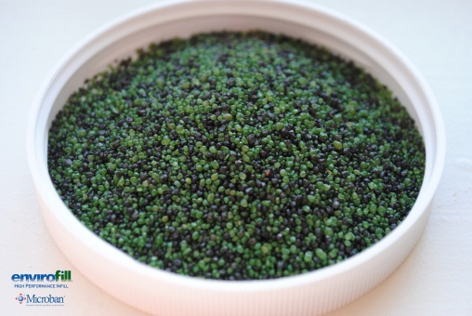
EnviroFill—This is acrylic-coated sand and is not a replacement for rubber. Drawbacks include the risk of chipping of the coating, use of dyes, and lack of testing. Moreover, acrylic-coated sand does not absorb shock and requires the use of a pad. Cost estimate: $0.22 per pound.

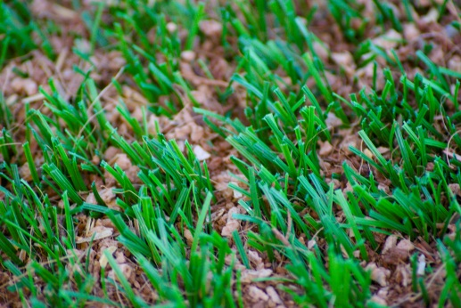
Organics—Various organic options exist, including coconut husks and cork. Organic infill has seen some success in the cool, damp regions of Europe. However, these organic options risk decomposition and breakdown. Organic infills can float and migrate away, and most need to be regularly watered in order mimic the European climate.

So what’s the big picture?
The fact is that the so-called “alternative” infills are not risk-free, and they have not been subjected to the same level of scrutiny that crumb rubber has. Of all the other options, our favorite is Nike Grind because of the strength of Nike’s QC processes and the environmentally friendly recycling process.

