3DSustain
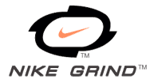
Due to the emerging “concussion discussion”, shock absorbing pads are a growing trend in the world of synthetic turf.
AstroTurf is celebrating its 50th anniversary, so we’ve seen a lot of trends. While others might just slide a pad under an existing system and call it a day, AstroTurf knew that more needed to be done to create a truly pad-friendly, player-friendly system.
For this reason, AstroTurf has collaborated with industry leaders Nike and Ecore to painstakingly engineer 3DSustain. This fourth generation system is designed from the bottom up to provide sustainable, lasting player protection and durability.
Horseshoe + XP Face Fibers – a blend of the industry’s best monofilament and slit film fibers for great resistance to wear and gorgeous aesthetics

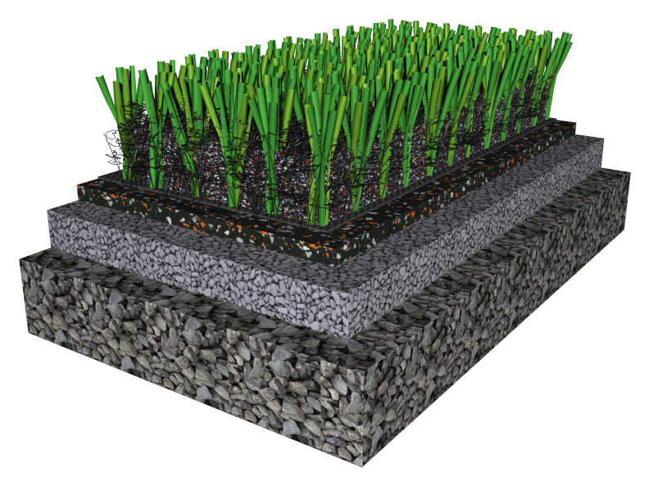
Nike Grind Infill– Tire-free infill option that offers shock absorption and is taken from Nike’s manufacturing waste

Silica Sand layer – for ballast and speed
RootZone – Long-time hallmark of AstroTurf’s innovative 3D system, the RootZone encapsulates infill for less splash and contributes to consistent shock reduction and optimal cleat release

, featuring Nike Re-Grind rubber from Nike’s Reuse a Shoe recycling program

3DSustain by the Numbers:
1248 = Density Score ► Sustained Resistance to Wear
2000 = Number of compressions applied to the system during testing ► Thoroughly Vetted
52 = Ounces of Fiber Per Square Yard ► Heavy System Weight for Durability
10 = Thickness in mm of the NRG Pad ► Sustained and Consistent Energy Dispersion
30 = Minimum Gmax reduction over traditional turf systems ► Substantial Shock Reduction
1.5 = Height in inches of the turf ► Next Generation Design
0 = Tires used in the infill ► Meets Nike’s stringent environmental standards
20 = Temperature reduction in Degrees F versus traditional SBR ► Comfort on the Field
80,000 = Pounds of Nike Grind infill prevented from going to a landfill per field ► Significant Sustainability

