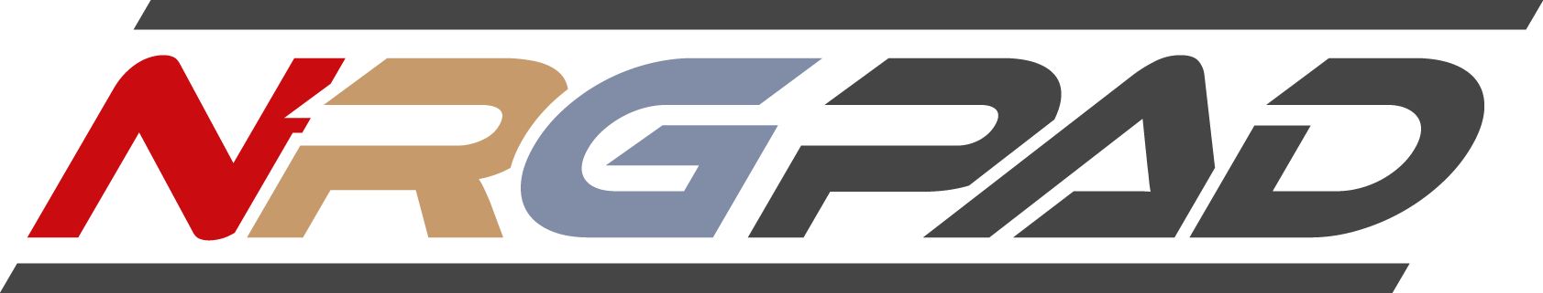
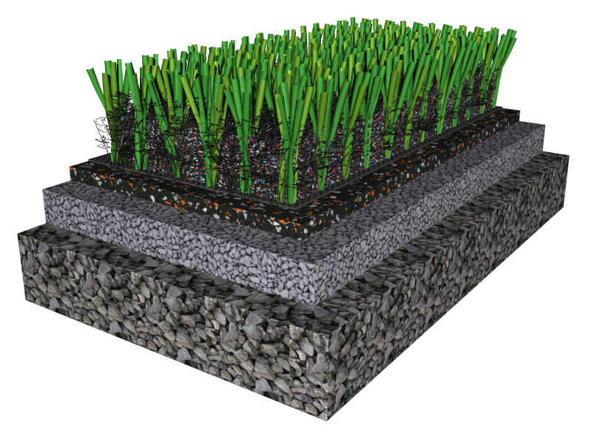
With the new , athletes benefit from superior system elasticity—resulting in shock attenuation for athletes, greater energy return for player performance and a more grass-like system due to better energy restitution. The permits the use of a shorter, firmer, faster turf system without sacrificing shock attenuation.
The current “concussion discussion” makes clear that guaranteed and predictable shock reduction is paramount. In fact, the ability of a system to attenuate shock of falling athletes is the most important aspect of field playability and player protection.
For this reason, AstroTurf® has teamed up with Ecore® and Nike. These industry veterans have joined forces to develop an advanced playing system which is ideal for player protection and performance.
Facts:
- The NRG Pad uses re-cycled rubber granules bound by high-grade urethane under extreme pressure—no competing pad technology is as durable and proven in-use
- As an additional product enhancement, the NRG Pad corporate Nike Re-Grind (“NRG”) particles for extra resiliency and strength. As the exclusive synthetic turf application for Nike’s Re-Use A Shoe program, the NRG Pad helps prevent thousands of shoes around the world from going directly into landfills
- Available in 8 mm and 10 mm thicknesses to suit a range of budgets
- NRG Pad is ideal under AstroTurf 3DSustain, a short-pile turf system with a heavier sand content and Nike Grind infill
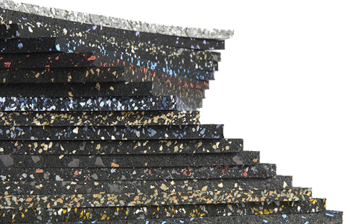
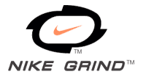
- Provides a minimum of a 30 point Gmax reduction as compared to traditional turf systems over a stone base.

