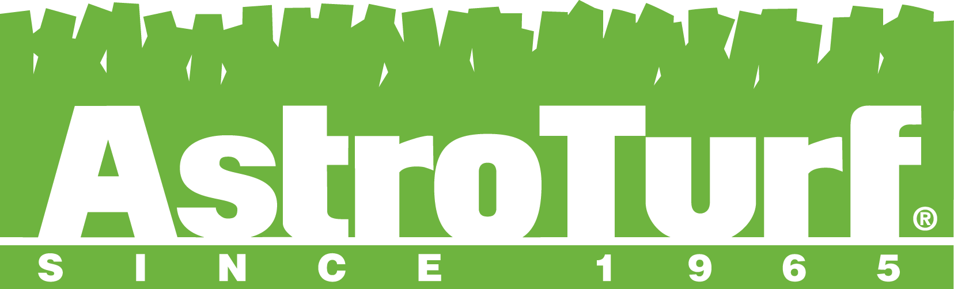
MAINTAIN THE GAME™

In response to the Synthetic Turf Council’s decree that synthetic turf maintenance should be a vital part of every field owner’s program, AstroTurf® is proud to offer the Maintain the Game™ Service Program. The Maintain the Game™ Service Program is a comprehensive solution to standardize the care and maintenance of all AstroTurf surfaces to provide optimum performance, playability, safety, and longevity. Services include professional inspections with several cleaning options to suit the needs of every field owner. Services are provided by AstroTurf’s certified maintenance provider, Sport Install, and/or their regional affiliates. All cleaning options include use of state-of-the-art SMG synthetic turf maintenance equipment.
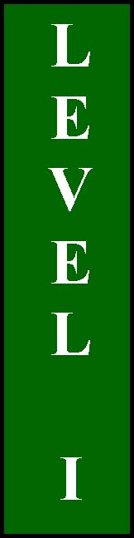
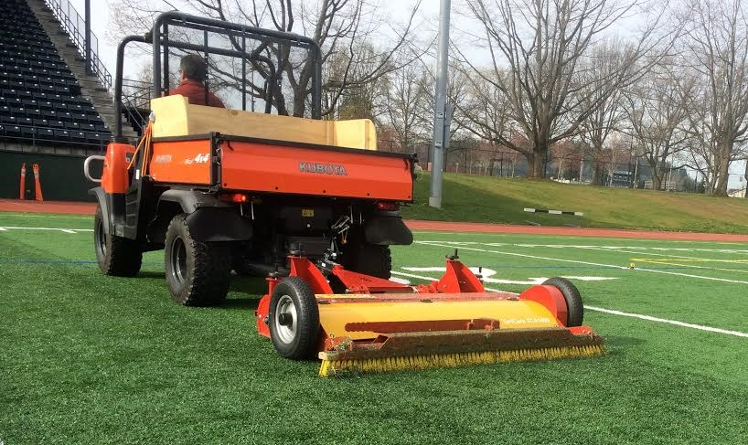
TCA 1400 Surface Clean
Surface cleaning with the SMG TCA1400 multi-function tow behind sweeper is a great way to maintain AstroTurf in optimum condition between SportChamp cleanings. The TCA1400 has a soft-bristled rotating brush to remove debris and a rear leveling brush to settle the infill and lift the turf fiber. These processes can be done in combination for quick efficient cleaning/grooming of the surface.

SportChamp One-Day Service
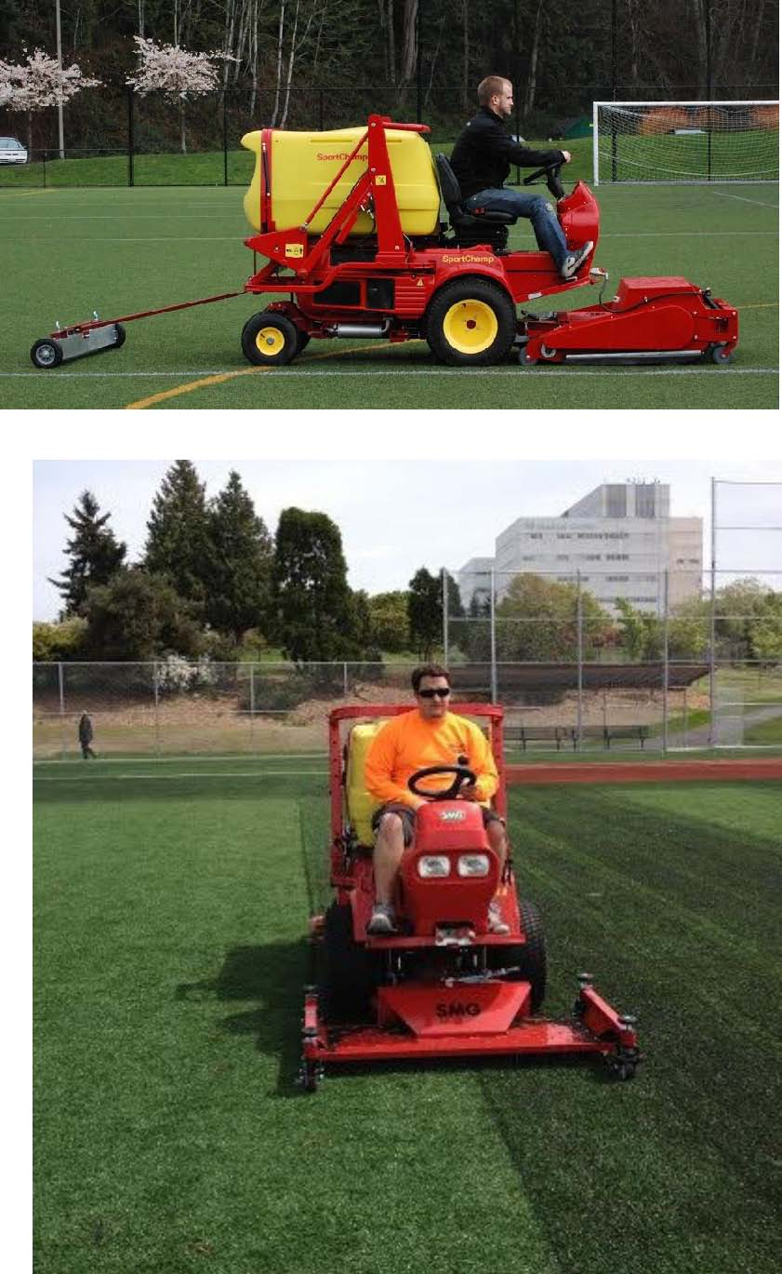
The SportChamp One-Day Service includes a field inspection along with a three step cleaning and maintenance process designed to enhance the performance and safety of the turf system. The first process is to vacuum the field with the SMG SportChamp to remove debris and other contaminants while cleaning the top layer of infill rubber and simultaneously returning it to the turf surface. During the cleaning process we
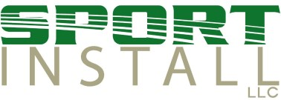
www.sport-install.com
(314) 985-4116

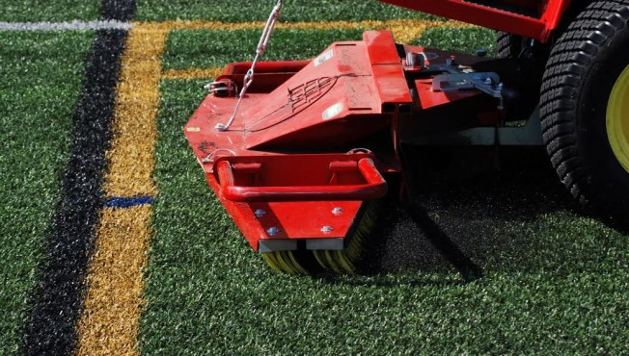
utilize a tow behind magnet sweeper to pick up ferrous metal objects. Next, we utilize SMG’s spring tine attachment to lift the turf fiber and de-compact the infill material to enhance resilience and drainage. The final process is to groom the surface with the SportChamp brush attachment to evenly redistribute infill material.
SportChamp Two-Day Deep Clean
The SportChamp Two-Day Deep Clean Service includes a field inspection, along with a three step cleaning and maintenance process designed to enhance the performance and safety of the turf system. The first process is to vacuum the field with the SMG SportChamp Rotating Brush Attachment to remove debris and other contaminants while cleaning the top layer of infill rubber and simultaneously returning it to the turf surface. The two-day deep clean service allows the certified technicians to adjust the depth of the rotating brush deeper to process and clean more infill rubber. During the cleaning process we utilize a tow behind magnet sweeper to pick up ferrous metal objects. Next, we utilize SMG’s spring tine attachment to lift the turf fiber and de-compact the infill material to enhance resiliency and drainage. The two-day process allows for additional time to deep tine the field as needed. The final process is to groom the surface with the SportChamp brush attachment to evenly redistribute infill material.
www.astroturf.com
(800) 723-TURF

SERVICE PROGRAM

LEVEL I | LEVEL II | LEVEL III
TCA 1400 | SportChamp | SportChamp
Surface Clean | One Day | Two Day Deep
 |  | Clean

TCA surface clean/brush | X
General field inspection | X | X | X
SportChamp quick clean |  | X
SportChamp deep clean |  |  | X
SportChamp spring tine decompaction |  | X | X
SportChamp grooming |  | X | X
Magnet sweep field for removal of ferrous metal |  | X | X
Warranty seam repair, as necessary |  | X | X
Infill depth measurements |  | X | X

Additional services available:

G-max testing

SandMatic infill top-off

RenoMatic infill removal/leveling

Baseball clay removal/RotoTine

Customized options are available. Multi-field facilities will receive discounted rates.

These specialized maintenance programs do not take the place of “routine maintenance” which should be conducted on a regular basis. Owners are still required to perform routine maintenance as outlined in their AstroTurf Owners and Maintenance Manuals.

www.sport-install.com www.astroturf.com
(314) 985-4116 (800) 723-TURF
