Ptolemy Logo and Icon Set

Ptolemy
Ptolemy is an online performance management and professional development package aimed at UK schools.
Its focus is on the value of detail, on the benefit of the little understandings and insights that occur in multiple conversations around a school, which Ptolemy helps capture, bring together and present in a format that supports decision making.
It looks at the dynamics of the school which in turn supplement an understanding of its outputs.
The product is built and tested but the logo design is the first stage of developing its ‘look and feel’.

Design Vision

Ultimately I want a clean looking website that will look something like this i.e. clean but with points of colour
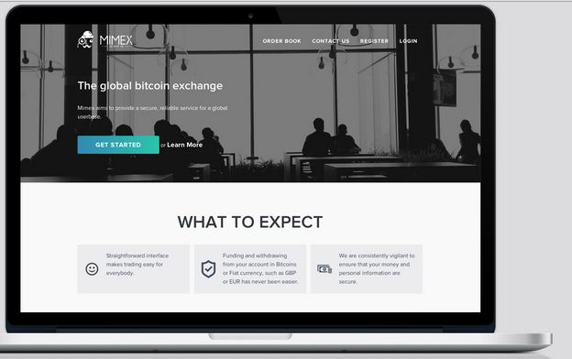

The first stage is to get the right logo. As I want a clean website I think something monochrome i.e. one colour would be best but I could be persuaded.
I would be happy to have a colour theme adjusting between the different logos/ icons.
I quite like the classical/ modern look of the starbuck logo. Our brand will be based on the character Ptolemy but I would like the logos to suggest the function too. It shouldn’t be too informal.


Here are some Ptolemy images.
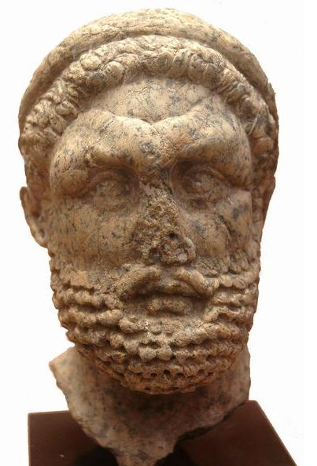

There are 4 main logos required
Note: Square brackets are instructions

Title | Must Include Text | Product Description
Ptolemy [Main Brand} | Ptolemy  School Positioning System [Smaller]  Know where you are, know where you’re going[Strap] | Provides diagnostic information for school leaders on the dynamics of their school to aid decisions on deployment of resources and foci for optimum improvement.
Teacher Ptolemy | Teacher (Ptolemy optional) | Supports, records and reports on teacher knowledge, skills and impact.
Leader Ptolemy | Leader (Ptolemy optional) | Supports, records and reports on leader knowledge, skills and impact.
Policy Ptolemy | Policy (Ptolemy optional) | Assists headteachers in designing tests to see if the most important knowledge in their schools is understood by all people e.g. Health and Safety & Curriculum (e.g. English).

Logos should be scalable – for print and web use – and in format png, jpeg, amongst others

Smaller Reporting Logos
Following the same theme as the main logos but slightly smaller.
These are for reports i.e. the means by which the user gets information out of Ptolemy.
Text does not have to be included in the logo
Report Name | Description
Quality of Teaching(All) | Big data set on the quality of teacher performance. Work with chn as well as professional development activities.
Quality of Teaching(individual) | As above for a single teacher
Subject Co-Ordinator | Work of individual colleague responsible for a subject e.g. English leader.
Comparing teachers | Putting Stats of Teachers beside each other so they can be compared
Quality of Leader (All) | As Quality of Teaching above but for leaders.
Qualiyt of Leder (Individual)
INSET Reports | The outcomes of 1:Many training sessions
Policy Knolwedge | Test results on policy.

Icons
There are other, smaller, logos that are also required.
They should reflect the colour/ shape/ theme of the 4 main logos but can be much simpler. More like icons.
Here are some I like.


https://www.behance.net/gallery/7688587/Website-Vector-icons
None of the icons must have a text.
Icon/ Event | Description
Book Look | Books are taken in by leader to consider the quality of student work and teacher marking
Learning Environment | Classrooms are looked at to consider the quality of display, seating arrangements, resourcing and health&safety
Lesson Observation | Leader observes and discusses a lesson
Coaching | 1:1 training
INSET | 1:Many training
Performance Management | Judgement on overall performance – good or unsatisfactory
Assessment Moderation | Discussing student work – do we agree how good it is?
Attainment Review | Are students making enough progress
Planning Scrutiny | The plans teachers have for lessons are looked at for quality control.

