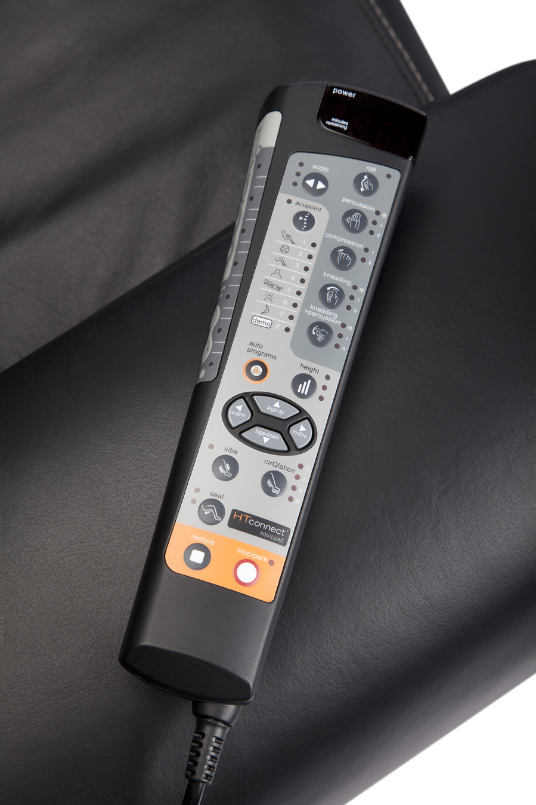
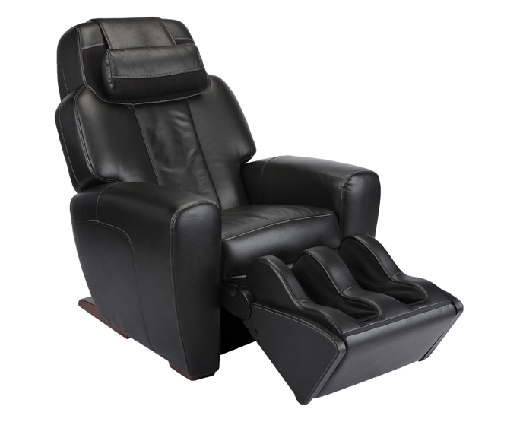
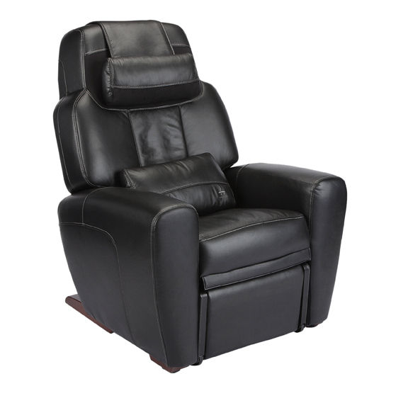

AcuTouch® 9500x Massage Chair
$6,799.00

AcuTouch® 9500x Massage Chair is the premier name in home wellness.
Improves circulation and invigorates sore, tired muscles; Premium leather upholstery; A wealth of auto-massage programs

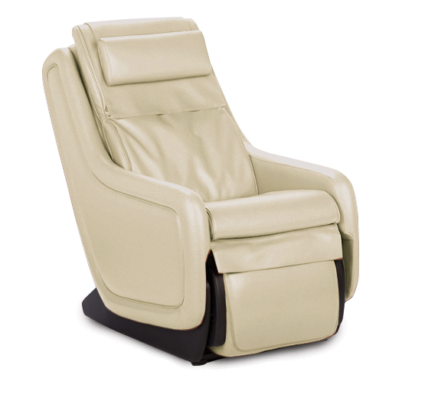
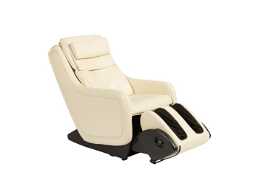

ZeroG™ 4.0 Immersion Seating
$3,899.00
Recline to zero-gravity, and simply point to where it hurts. This ‘personal chiropractor’ will leave you relaxed, rejuvenated and ready to live life to its fullest. Immerse yourself in wellness.

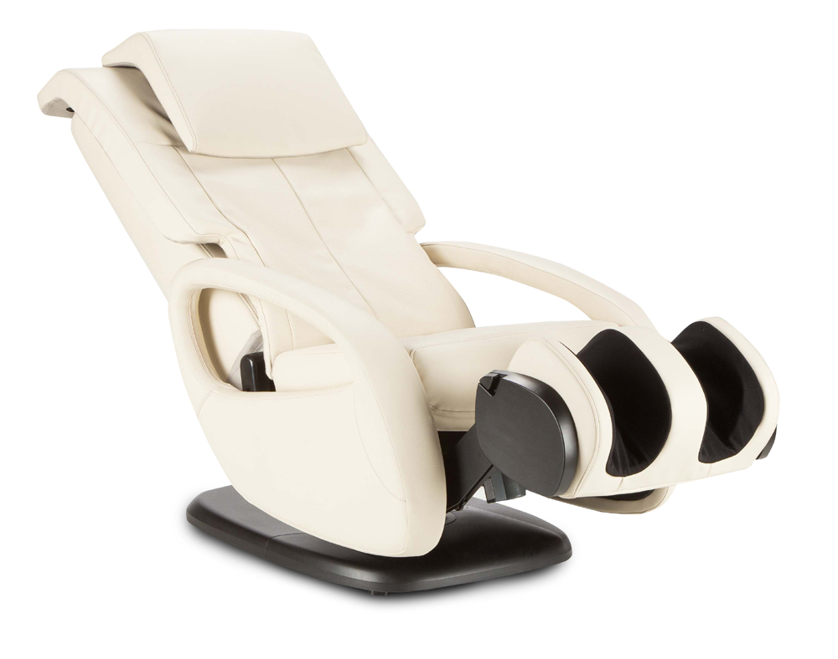
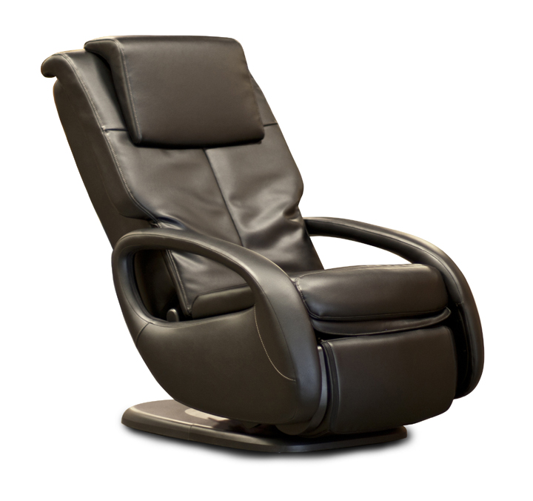

WholeBody® 7.1 Massage Chair
$2,499.00

Style and elegance while soothing comfort like a warm oil massage

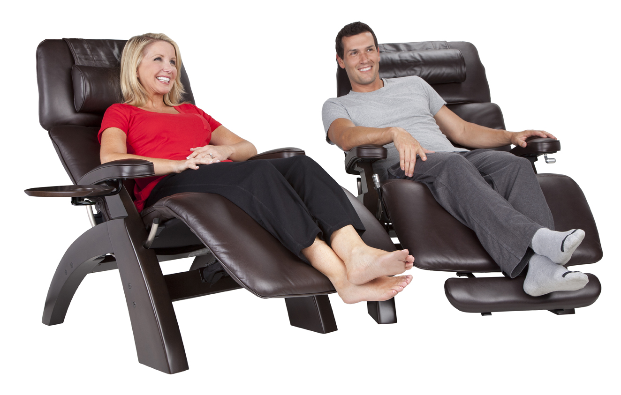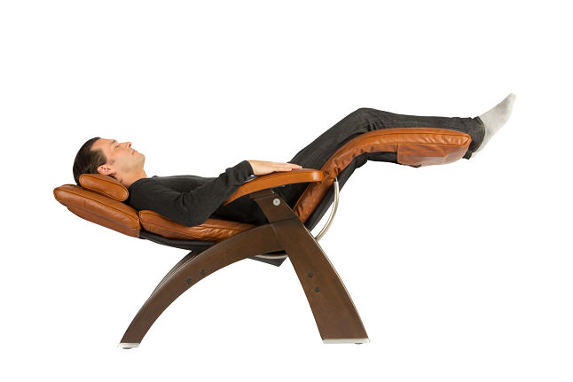

PC-510 Classic Power Zero-Gravity Recliner
$3,399.00–$3,699.00
- Smooth power recline with digital acceleration
- Subtle thumb-control lever
- Sleek ergonomic pad design
- High density lumbar support
- Sculpted leg accents with integrated floor guides
- Articulating headrest
- Hand-carved and hand-stained 100% renewable solid parawood base

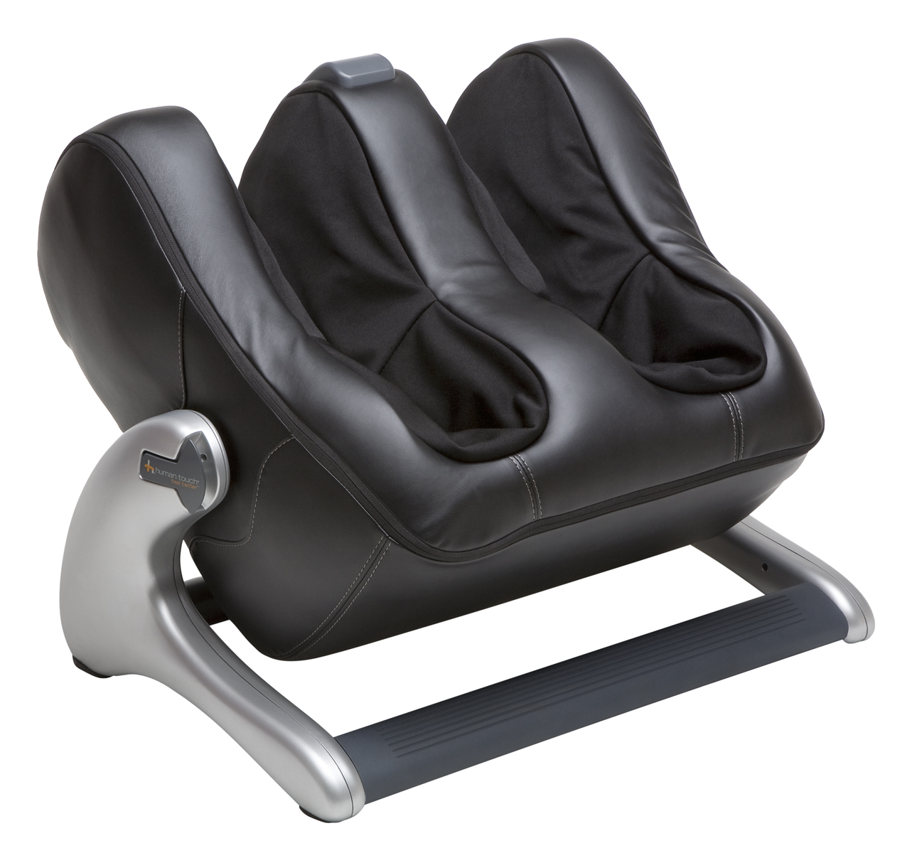
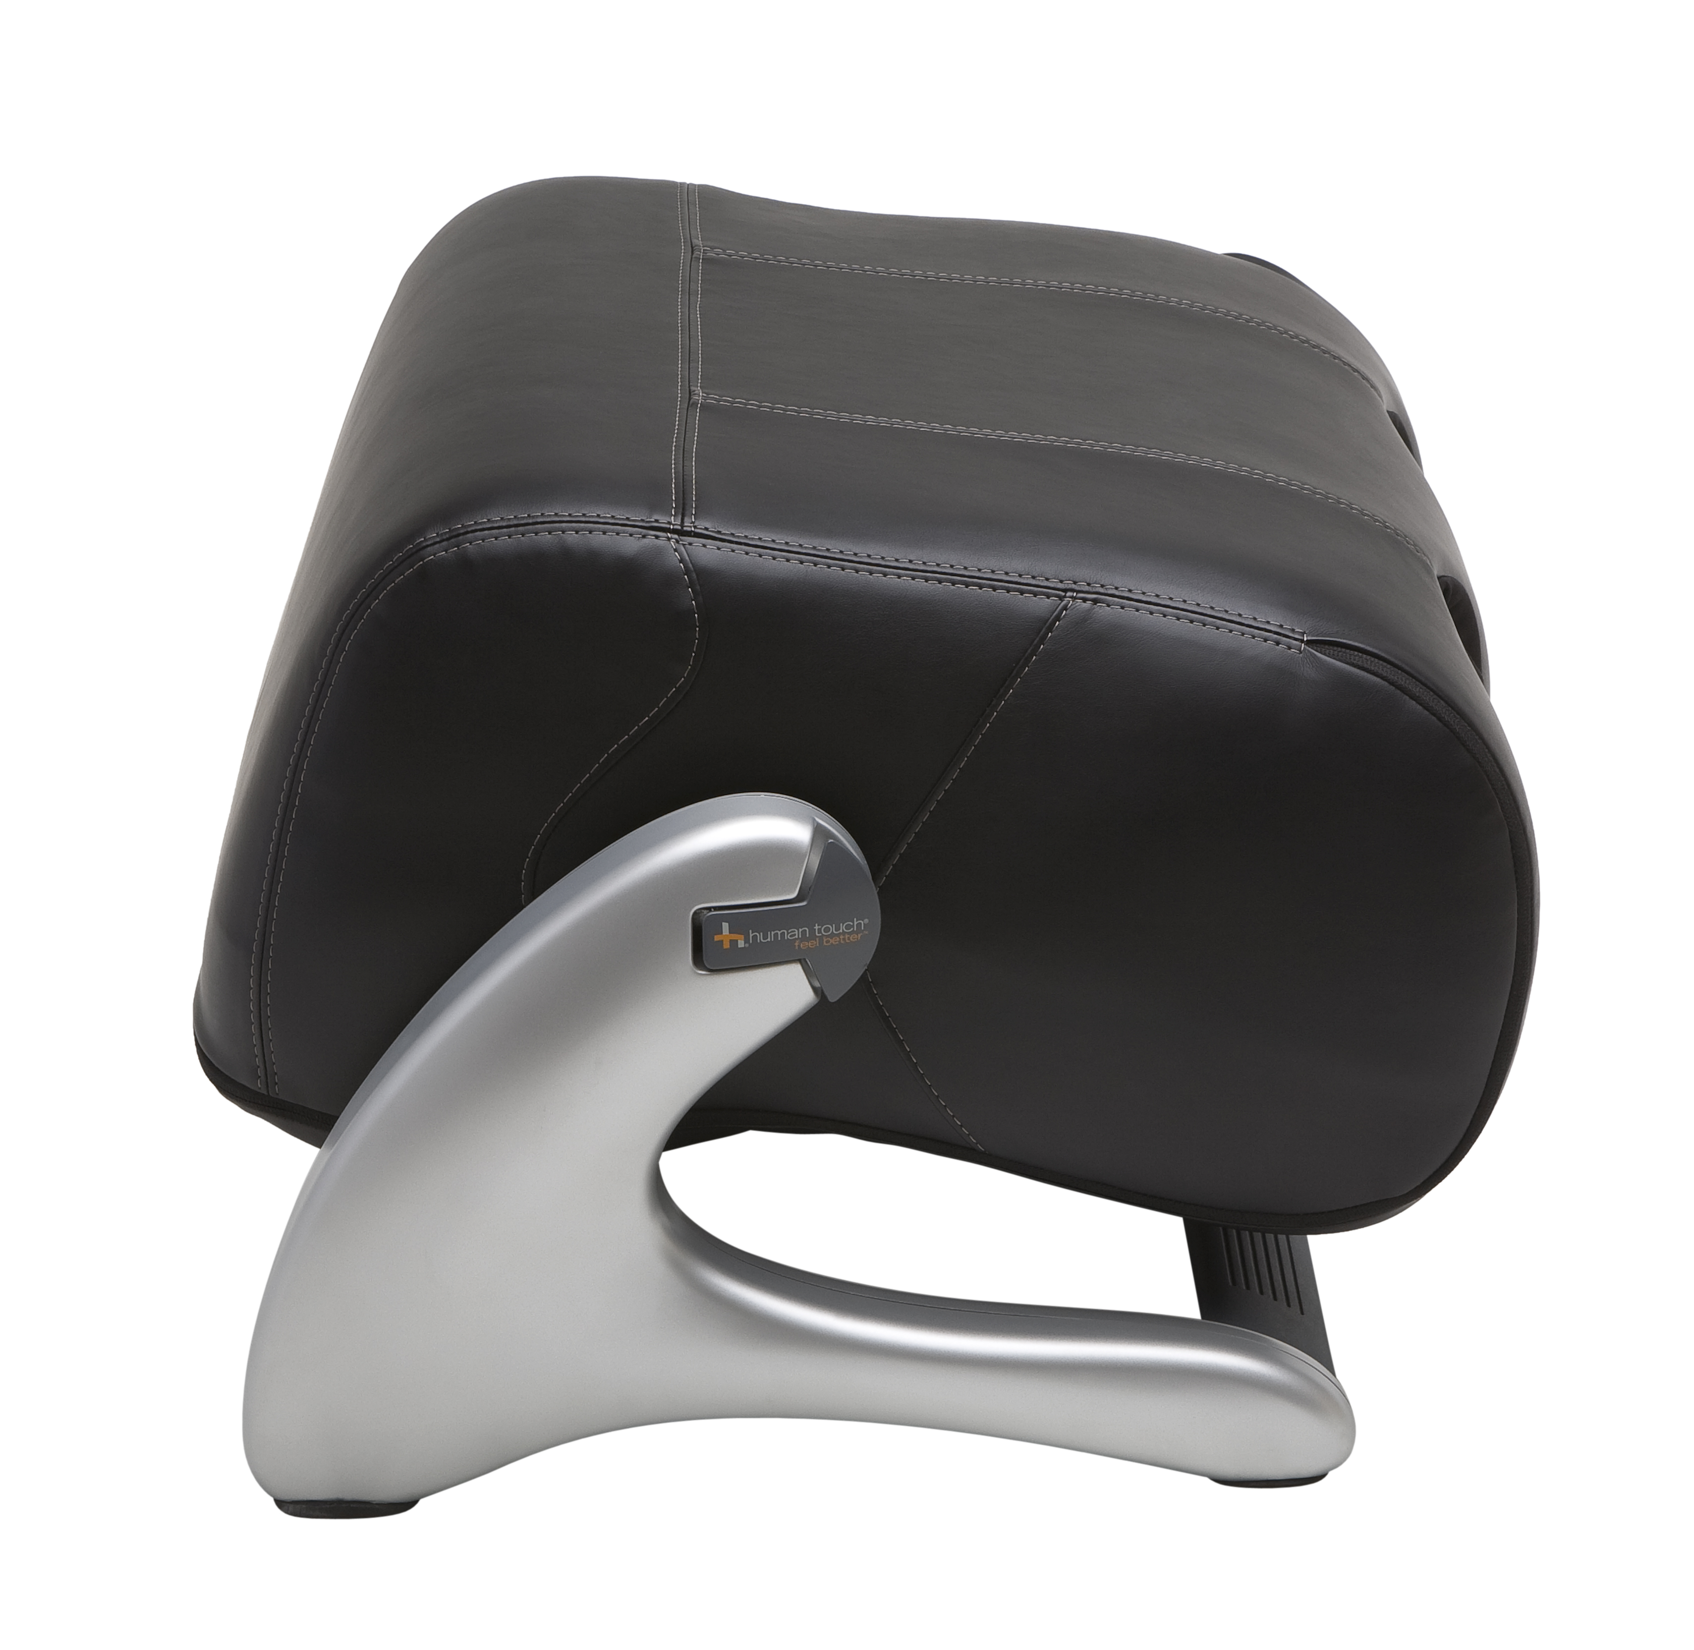

HT-1360 Elite Foot and Calf Massager
$579.00

The latest robotic foot and calf massage technology with soothing vibration, doubling as a comfortable footrest in a snap.

