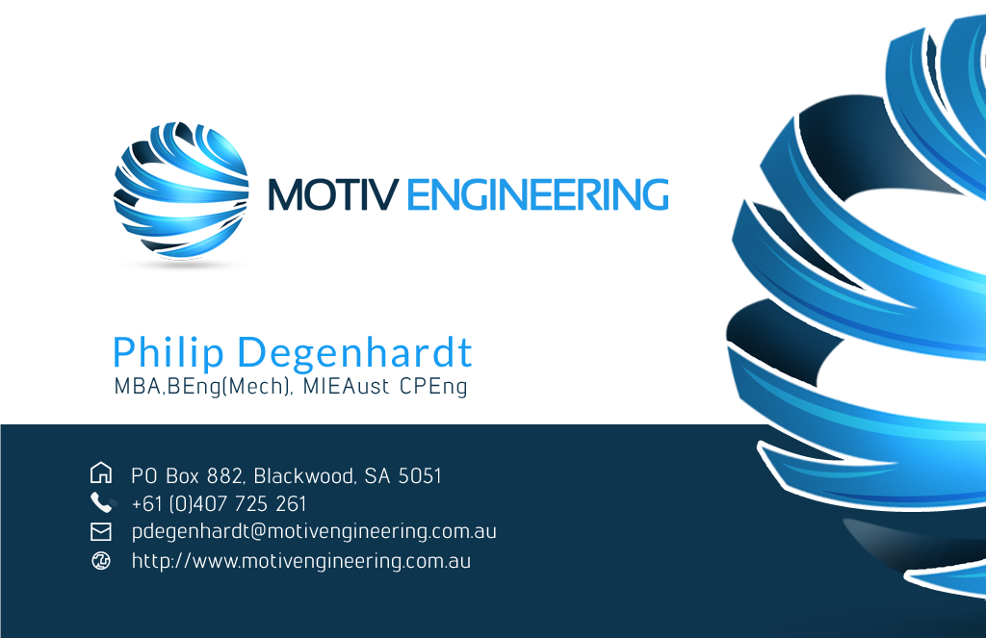
Keep aligned with logo. Move up a little bit.
Move logo left and up a little bit. Increase Size a little bit

Increase size

Can we please use logos similar to below for contact details and house logo for address.

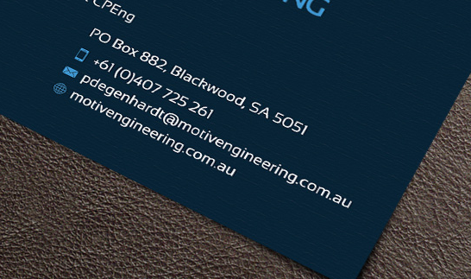

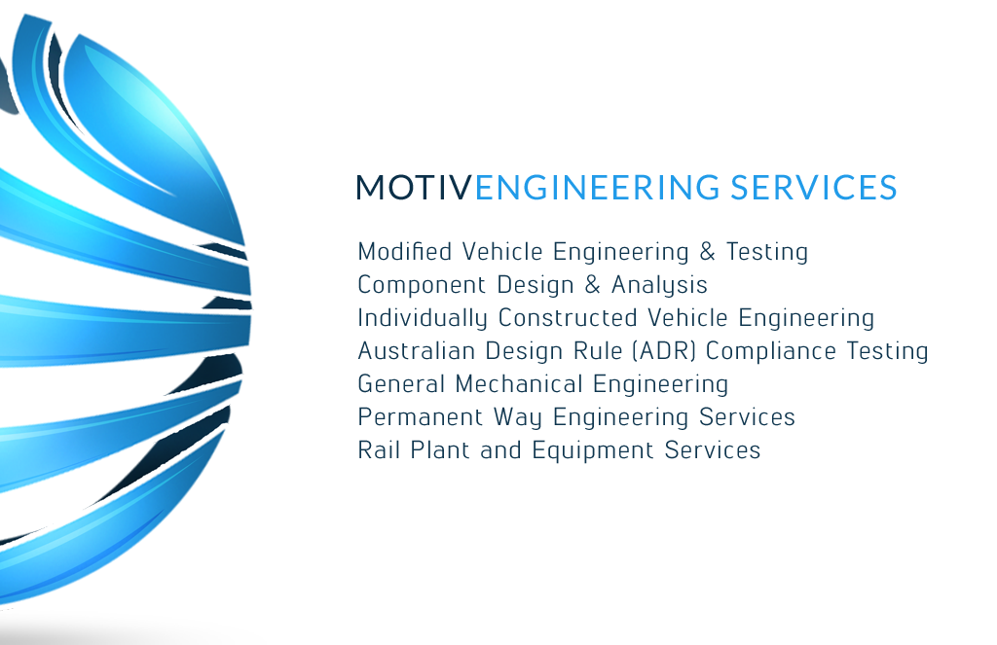
Engineering

