
Above is the old logo. We learned our lesson! Again, please share with us the meaning behind your designs it will truly guide our decision.

We want the name of our bank to be included with your logo design. You can use whatever font and style that you see fit. The Chinese text that reads Zigong Commercial Bank is below:
自贡市商业银行

Location:
Zigong is located in Sichuan China. Sichuan can be translated to four mountains; Sichuan has mountains surrounding it in every cardinal direction. Where Zigong resides was once a vast inland sea , Changes in the environment caused the water levels to subside leaving behind salt, brine, natural gas, humidity and fog.
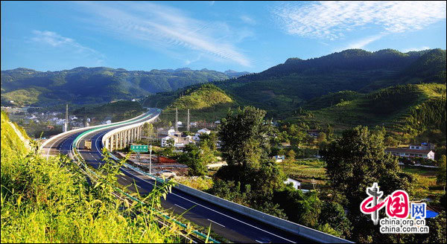
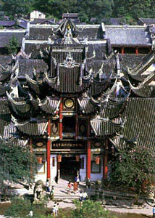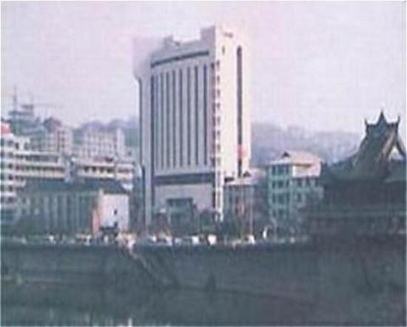
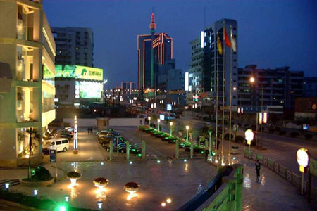
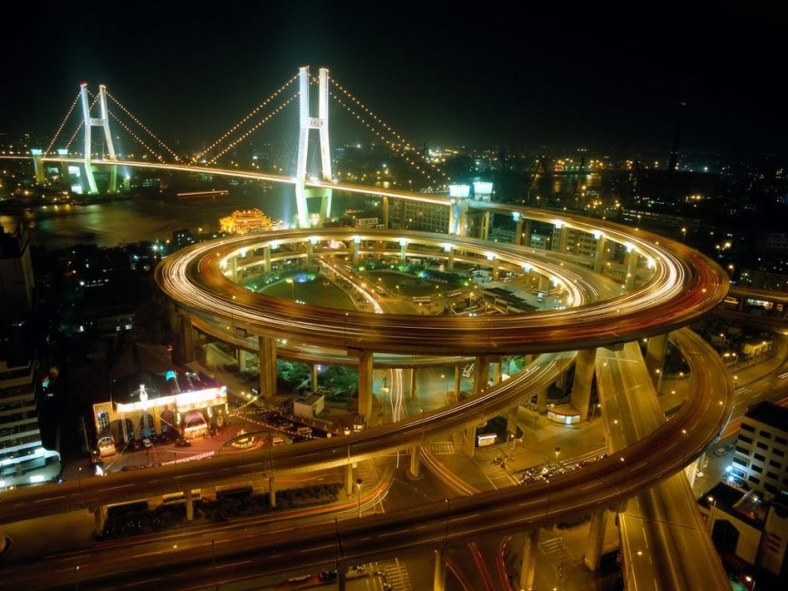

Salt:
The people of Zigong have been drilling for salt since 76-88 AD. Before refrigeration, salt was a key chemical used to preserve meat, fish, and vegetables. Today Zigong is a primary source for natural gas, coal, and inorganic chemical production in addition to salt.
A lot of money was generated from salt making Zigong a wealthy town. After the Fall of the Last Emperor, The Republic of China under Sun-Yat-Sen, secured loans using the revenues generated from the taxation of salt. The Chief Inspector of the Chinese Salt Administration stated “The best salt in China is produced by the wells of Sichuan.” The best salt wells in Sichuan are in Zigong. The Percussion Drilling rig was invented and developed in Zigong.
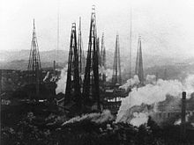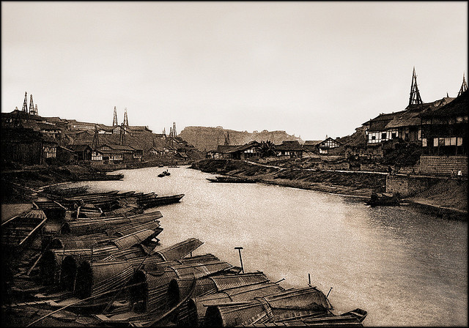

The Ancient Streets:
Along the Fuxi River are the ancient streets, which are several stone paved roads, traditional houses, and shops. These streets show Zigongs roots as a large salt trade center from the times when salt was more valuable than gold. Several Salt Well heads are capped and marked along the streets that follow the river. At the end of the street is a hand rowed ferry boat that takes a visitor to the opposite shore where stone steps lead up to the city.
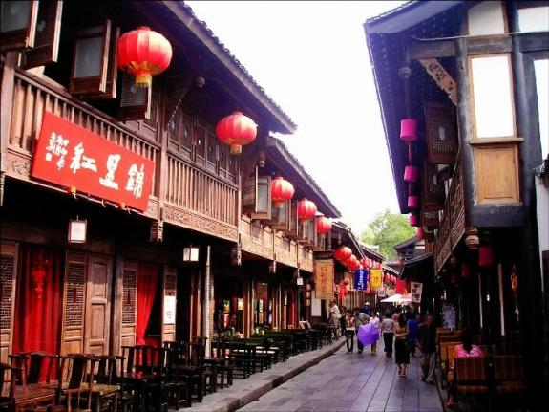
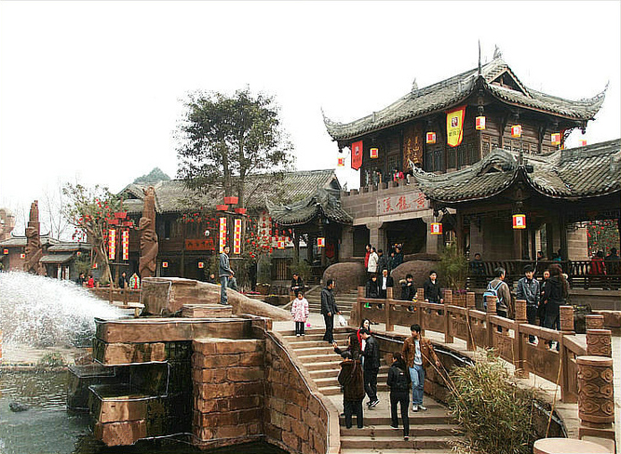

Chinese Lantern Festival:
Zigong is the originator of the Chinese Lantern festival which has been copied in Beijing, Hong Kong, & Shanghai. Zigong is also known as the “Lantern Town in the South Kingdom”.
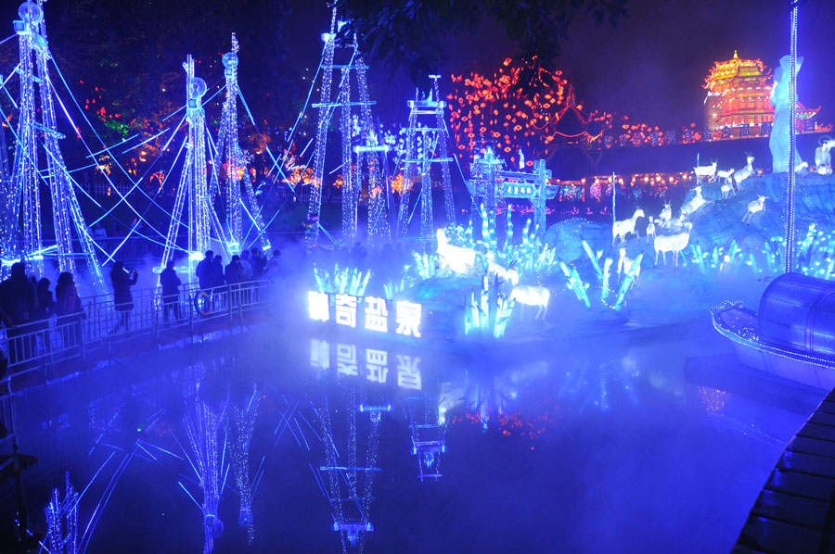
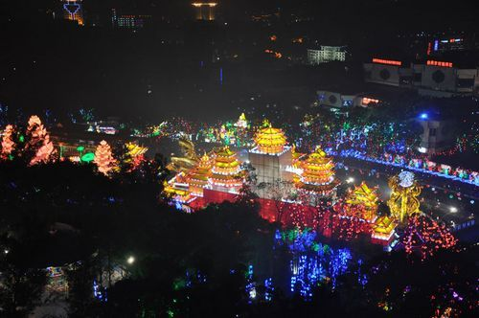
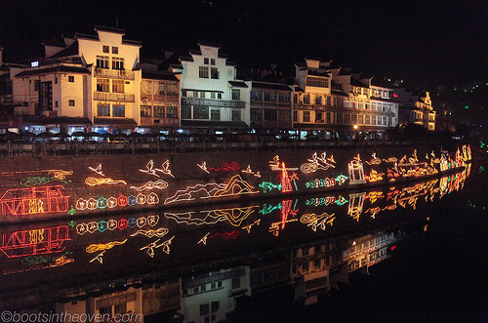
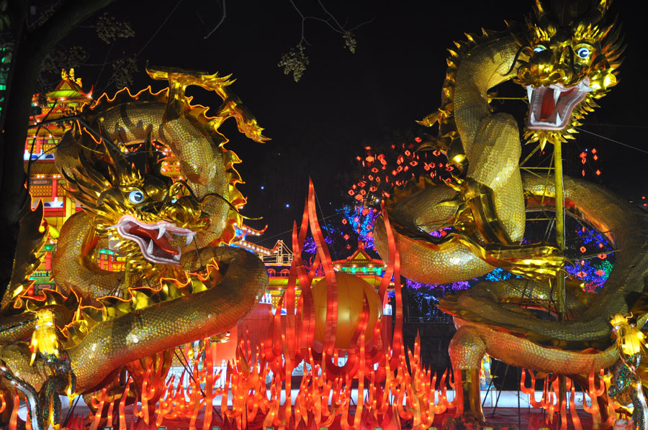

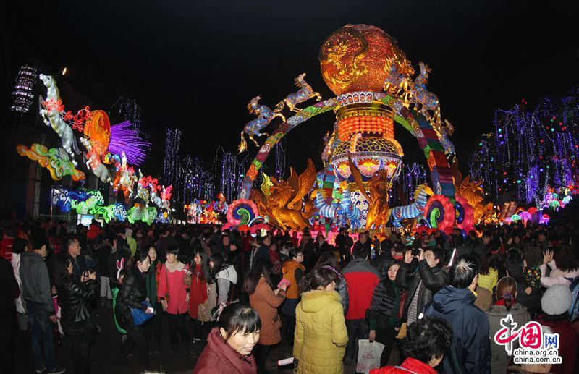
Zigong Teahouse:
Zigong has a beautiful historic teahouse which was built as an assembly hall for shipping merchants, mostly the wealthy salt merchants.

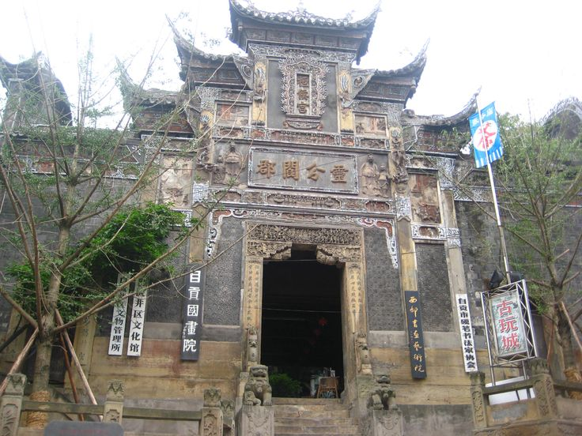

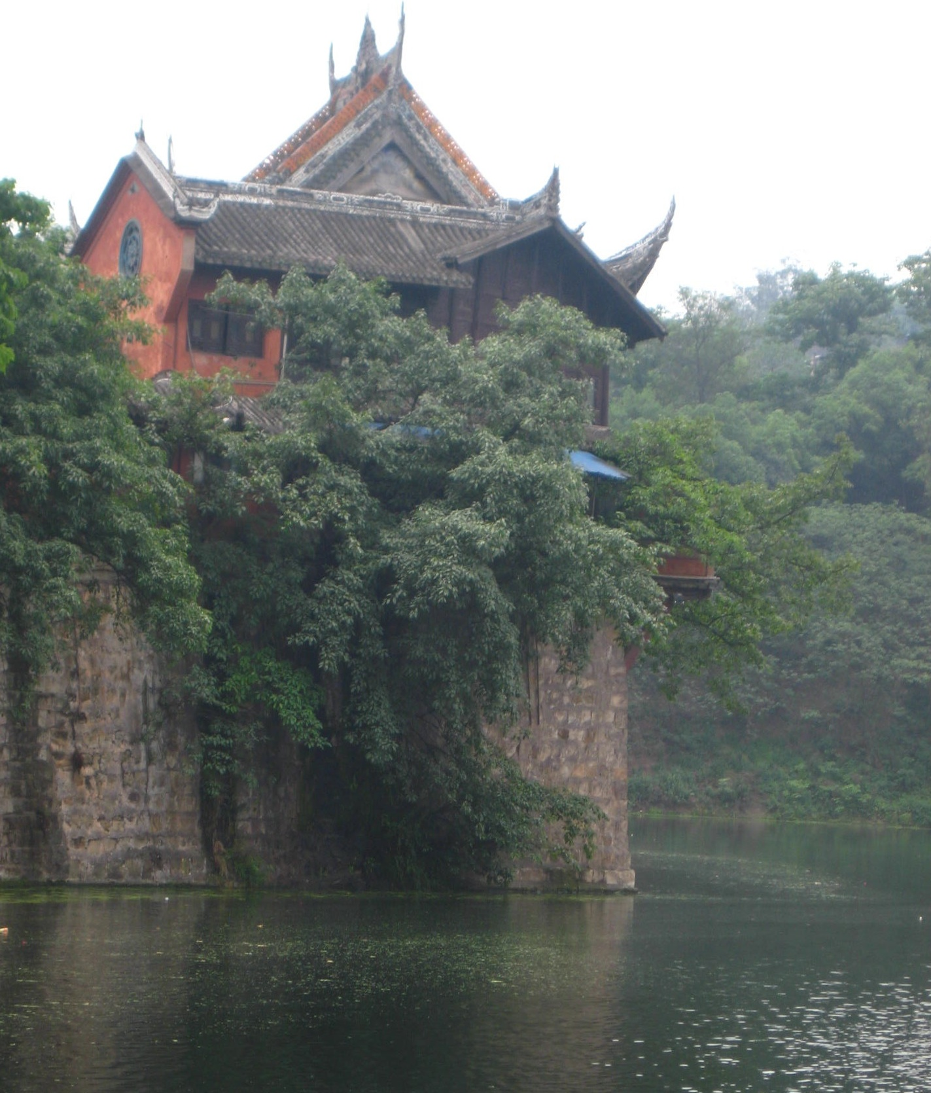
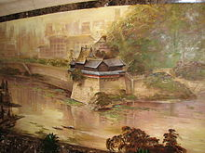

Dinosaurs:
In the 1980’s vast Dinosaur Fossils were excavated in the city. Dashanpasauras is a dinosaur named after a township in Zigong. The fossils found were unique and featured the intact bone remains of dinosaurs. The Zigong dinosaur museum was established in 1987 and is the first specialized dinosaur museum to open in all of Asia. Some of the dinosaur remains that can be found there are Omeisaures, Gigantspinosaurus, yawgchuanosaurus Hepingensis Huayangosaurus, and Xiaosauris.
