COCONUT OIL PACKET INFO: She’s a superfood!

- Extra virgin, unrefined
- Free of bleach, pesticides, hexane and trans-fats
- Non-GMO
- MCT’s for weight management and energy
- Cold pressed to retain natural health benefits
- Cholesterol-free

This pure and natural coconut oil is 100% unrefined, unbleached and free from pesticides, solvents and trans-fats. Coconut oil is one of the best natural sources for Medium Chain Triglycerides (MCTs) that regulate body weight and provide instant energy. A majority of the MCTs in coconut oil are lauric acid, which when in the body, gets converted to monolaurin a potent natural antimicrobial and is a major immune boosting compound found in mothers milk. Further, coconut oil is the best natural source of saturated fat, which unlike other oils doesn’t produce harmful trans-fats or free radicals when heated in cooking. Coconut oil truly is the world’s healthiest oil and will help you get your best health through food!

USES:

Cooking: Use as a delicious replacement for oil or butter in any recipe!

Dietary Supplement: For best therapeutic benefits consume 1-4 tablespoons per day: add to smoothies, on toast or straight from the spoon!

Skin and Hair Care: Add the desired amount to the skin or hair and massage in. For hair care allow to sit for 1-2 hours and wash thoroughly.

Keep lid tightly sealed and store in a cool dry place. Refrigeration not required. May be solid at room temperature (<24°C).

Ingredients: Natural unrefined virgin coconut oil.

THIS IS ALL THAT CAN GO ON THE LABEL, USE AT YOUR OWN DISGRESSION!

This is the nutrition data to be included on the back label.
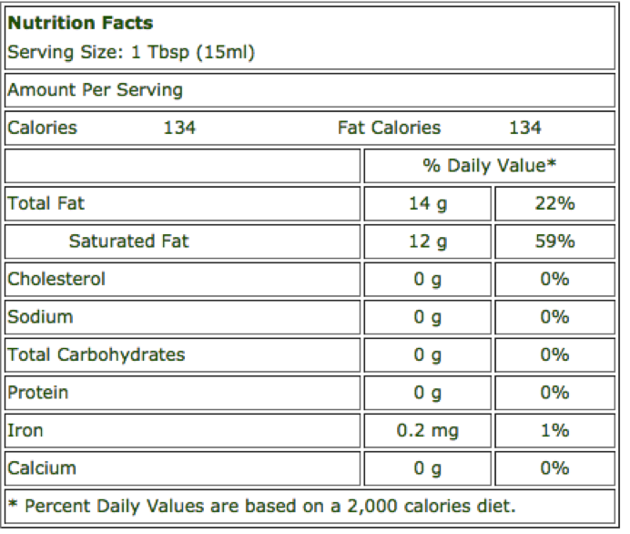

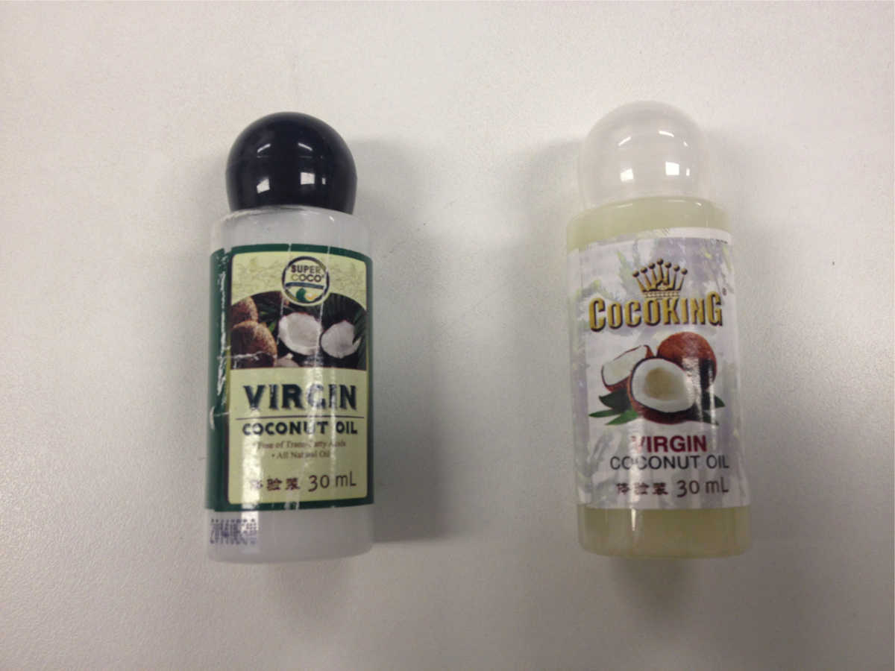
This is a couple of our competitor’s designs; I personally like the green one. The darker label makes better contrast to the oil (making it look whiter, our oil look s like the left not right) and it gives a good natural/fresh feel
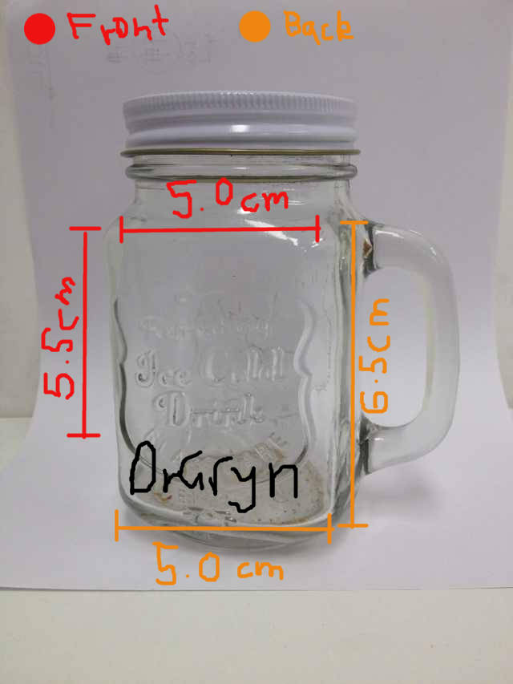
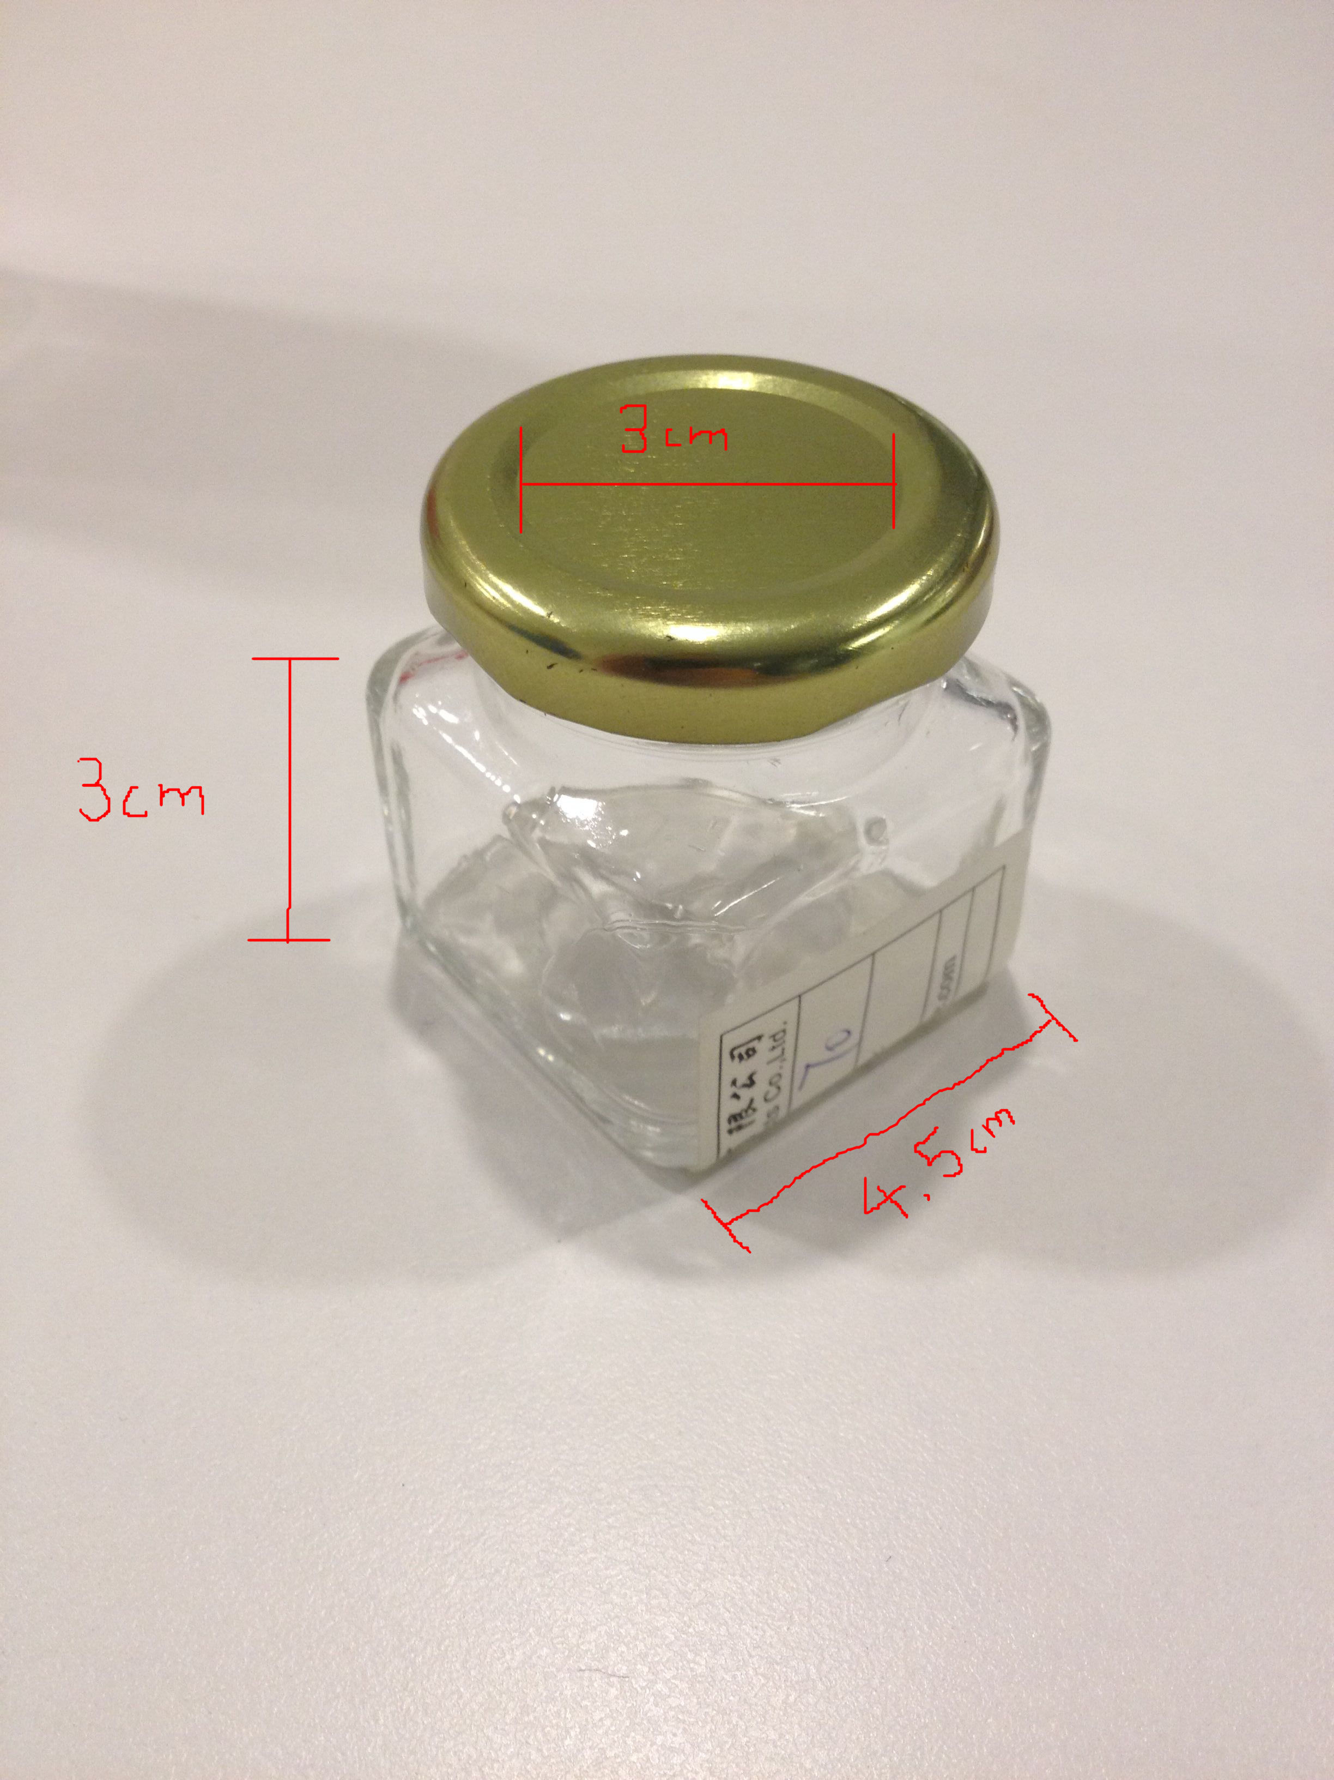

These are the dimensions for the two jars. The big one (350mL) has different sizes front and back labels because we will have our logo embossed in the glass (front: 5cm x 5.5cm, back 5cm x 6.5cm)

Small will have Front and back labels of the same size (3cm x 4.5cm) and a circular one for the lid (diameter: 3cm)

IN SUMMARY:

We want a natural, eco friendly feel for the labels:

The big jar MUST have on the back label:
- Nutrition info
- A barcode
- A QR code

Labels should also include the company logo (attached in separate .AI file) and ‘doctor badge’.

We also need the colour (pantone codes preferred) codes for everything used, MAXIMUM of 8 colours!

