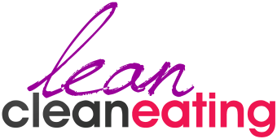
MENU:
> Home
> About
> The Plan
> Shop

HOME PAGE – DESIRED LAYOUT

LOGO
MENU

HEADER (Copy):
GET SLIM
BOOST ENERGY
GUILT FREE
WITH LEAN CLEAN EATING!
With Adriana Solorzano

EMAIL SIGN UP:
Join the Lean Clean Eating Movement!
GET A WEEKLY SERVING OF INSPIRATION & ADVICE THAT WILL CHANGE YOUR LIFE…BRING IT ON!

Name: …………… [Input Field]
Email: …………….. [Input Field]
HOOK ME UP! [Button]

HOOK ME UP

o

EMAIL

o

NAME

o

Side Bar Ad #1 (Copy):
The ULTIMATE Lean Clean Eating Guide
GET IT NOW! [Button]

BLOG
Side Bar Ad
BOOK

Side Bar Ad
12 WEEK CHALLENGE
Side Bar Ad #2 (Copy):
12 WEEK CHALLENGE
Healthy, Happy & Hot In No Time Flat!
JOIN US NOW! [Button]
BLOG:
Blog posts go here.

HOOK ME UP

o

EMAIL

o

NAME

o

EMAIL SIGN UP (Copy):
Join The Movement!
Join the Lean Clean Eating Movement and get a free copy of The Kick Start Plan (valued $27.00)!
NAME:.... EMAIL:.......

SIGN ME UP! [Button]

o

FOOTER
FOOTER:
> Community
> Free Resources
> Press
> Contact

SOCIAL MEDIA BUTTONS:
> Facebook
> Twitter
> YouTube


PROFILE PHOTO HERE: https://www.dropbox.com/sh/n6t0han2t3tmmb8/U0W8mdRcao



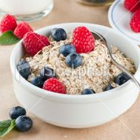
iSTOCK PHOTOS HERE: https://www.dropbox.com/sh/xgqlnsyx5oi96qy/7ik3jiBgg8
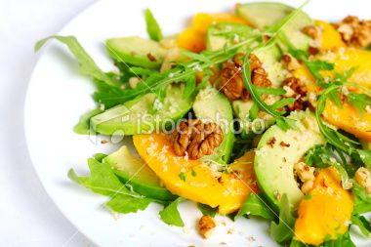

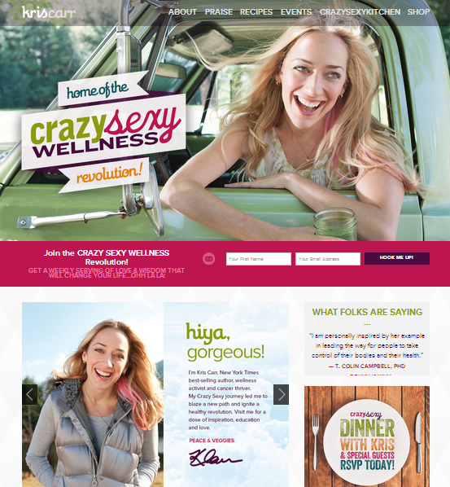
http://kriscarr.com/ - LOVE this design/style, this is what we are after!!!
SAMPLE STYLE:
