Same banner as www.rinstrum.com – but using axleWEIGHr logo
 |  | Regional Phone Number  Australia 07 32167166  USA Toll Free 1 877 829 9152  Ph: +1 248 680 0320 |  |  | Site Search
In Motion Axle Scale by Rinstrum Smart Weighing Solutions
Home About Document Download Contacts
Video Demo  https://www.youtube.com/watch?v=0sKtAPvDaLM |  |  | - Monitor yields, loads, wastage and compliance  - Document truck weights and eliminate overload fines.  - Determine and maximise your load and axle weights before you go over a weighbridge.  - Relocatable design for rented or variable work sites.
Drive over the scale at a constant 3-5 km/h. The scale will automatically weigh each axle and print a receipt with individual axle weights and the total. If you store the trucks ID and tare weight, or use 2 pass weighing, the controller will calculate the Gross, Tare and Net values. | 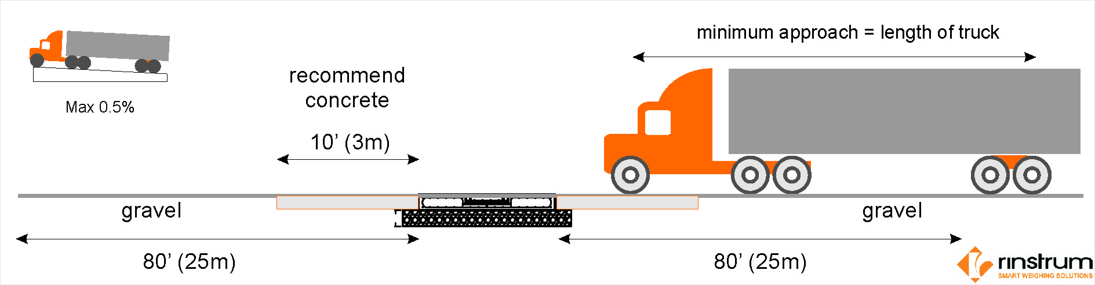
EASY  Just install, add power, zero the scale and start weighing. The axleWEIGHr is preconfigured for easy installation. The load cells are factory calibrated and the indicator is preprogrammed. All wiring is DIY terminating with screw on watertight M12 connectors. | ACCURATE  On average better than ± 0.5% repeatability can be expected. Company testing as well as numerous field installs have shown that with extended flat and level concrete approaches better accuracy can be achieved. Individual results may vary. Well maintained vehicles weigh the best. Never worry about being overloaded again. |  | ECONOMICAL  About 1/3 of the cost of a full length truck scale. With the axleWEIGHr you will always know the total vehicle weight and the individual axle weights. Installation generally in half a day and no costly foundations. No limit on the number of axles. Can even be installed in a gravel driveway removing the need for costly approaches and exits. | INNOVATIVE and TRUSTED  Rinstrum's patented design produces fast accurate weights without stopping on the scale or interrupting the flow of traffic using weighing technology that we have been fine tuning over the past 20 years.
User Installation  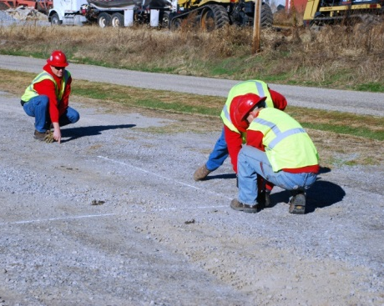  Step 1: Choose site that is flat and level twice the length of your longest truck  (click through each photo and text as per page 3) |  |  | Components  - Outdoor Controller with built in lights 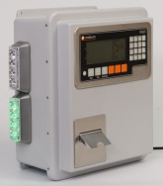  - Indoor controller with external lights 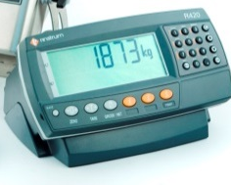  - 11ft or 12 ft deck  - Remote Display (Optional)  - Clicker System (Optional)
Testimonials Scrolling
Navigation |  |  | Links: Facebook, Youtube

 |  | Regional Phone Number  Australia 07 32167166  USA |  | Site Search
In Motion Axle Scale by Rinstrum Smart Weighing Solutions
Home About Document Download Contacts
Same as current Rinstrum site.
http://www.rinstrum.com/company.php
 |  |  | Links: Facebook, Youtube

 |  | Regional Phone Number  Australia 07 32167166  USA |  | Site Search
In Motion Axle Scale by Rinstrum Smart Weighing Solutions
Home About Document Download Contacts
- R400-665 axleWEIGHr User Guide
- R400-664 axleWEIGHr Operator Sheets
- R400-750 axleWEIGHr Data Sheet
- AXLE-600 axleWEIGHr Installation Guide NEW
- AXLE-601 axleWEIGHr US order form
- AXLE-602 axleWEIGHr AU order form
- P057-600 Scale Drawing

 |  |  | Links: Facebook, Youtube

 |  | Regional Phone Number  Australia 07 32167166  USA |  | Site Search
In Motion Axle Scale by Rinstrum Smart Weighing Solutions
Home About Document Download Contacts
Same as current Rinstrum
http://www.rinstrum.com/contact-rinstrum.php

 |  |  | Links: Facebook, Youtube

