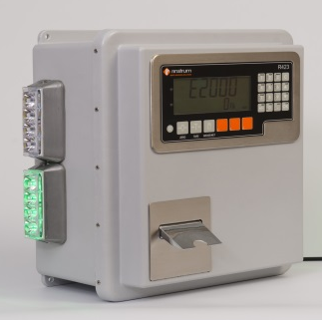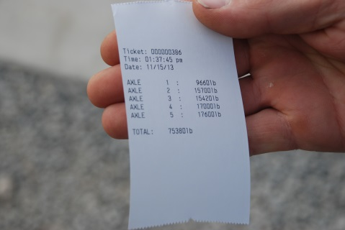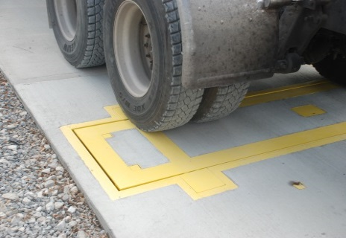
Rinstrum's Weigh In Motion Axle Scale is a fast, accurate and economical way to monitor commodities and truck load limit weights that are coming into or leaving your facilities.

- Patented Design  - Save time and money  - Weather resistant enclosure  - Red/Green traffic control lights  - Automatic print: Time/Date, Truck ID, Axle weights, and Gross, Net, Tare weights  - Inbound/outbound operation  - 250 Truck ID's with totals  OPTIONS  - Indoor controller/printer with outside traffic lights  - 100mm remote display with super bright LEDs and traffic lights  - Remote Truck ID key-fob so you don't have to leave the cab  - Two scale bi directional dump station system. Install a scale before and after the pit. | OPERATION: Drive over the scale while moving at a constant 3-5 km/h. The scale will automatically weigh each axle and print a receipt with individual axle weights and the total. If you store the trucks ID and tare weight, or use 2 pass weighing, the controller will calculate the Gross, Tare and Net values.  - Monitor yields, loads, wastage and compliance  - Document truck weights for Chain Of Responsibility requirements and eliminate overload fines.  - Determine and maximise your load and axle weights before you go over a weighbridge or to your local elevator.  - Relocatable design for rented or variable work sites.  EASY: Just install, add power, zero the scale and start weighing. The  Weigh In Motion Axle Scale is preconfigured for easy installation. The load cells are factory calibrated and the indicator is preprogrammed. All wiring is DIY terminating with screw on watertight M12 connectors.  ACCURATE: On average better than ± 0.5% repeatability can be expected. Company testing as well as numerous field installs have shown that with extended flat and level concrete approaches better accuracy can be achieved. Individual results may vary. Well maintained vehicles weigh the best. Never worry about being overloaded again.  ECONOMICAL: About 1/3 of the cost of a full length truck scale. With the Weigh In Motion Axle Scale you will always know the total vehicle weight and the individual axle weights. Installation generally in half a day and no costly foundations. No limit on the number of axles, allows for any truck configuration or length. Can even be installed in a gravel driveway removing the need for costly approaches and exits.  INNOVATIVE: This patented design produces fast accurate weights without stopping on the scale or interrupting the flow of traffic.  WARRANTY: One year on printer, two years on controller, 5 years on load cells and precast concrete.  *In Motion Axle Scales are not certified as Legal-For-Trade
Operation
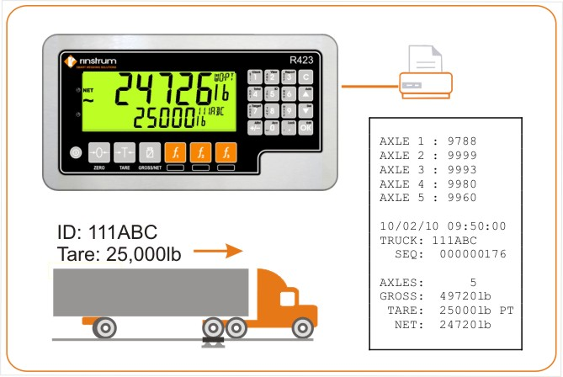 | 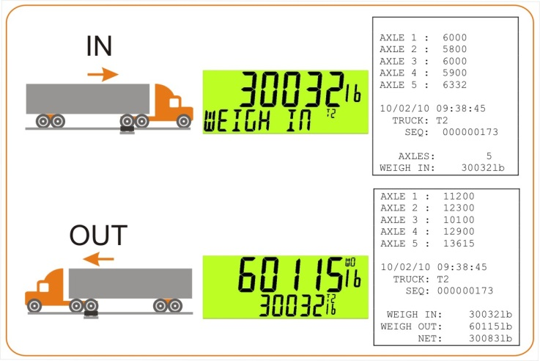
Single Pass Weighing With Known Tare Weight  Press the TRUCK Key  Enter your known Tare weight then OK  Drive over the scale  OR  Press the TRUCK Key  Enter Truck ID to recall a storred Tare weight then OK  Drive over the scale | Two Pass Weighing – Weigh In and Weigh Out  INBOUND  Press the TRUCK Key then OK  Drive over the scale  OUTBOUND  Use Up/Down arrows to select your Truck ID then OK  Drive over the scale
Overall Configuration
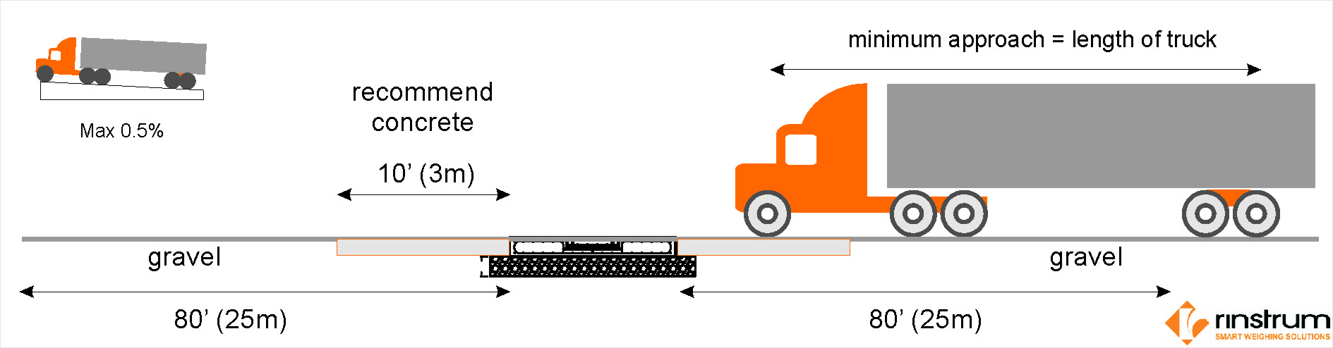
Remote Display Option
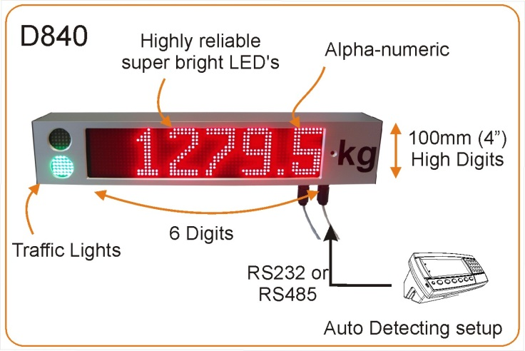

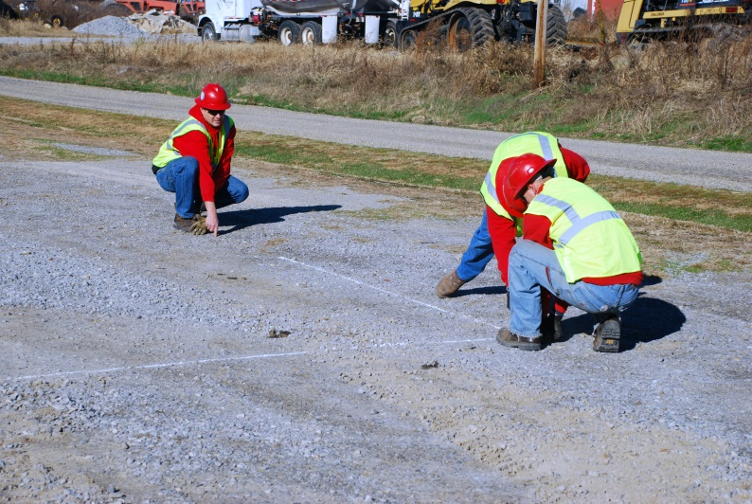  Step 1: Choose site that is flat and level twice the length of your longest truck | 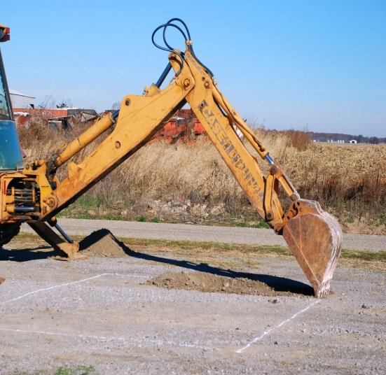Step 2: Excavate and compact 4.2m X 3.2m x 0.6m deep. Dig a trench for home run cable and water drains. | 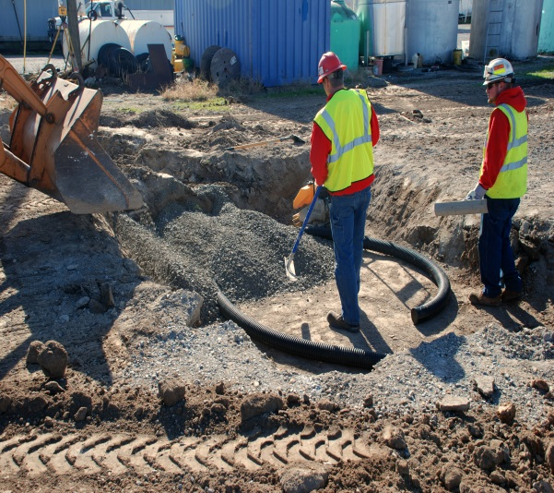  Step 3: Lay 100mm drain coil and first 150mm layer of 20mm road crush stone. Compact to 95%
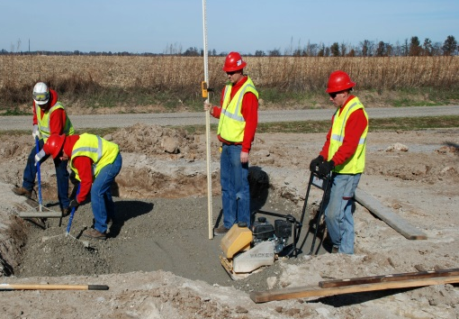  Step 4: Lay second layer of 20mm road crush stone, compact to 95%. Surface should be 295mm below grade or approach. | 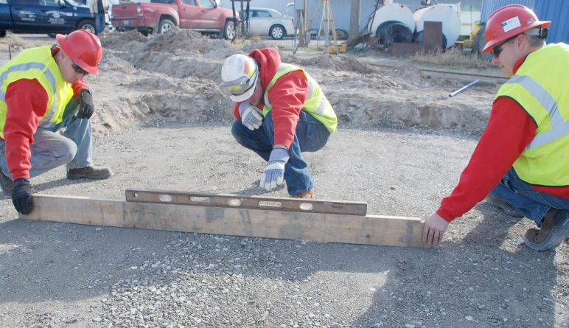  Step 5: Entire foundation must be flat and level. This critical step is best achieved with a laser level to ensure accuracy. | 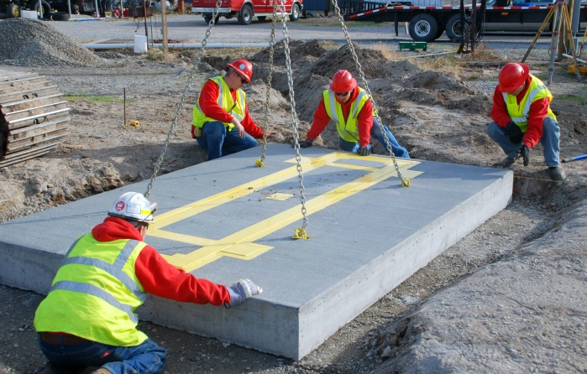  Step 6: Set 30m of builder's string line parallel to the approaches and install the scale along this line.
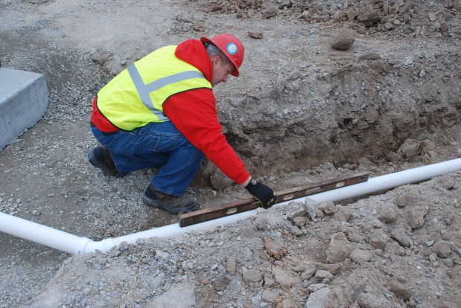  Step 7: Slope 90mm PCV storm water pipe away from foundation and run 25mm conduit from scale to controller. Back fill perimeter of scale, drains and conduit runs. | 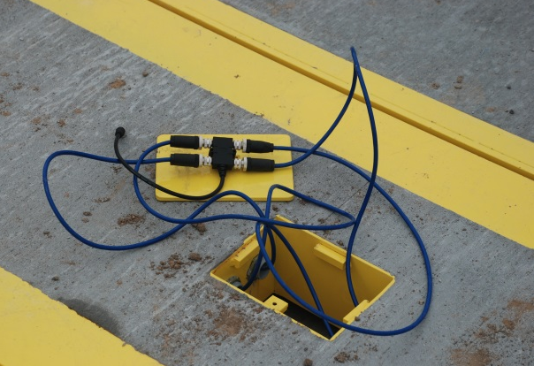  Step 8: Install home run cable from controller to 4 way connection. Terminate the watertight loadcell connections at scale and controller using the M12 screw on connectors. | 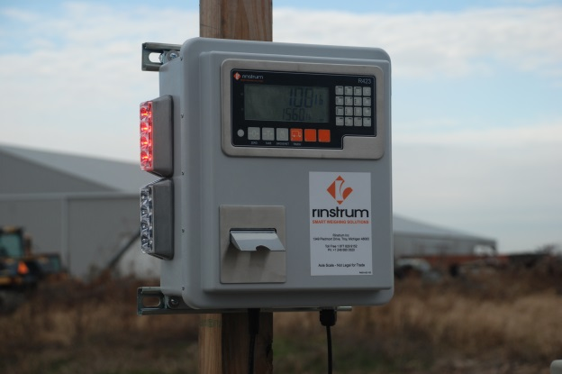  Step 9: Install controller on a suitable post, pole or wall and complete electrical connections. Apply power and weigh your trucks.

SPECIFICATIONS:
Capacity | 20t ( axle load, dynamic or static weight )
Display Resolution | 10kg
Operating Speeds | Structurally certified for "in road use" at 65 km/h up 22.7t axle load  Recommended speed 3 – 5km/h  Speed error above 11 km/h
SCALE
Precast Scale Module | Dimensions: 8.5’ x 12’ x 11.5” (2.65m x 3.65m x 0.295m)  Weight: 7.3t
Scale Insert | Dimensions: 2.5' x 11' x 5" (0.76m x 3.4m x 0.125m)  Weight: 0.7t
Home run cable | Prewired, 30m cable fitted with M12 screw on connector
Load Cells | Outboard, self-contained, 4 x 10t folded shear beam load cells, 150% capacity safe load  Stainless Steel, Hermetically Sealed, IP68 ingress Protection, M12 Watertight connectors
ELECTRONICS
Zero Cancellation | +/- 2.0mV/V
Span Adjustment | 0.1mV/V to 3.0mV/V
A/D Type | 24bit Sigma Delta with ±8,388,608 internal counts
Operating Environment | Temperature: ambient 5 °F to 140 °F (–15 to +60°C)
Operating Environment | Humidity: <90% non-condensing
Display | LCD with two alpha-numeric displays areas and LED backlighting:  Primary display for axle weights: 6 x 1.12" (28.4mm) high digits  Secondary display for previous total weight: 9 x 0.7" (17.6 mm) high digits
Calibration | Factory calibration of load cells and WIM indicator controller
Calibration | Dynamic scaling factor to compensate for dynamic weighing characteristics
Serial Outputs | Serial 1A: RS-232 serial port for remote display, network or printer supports.
Serial Outputs | Serial 1B: RS485 transmit only for remote display
Battery Backed Clock Calendar | Battery life 10 years minimum
Additional Communications * | Module: RS232/RS232 Module: RS232/RS485 Module: RS485/RS485
Data Storage Device * | 1
Ethernet TCPIP* | 1
SITE REQUIREMENTS
Approach – customer provided | A poured 3m minimum concrete approach either side of the scale is not required but is recommended to improve accuracy. WIM scale will work satisfactory with road crush, “flat and level” approaches. Minimum one truck length "flat and level" approach on either side of the scale is required.
Foundation – customer provided | 300mm bed of 20mm road base crush stone with fines is recommended

* optional modules requiring additional configuration
** Specifications subject to change without notice, please verify with Rinstrum prior to order

www.rinstrum.com | Email: sales@rinstrum.com | Ph: +61 (0) 7 3216 7166

