Operation
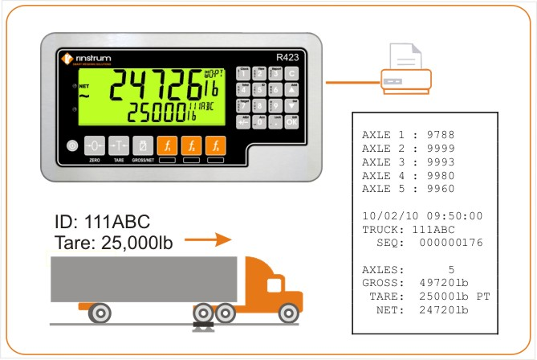 | 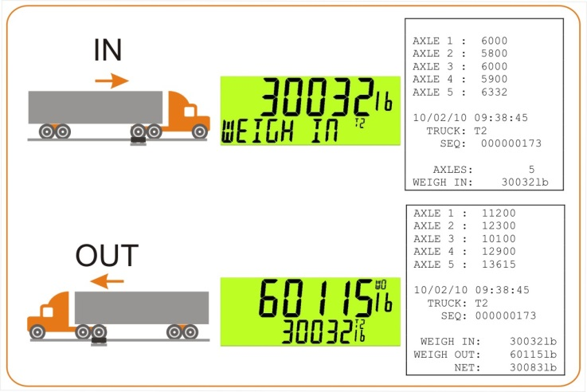
Single Pass Weighing with Known Tare Weight  Press the TRUCK Key  Enter your known Tare weight  Drive over the scale  OR  Press the TRUCK Key  Enter the Truck ID to recall a storred Tare weight  Drive over the scale | Two Pass Weighing – Weigh In and Weigh Out  INBOUND  Press the TRUCK Key then OK  Drive over the scale  OUTBOUND  Use Up/Down arrows to select your Truck ID then OK  Drive over the scale

