Introducing Lovelife by OhMiBod
- 7 beautifully crafted toys, Designed for Asian women to enjoy!
- Red dot award winning American designs.
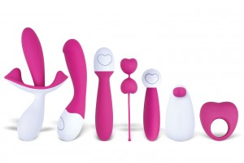
- Excellent quality, that leads to a satisfaction that has to be felt to be believed.

Love Bunny your new best friend!
- With every purchase receive a FREE LOVE BUNNY & personal lubricant for you to enjoy.
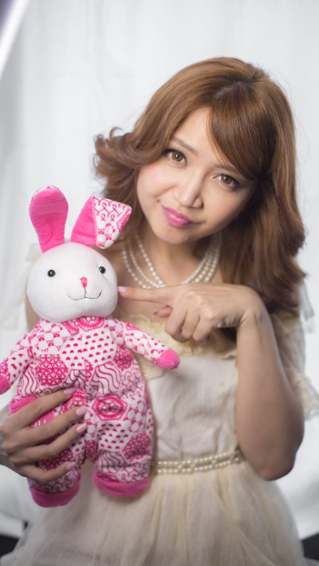
- Love Bunny keeps your pleasurable little secret private; she is cute, cuddly and discrete with your toy.





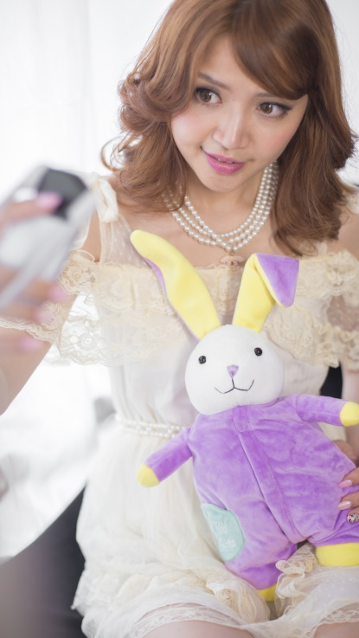
Let’s Take A Selfie!!!

Description of social media campaign follows.

Prices:
冒险：788 394元
相拥：620 310元
跳动：450 225元
分享：530 265元
微笑：550 275元
探索：550 275元
追梦：620 310元

Web: www.lovelike.com.hk TEL:020-86660282
E-mail:peter@cupidoconcept.coom
ADD: 广州市珠江新城海安路13号财富世纪广场A2 栋1001室

