Alterations to Flyer and Banners
Hello,
Firstly we really like your design, we just want to fix a few things, also we need to point out we need these designs to be in Chinese (中文) which is why I have attached everything below in Chinese so you know where to put it.
I hope you can follow the changes I am out lining here, but we can skype tomorrow, I have a dead line for this project which is the night of the 30th as we need to get these items printed ASAP.
- For the prices, we need the Chinese to be correct you can see here you have some squares instead of characters also instead of saying prices we need the text to say the underlined characters below. (No English please)
Also we need the first prices (left hand side) with a line through them to show that this is the discount.
e.g. 788 394
大家一起来玩自拍吧！
“Let’s take a selfie” ( do not include)

机不可失！五折疯抢啦！
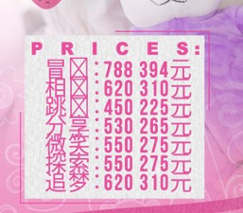
冒险：788 394元
相拥：620 310元
跳动：450 225元
分享：530 265元
微笑：550 275元
探索：550 275元
追梦：620 310元

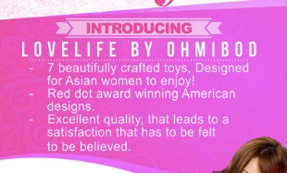
- We decided this was too much text, so we have an idea, which is to reduce the amount of text and use icons, so people get a visual understanding of what they are looking at.
Again the text will be in Chinese, but I’ll explain:
Point 1: Describes 7 designs, we just want an icon with a box ribbon.
Point 2. Describes the quality, we want an icon of a trophy.
Point 3: Describes the satisfaction you get from our toys, ideally we’d like this icon but could be hard, so a smile face is also ok.
(I understand we aren’t providing any Ai files for this so let’s just see what you can come up with.

隆重介绍OhMiBod名下的Lovelife品牌
- 做工精美 （gift box)
- 红点大奖 (trophy 1st place)
- 欲罢不能（Smile emoticon)

- Again we have deleted a lot of the text here to make more white space.
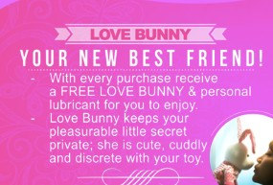
Please keep the “Love bunny” in English but then just swap out the other text for the Chinese provided.
爱爱小兔，您新的小伙伴！
- 为你专设的免费的爱爱小兔和水溶性润滑液

- Can we please use the original version of our logo, with black and pink, just for branding consistency.


There will be 4 banners, the Banner sizes will be 1.6m X .06 m
2 banners will be identical they will be the new edit of this side of the flyer.
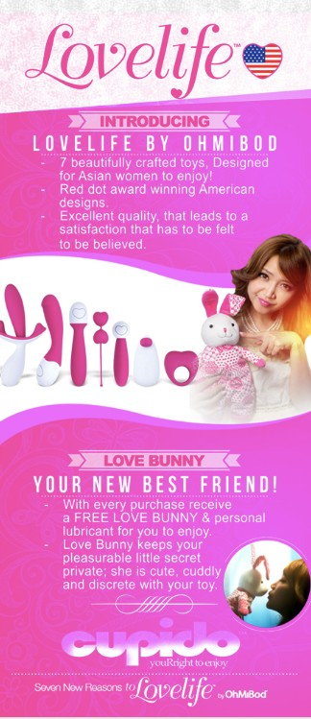

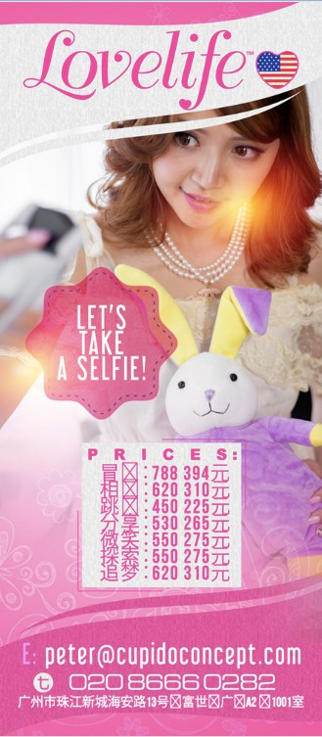

The other two banners will be variations of the other side of the flyer.

One of the banners will include edited version of the flyer with the prices.
The other banner will explain how to do the social media selfie strategy.
It will be the same except in place of the prices we will add the following text in Chinese.
Here is the explanation of the strategy in Chinese.
微信用户，请这样做:
- 加我们的官方微信：LoveBunny_China
- 拿着兔兔并拍照上传到你的“朋友圈”，并截图
- 把截图发送到我们的官方微信
- 我们收到截图后立刻赠送您一只官方的爱爱小兔
- 每购买一个产品都会获赠一个官方小兔

