
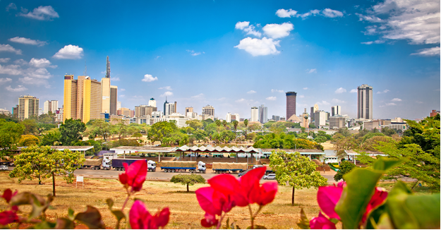
Training Program Outline
In Conjunction With
MiNage’ and
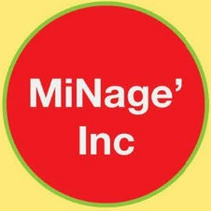

Table of Contents
Overview……………………………………………………………………………………………………………………3
Construction
Introduction……………………………………………………………………………………………………………….4
Detailed Outline of Skills………………………………………………………………………..………………….4
Training Time & Costs……………………………………………………………………….……………………….5
Aquaponics
Introduction……………………………………………………………………………………………….……………….6
Program Details…………………………………………………………………………………….…………………….6
Benefits…………………………………………………………………………………….…………………………………7
Training Time & Costs……………………………………………………………………….…………………………8
Landscaping
Types of Equipment…………………………………………………………………………………………….………9
Training Time & Costs…………………………………………………………………………………………………10
Commercial Fish Farm
Introduction……………………………………………………………………………………………………………….10
Production Costs & Revenue Generation Estimates………………………………………..………….12
Training Time & Costs…………………………………………………………………………………………………12
Pictures of Fish Farm Operating…………………………………………………………………………….13-14

OVERVIEW

Global Mobility Enterprises is an American corporation that is dedicated to fostering cross cultural learning and experiences for the purpose of bettering people in all areas of the world.
Our goal is to give African people training in fields that will improve daily life and give them business opportunities. It will open up opportunities to be able to better feed their families, live in safer, easier to build, affordable homes, and earn a living so that they can be proud of themselves and their ability to support their family.
In addition to training programs in Africa, we have several different areas of practice, including working with investors who want to open a company in the United States, and helping them to navigate the detailed business processes in order operate successful businesses.
We also have a sister company, International Cultural Exchange Institute, which has U.S. Department of State approval to administer internship programs in the United States for foreign students who are enrolled in college, university or other post-secondary education and desire to increase their skills, knowledge, and education by having experiences in America. This organization also assists with visa processing for all of our clients.
All of the training programs you will read about in this manual are taught in Nairobi, Kenya, with the exception of the Commercial Fish Farming program which is taught in the United States.



CONSTRUCTION
We teach many aspects of the construction trades including foundation engineering and construction, panelized home building techniques which will allow customization of the interior of the home, including cement siding and shingles which are fire proof. Plumbing and electrical trades are a required aspect of home building, and as such are a potential class that can be added to one’s repertoire. We can teach you how to enhance the design of the interior of the home including arched doorways, custom cabinets, custom floors, and landscaping for beautifying the home. Our training programs teach students to build an energy efficient home, and how to make it livable and functional.
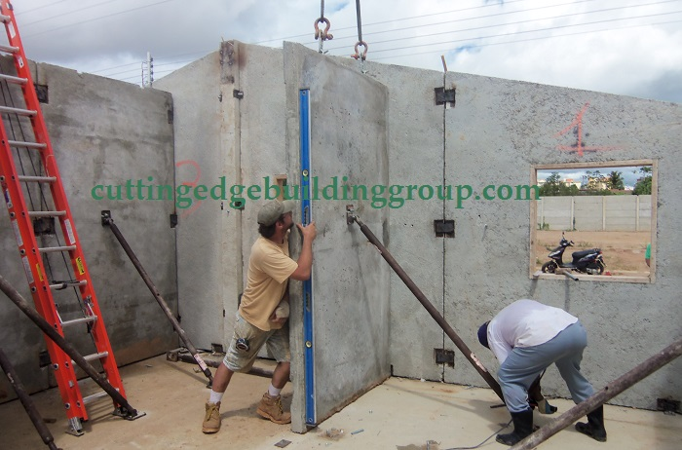
Concrete 101
- Making Concrete
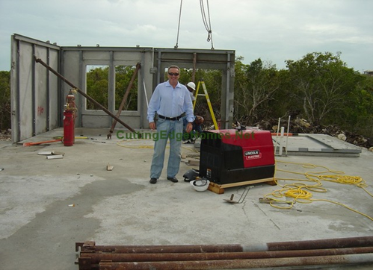
  - Formulas
  - Basic concrete chemistry
  - Unique properties of concrete for builders
  - Ratios: Different formulas for
different applications
  - Mixing
  - Types of pours
    - Foundation
    - Pre-cast
    - Cast and place
- Safety
  - Basic safety practices
  - Hazard communication
  - Respiratory protection
  - Confined spaces
  - Guarding openings and holes
  - Overhead equipment
  - Forklifts
- Design and Engineering
  - Drafting
  - Details
  - Reinforcement
  - Review of concrete structural engineering
    - compression strength
    - tensile strength
    - flexural roll

Each participant will receive a start-up kit which includes:
- Concrete Vibrator Tool
- Free Generator
- Tool belt
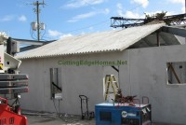
- Tape measure
- Construction pencils
- Marking tape
- Spray paint
- Finishing tools
- Hard Hat
- Gloves
- Respiratory gear
- Hammer
- Knee Pads
- Safety Glasses
- Clamps

Trainer Biography
Bob Paulsen holds a Bachelors and Masters of Science in Civil Engineering, as well as being a licensed General Contractor in two American States (states of Virginia and Florida). Mr. Paulsen has published and presented various papers on high-performance concrete mix design for American Concrete Institute and is a seasoned international speaker on construction technologies. In October 2008, he was the featured speaker at the 4th International Housing Finance Workshop in Lagos, Nigeria.
Bob has over 25 years’ experience in construction and his consulting focuses on three key areas: 1.) Identifying and blending emerging international technologies with current African construction practices, 2.) Locating international experts to train local workers and manage major construction projects, and 3.) Construction business consulting that focuses on guiding a business through the strategic planning process, improving their organizational structure, and identifying key performance metrics.
Training Time and Costs
Construction training duration is 5 days, 8 hours per day and will include cement and mixing products for use during the training. Any home panels that are made during the training will be left with the participants for their own use. Cost is $5900 per participant, and classes of 12 or more participants are required. Additional follow up training and more detailed home building training can be added at the client’s request for additional fees. 50% Deposit due upon registration.
Class Dates (2015) | Final Registration and Deposit Due
May 24-28 | December 31, 2015

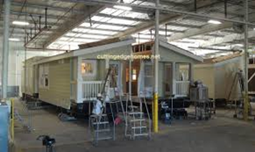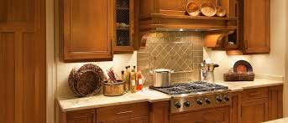
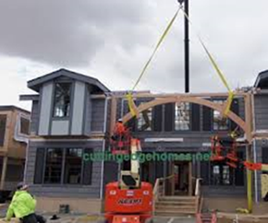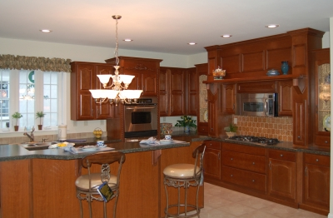

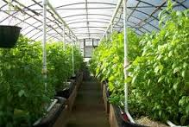
Aquaponics I.
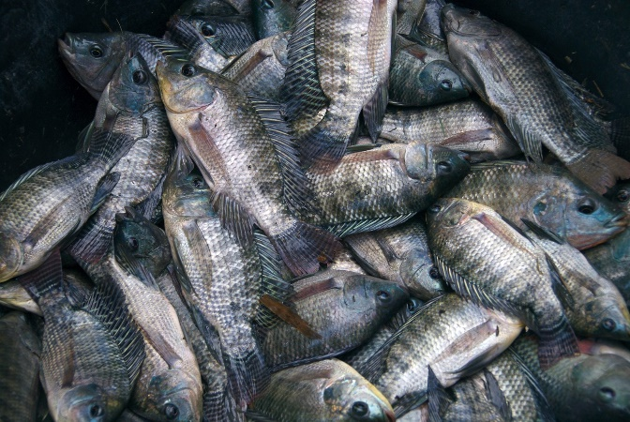
Hydroponics is growing plants in a solution of water and nutrients, without soil. Hydroponics is growing plants in a solution of water and nutrients, without soil. The solution is created by adding the elements a plants needs to water, which is fed directly to the plant’s roots. In some hydroponic systems the roots are in a growing medium which keeps them moist, aerated and helps to support the plant. Hydroponics provides the plant with the ideal water and nutrient ratios and optimum conditions for growth.
In aquaculture, the water quickly becomes nutrient rich due to the fish digesting their food and excreting waste. The waste water is usually filtered and/or disposed of to keep the tank water free of toxic buildups.
In aquaponics, the fish waste provides a food source for the growing plants and the plants provide a natural filter for the fish. This creates a mini ecosystem where both plants and fish can thrive. Aquaponics is the ideal answer to a fish farmer’s problem of disposing of nutrient rich water and a hydroponic grower’s need for nutrient rich water. Aquaponics is a growth industry because of the ability to provide high quality, locally-grown fresh food on a year round basis.
Although the practices of fish farming and soil-less plant culture have been traced to ancient times, the combination of the two is quite new. Research in aquaponics began in the 1970’s and continues today. Several Universities worldwide are dedicating resources to further the technology.
Aquaponics gardens bring science and ecology to life by showing a living, breathing example of what can happen when people work with nature to grow their food.

Training Programs
We offer comprehensive, experience-based aquaponic training programs that provide hands-on learning and real-world experience in aquaponics. Our mission is to be the leading purveyor of quality, science-based aquaponic systems, training and support and to promote and cultivate success for our customers in aquaponic food production, helping to fill the global demand for sustainably grown, premium quality fish and vegetables.
Lessons students will learn from aquaponic gardening class
Biology - What role does nitrifying bacteria play in aquaponics? Where does it come from?
Physics – How does water move throughout the system? What light spectrums grow plants best?
Chemistry – What happens to the uptake of iron in plants if pH gets too high? How is oxygen in the water affected by temperature?
Horticulture – What does a plant need in order to grow properly?
Zoology – What do fish need in order to grow properly?
Ecology – What happens if an eco-system becomes out of balance? What role do composting red worms play in aquaponics?
Nutrition – What is the difference between freshly picked food you grew yourself and food from the market?
Benefits
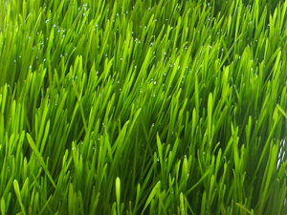
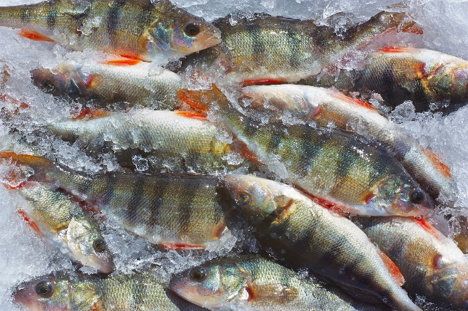
The vegetable crops from these systems can be harvested daily to meet market demand. Our systems are designed for tilapia that means you will harvest a tank full of fish every 4 or 6 weeks. If you use two modules, you will harvest a tank full of fish every 2 or 3 weeks. With 3 modules, it is every 1-2 weeks.
One acre [four 90’x 120’ sq. ft. units] Aquaponics Systems produces 240,000 to 800,000 vegetables and up to 92,000 pounds of fish per year ▪ A single 90′ x 120′ unit produces 60,000 to 200,000 vegetables and up to 23,000 pounds of fish per year ▪ A 20′ x 30′ unit produces 3,600 vegetables and 1,400 pounds of fish per year. ▪ A 10′ x 20′ unit produces 1,100 vegetables and 400 pounds of fish per year.
- Aquaponics Gardening enables home fish farming. You can now feel good about eating fish again
- Aquaponics Gardening uses 90% less water than soil-based gardening.
- Aquaponics Gardening is twice as productive on a square foot basis as soil-based gardening
- Aquaponics Gardening is free from weeds, watering and fertilizing concerns, and because it is done at a waist high level there is no back strain
- Aquaponics Gardening is necessarily organic. Natural fish waste provides all the food the plants need. Pesticides would be harmful to the fish
- Hormones, antibiotics, and other fish additives would be harmful to the plants. And the result is every bit as flavorful as soil-based organic produce
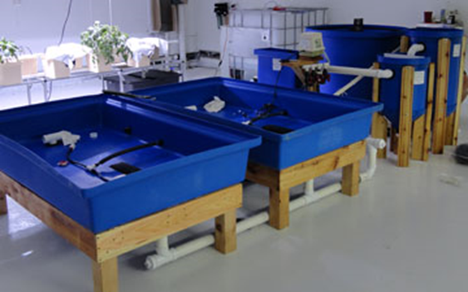
Training Time and Costs
Aquaponics training requires 4 days of instruction and can be done in any location. At the completion of the training program, participants will know how to successfully farm fish and vegetables and be able to feed their family for their entire lives or have the ability to start a business that enables them to sell fish and vegetables at market. Cost of the training is $2400 per person. Global Mobility Enterprises will provide the equipment required for training but if participants would like to have equipment for home use, it can be purchased separately Minimum class size required is 12 students.

Class Dates (2015) | Final Registration and Deposit Due
May 20-24 | December 31, ,2015

Commercial & Residential Landscaping 101
In order to ensure the exterior of buildings and homes are kept beautiful and free of fire hazards, it is important to have the proper equipment, training, and knowledge. Global Mobility Enterprises can provide equipment and training which will prove to be extremely useful in daily life.
Some of the equipment to be utilized and potentially purchased is as follows:
- Weed-Whacker: A tool which uses a flexible monofilament line instead of a blade for cutting grass and other plants which are near objects or hard to reach places including steep or irregular terrain. It typically has a long shaft with a handle and a cutting head at the end of the shaft.
- Lawn Mower: Used to trim grass and can be a hand-pushed object or a ride on style.
- Brush Cutter: A heavy duty tool that can clear saplings or dense under growth with ease.
- Chainsaw: A handheld, gas powered saw which has the power to cut large trees.
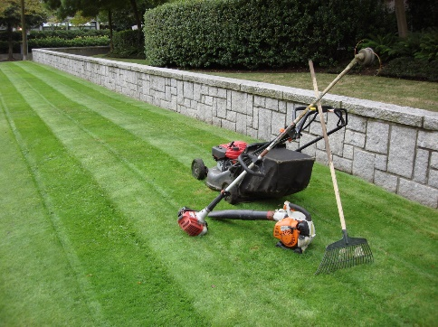
- Blower: A tool which blows air with extreme force in order to push debris from one area to another.
- Hedge Trimmer: Either electric or gas powered versions exist, and are used to efficiently trim bushes and hedges for a manicured look.
Other Skills
Sprinklers: Learn how to dig proper ditches for efficient drainage, lay sprinkler pipes, and sprinkler head placement for most effective water coverage. Also understand electric control panels and how to program and operate.
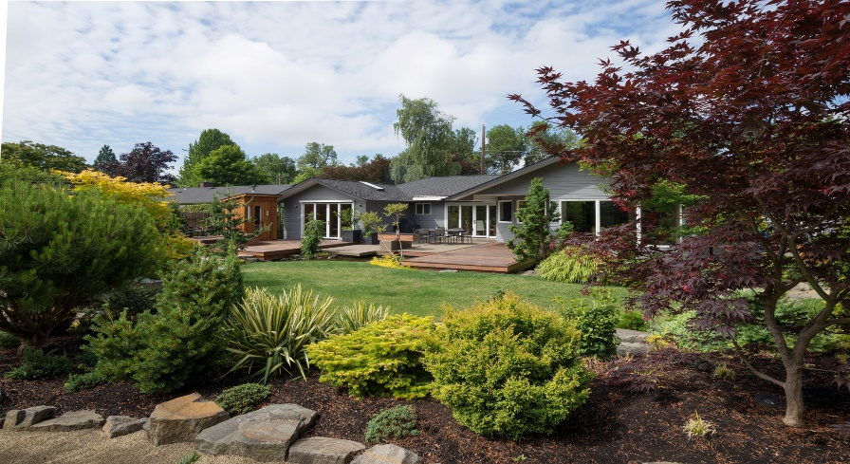

Design techniques: Learn how to beautify grounds through design and strategic placement of specific plants and hardscape items.
Equipment: This training will provide participants with a weedwhacker and a blower so that they may have the tools to start a business right away upon completion of the training.
Training Time and Costs Training program can be customized for 3 days. Cost: $2100 per person. Minimum class size of 20 required. Classes to be provided in Nairobi, Kenya.
Class Date | Final Registration and Deposit Due
May 20-23 | December 31, ,2015

COMMERCIAL FISH FARMING
Commercial fish farming can be accomplished on a large scale inside of specialized enclosures which can be installed in any location in the world. The term “aquaculture” is used to describe the process by which fish are grown and harvested in these farms. The result is a business that provides a much needed commodity, jobs for local residents, and profits for the business owner.
Global Mobility Enterprises provides access to the technology and equipment as well as training for potential business operators and employees. This ensures that individuals have the knowledge and experience required to successfully run the aquaculture farm on a daily basis.
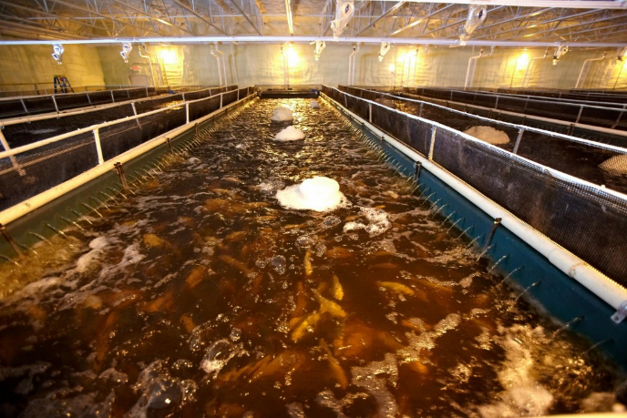
The Aqua 2100 system utilizes air to circulate water to the culture tank from the rotary drum filter. The system is designed to provide two “opposing flows” of water, created by compressed air being introduced at the base of each side of the tank. As the air rises through the water it not only provides oxygen but also creates two opposing circulating flows. This circular pattern enables solids to be gently drawn into the outflow ports located at the bottom on both sides of the tank and passed through, intact to the rotary drum filter.
The unique (Patented) “Opposing Flow” technology also creates a continual current in the culture tank. After the biofilter, the purified water is evenly distributed back into the culture tank, entering from both sides of the tank causing the fish to align themselves in the current, constantly swimming “upstream” facing either side of the 40’ long tank. With this constant swimming motion the fish can metabolize the high protein feed into flesh which will give them a higher yield as compared to fish grown in circular aquaculture tanks.
Oxygen is injected into the system at three points. One is in the biofilter area where there is 48 feet of Opposing Flows air diffusers. The second is in the culture tank itself where there is 80 feet of Opposing Flows air diffusers. The third is through the airlift water return system. Only one blower is required to handle all three of these processes and can also operate multiple tanks, although a backup is recommended. With this system we have densities of .75 pounds per gallon regularly.
Production Management for Twelve (12) Tank System
Tanks #1 & #2: 18,000 fish in each tank. After 2 months they average .3 pounds.
Tanks #3 – #6: 9,000 fish in each tank. After 2 months they average .75 pounds.
Tanks #7 – #12: 6,000 fish in each tank. After 2 months they average 1.25 pounds. Harvest 12 aquaculture tanks at 7,500 pounds per tank 3 times a year or 270,000 pounds per year.
Note: This management technique is one that has been used for decades called “Stock Splitting”. Fingerlings are contracted from a hatchery for a ten week delivery schedule or ponds are installed for the facilities own production.
Operation Cost for Twelve (12) Tank System
- Electric: $1,800 per month with an electric rate of $0.10 per KWH or $21,600 per year
- Fingerlings: 216,000 fish at $0.10 each = $21,600 per year
- Food: 270,000 pounds of fish x 1.3 FCR (Food Conversion Rate) x $0.32 per pound of food = $112,320 per year (It requires 1.3 lbs of food to make 1 lb of fish)
- Heat: 10,000 SQFT building heated with waste motor oil at $0.50 per gallon using 3,000 gallons per year = $1,500 per year
- Property Tax: $2,500 per year
- Sewer Tax: $5,800 per year
- Insurance: Building and Fish Mortality = $8,000 per year
- Miscellaneous: Soda Ash, Salt, Testing Chemicals = $15,000 per year
- Labor: Part time 20 hours per week (grading and harvest) $10.00 per hour or $10,400 per year
- Maintenance: Little to no maintenance is required because there are no moving parts. Rotary drum filter or blower may need to be replaced, but that is a rare occurrence.
One Time Cost: $730,000* for 12 tank system
Total Annual Cost: $200,270 (cost per pound $0.74)
Average Selling Price: $2.25 per pound x 270,000 pounds per year = $607,500 per year
Net Profit: $607,500 Revenue – $200,270 Costs = $407,230
Breakeven will occur in 21.5 months.
*One-time costs reflect the cost of the equipment only, and not the cost to deliver or set up the equipment. Additional details available upon request.
Note: These cost and production data are shown as an example of operating an aquaculture tank facility. Actual results may vary from state to state due to food cost, electric rate, insurance, labor and sale price which will affect the business profitability.
Training Time and Costs
Training will take place in the United States on an actual fish farm. The duration of the training is 4 days, and the trip to the US will be 6 days, 5 nights. The cost is $7100 per person, and will include visa processing, hotel, food, transportation, and airline tickets. If commercial farming equipment is purchased in conjunction with training, a discount of 15% will be applied to training costs.
Class Date | Final Registration and Deposit Due
February 2-6, 2015 | December 1, 2015
April 24-28-19, 2015 | February 28,2015
July 13-17,2015 | May 15, 2015
November 2-6, 2015 | September 1, 2015

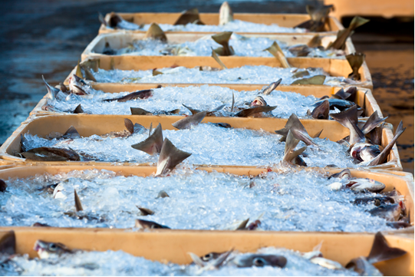 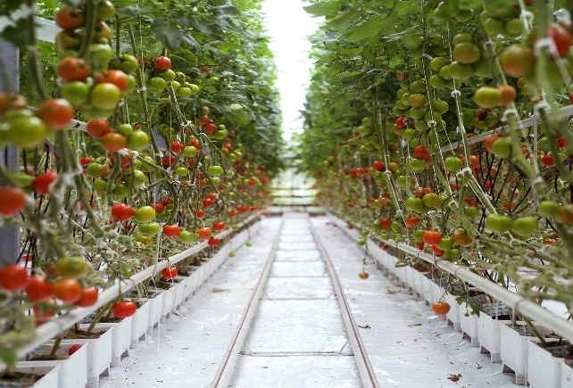 The system is specifically designed to work in conjunction with aquaponics, filtered water is diverted from the fish farm to greenhouses for plant growth.
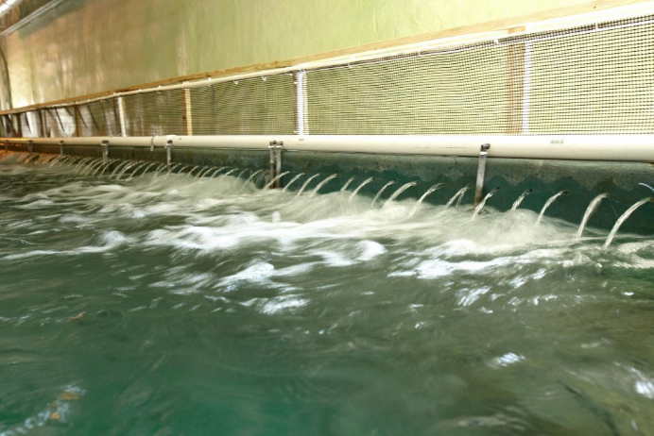
Opposing Flows Technology Air Diffusers oxygenating the water

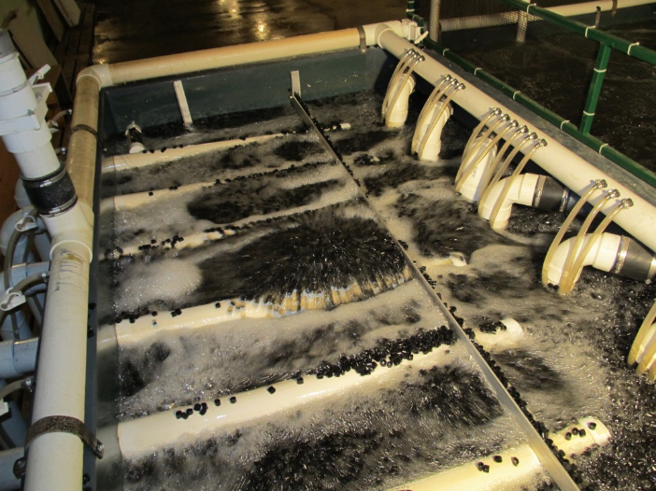
Integrated fluidized bed biofilter has 105 cuft of OFT media. It can handle 150 pounds of food per day

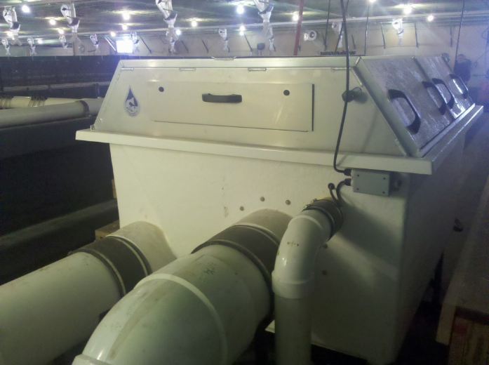
Custom made PR Aqua rotary drum filters remove the solids from 6-10,000 gallon culture tanks
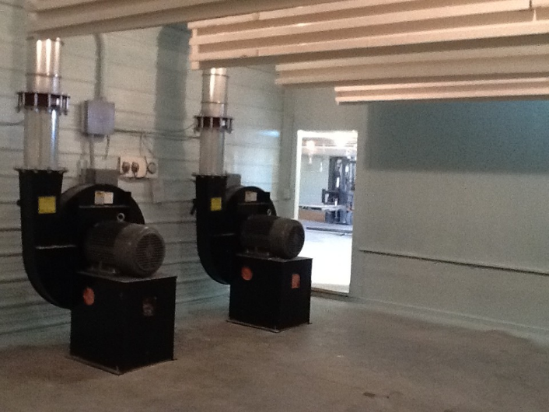
One 40 hp Chicago Blower will drive 12 aquaculture tanks, the second is a built in spare

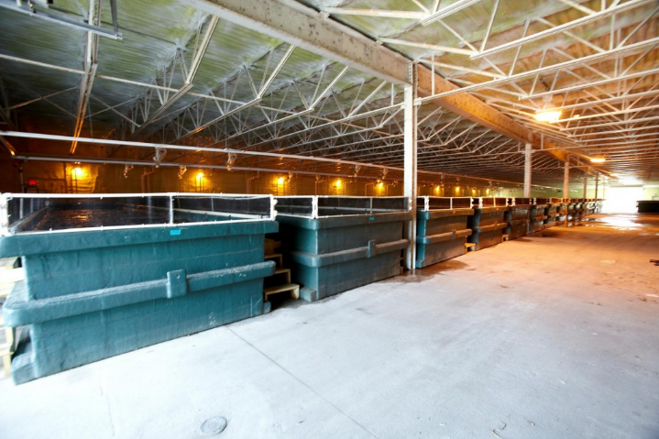
View of the harvest end of Opposing Flows Technology aquaculture tanks

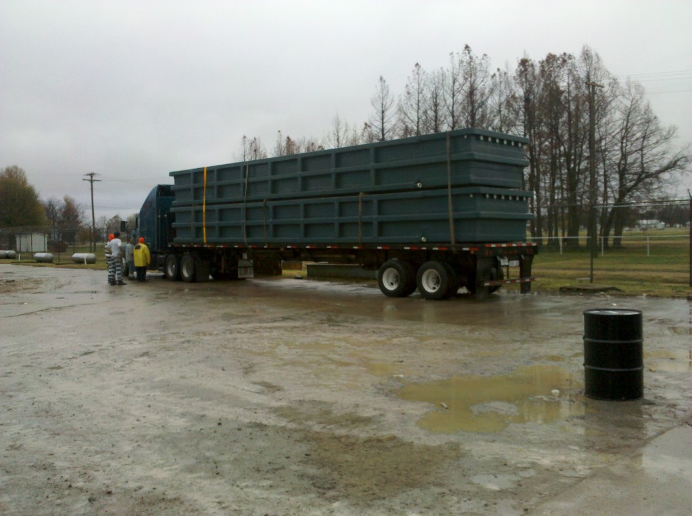

Global Mobility Enterprises 1-855-996-9373 www.globalmobilityenterprises.com

