Commodore Services & Catering
Your Partner in Success

About Us
Established in 1980, Commodore Services & Catering, a subsidiary unit of Commodore Contracting Group, provided catering and facilities services to the onshore and offshore oil and gas service institutions before expanding operations to cater to a wider spectrum of clientele including, but not limited to, labour camps, hotel staff, construction, education, healthcare and Government facilities and institutions.

Our Vision
Our Vision is to provide a world-class service, to partner with our clients in order to excel in the provision of contract catering and support services with a team and facilities of a standard of excellence to help us to exceed expectations.

Our Mission
To offer exceptional client value, by ensuring the highest quality of service delivery, implementing balanced solutions and being a preferred supplier across the spectrum of clients whilst ensuring the strictest and highest standards of food control and hygiene, governed by our HACCP, HSE and ISO9001 policies.

Our Values

Integrity: integrity is central to what we do and our understanding of integrity is holistic: we are responsible for achieving what we promise to do and we strive to exceed expectations. Integrity ensures the quality of our work, processes, procedures and our staff, as well as the ethical standards of our organisation. Integrity goes hand in hand with honesty, and it is our transparent approach to that helps ensure their continued business

Professionalism: with integrity comes professionalism. We exercise professionalism in our operations, our interactions with our clients, our policies, our procedures and in our staff. Our attitude is one that strives for teamwork, reliability, continual improvement and accountability.

Dedication: dedication is a value which permeates every aspect of our business, from the highest levels of management down. We strive to play a part in our client’s success. We safeguard our partners' success by going the extra mile, putting in the time and effort required to meet deadlines on time and on budget.

Who We Are
Commodore Services and Catering is all about great food and great service! It’s about listening to what our clients and customers need. It’s about making people feel cared for and looked after. Because we believe service is an honourable profession.

At Commodore we love working with our clients to create a bespoke experience for all involved. Our highly dedicated and professional team make sure the food we produce looks and tastes utterly beautiful and that every aspect of your catering requirement is managed carefully to meet and exceed your standards and expectations!

What We Do
From our humble beginnings in 1980 serving the offshore and onshore oil and gas service companies, we have grown thanks to the support of our partners and clients, which has allowed us to extend our culinary operations and expertise to cover the larger spectrum of clientele to include labour camps, hotel staff, construction, education, healthcare and Government.

We will work with you to ensure that all of your catering requirements are taken care of and handled every step of the way and will ensure that we accommodate all of the various nationalities and tastes whilst always ensuring a healthy, hygienic and clean environment, adhering to the strictest HACCP policies for food safety in preparation and environment.

Fostering relationships with our clients and partners is at the core of our business and has played a key part in our growth. By managing our clients' catering needs, we allow our clients to concentrate on their core business.

Service Pride
We are successful for one very simple reason; because we value our reputation for quality and service. We work hard to build long term relationships with our clients. We listen to their needs and work hard to meet their requirements. We deliver on our promises. We value our people and the communities that we serve.

We live by the mantra of teamwork, pride and commitment, together with the combination of expertise, quality and innovation, we will produce high quality masterpieces and culinary excellences whilst ensuring a quality of service and satisfaction to our customers.

Team Pride
A team of passionate, qualified and highly experienced professionals, who show utmost commitment to our clients and partners whilst always working to fully certified HACCP methodoligies to the highest hygiene levels.

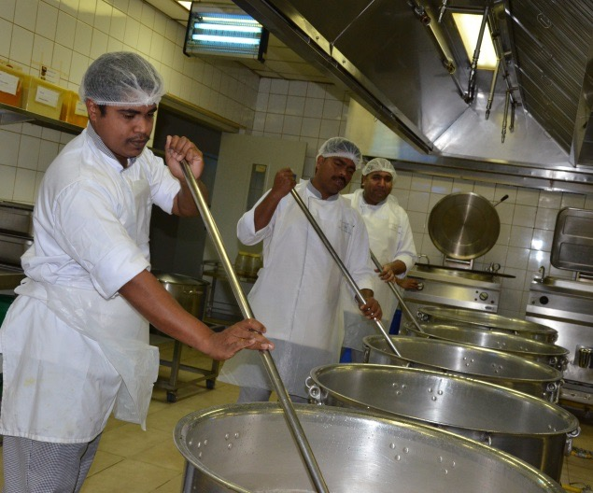

We recognise that our employees are the principal assets of the company. As such, we focus on their training needs, instil the values of professionalism, integrity and teamwork, provide career opportunities, and reward outstanding performance. Our values are based upon a passion for service and determination and to continually improve so we ensure customer satisfaction throughout. We take care of the quality of people we employ; ensure they are well cared for resulting in high morale and, importantly, bringing creativity and initiative to their work

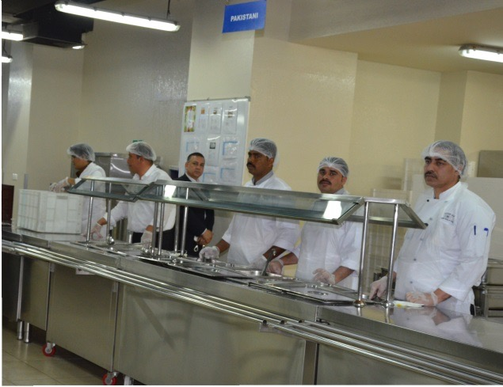

Menu & Capacity
Our Abu Dhabi central kitchen currently has the capacity to produce over 25,000 meals a day, 7 days a week, 365 days a year. That is almost 9 million meals a year. Your location is not a barrier or deterrent for our operations as we have served off shore clients too! You can be confident that we understand exactly what you need. We are always able to deploy a fully operational team on your site that will operate the kitchen!

Menu variation is tailored to the origins of our customers considering personal tastes and preferences and bringing a personal touch to those we live with and serve on site. We offer a wide range of multi ethnic menus, all of which are nutritionally balanced to provide the work force with healthy meals.

Menus are designed with daily multiple and well balanced choices to avoid repetition against guiding principles of taste, consistency and variety. Special menus are developed for special events, festive periods and other national holidays. Menu ingredients and methods of preparation meet the ethnic, religious and cultural requirements of a multi-national clientele.
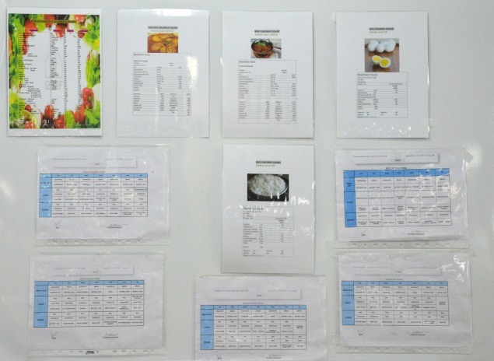

Operation (central kitchen and bakery)
Our Abu Dhabi services operate from our state of the art central kitchen. Our HACCP certified facility complies with the highest local and international hygiene standards and has the capacity to produce 25,000 meals a day. Our chefs and cooking team are fully supported by our facilities and cleaning team to ensure the highest and strictest standards in food safety, hygiene and management which is always being monitored by our on site HSE Inspector, who records, maintains and monitors all the records and food laboratory samples.



We have a number of dedicated zones in our central kitchen where specialized teams operate within their area of expertise has on-site production and consumption capability, allowing for seamless distribution to other sites.

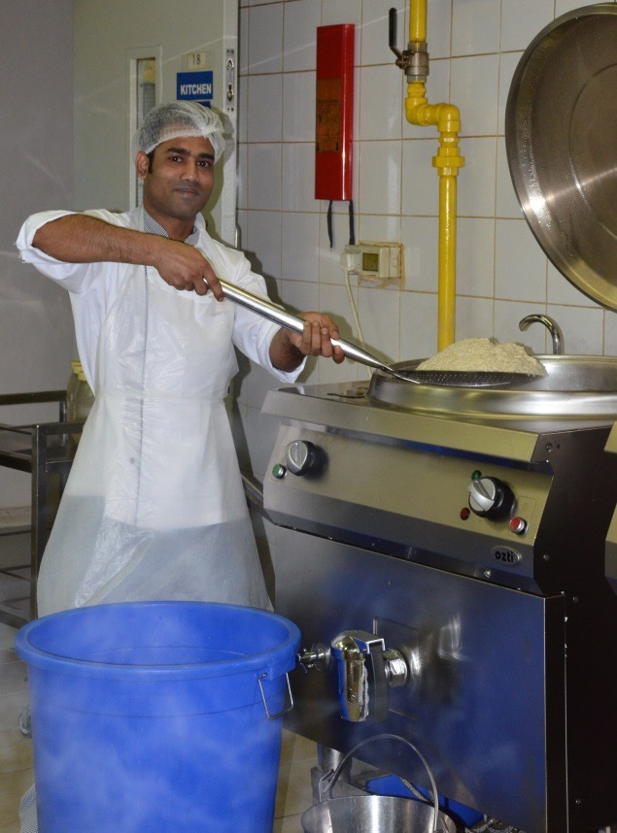

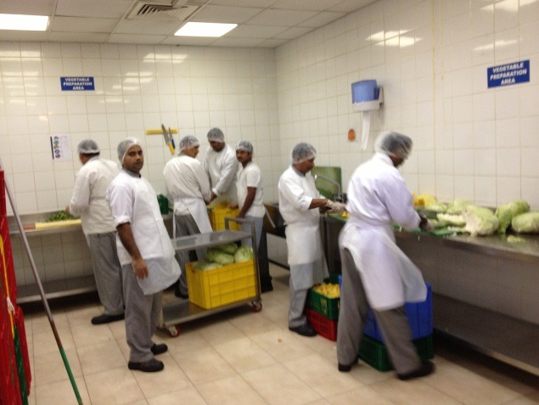

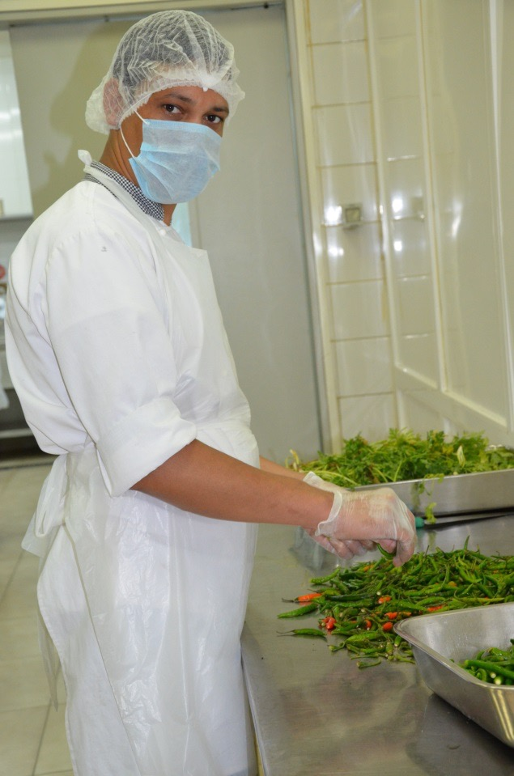

With our in house bakery and fully dedicated team, we ensure that bakery requirements are taken care of for each meal time and has capacity of 60,000 pieces daily.

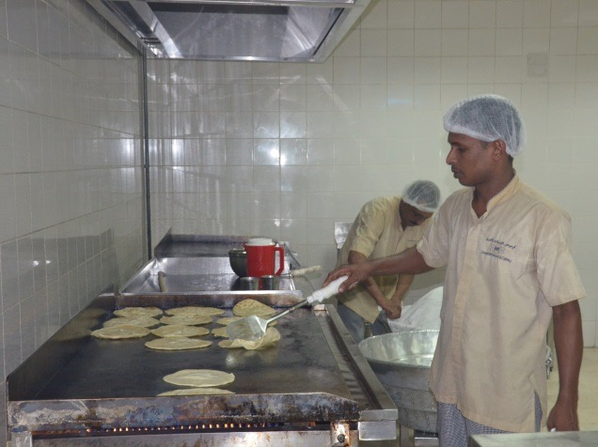
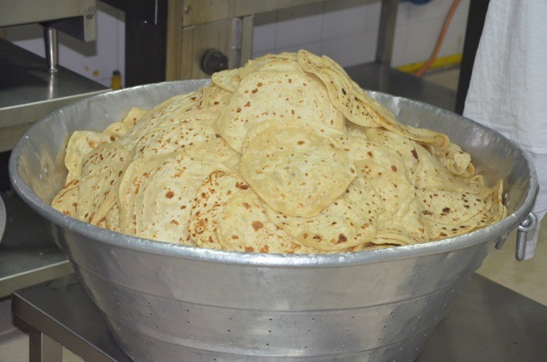
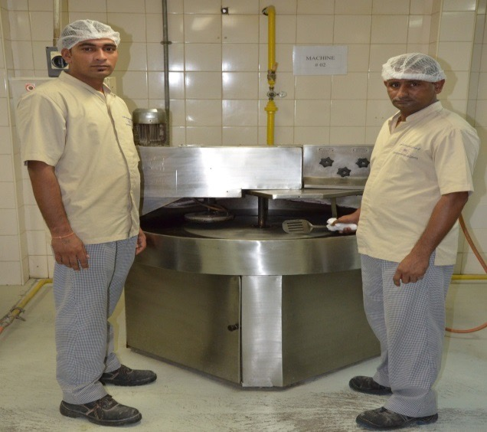
Service Offering and Location Catering
We self-perform support services on behalf of our clients including catering, commercial cleaning, and can operate your kitchen on your behalf with man power supply.

We can give you outstanding value for money and economies of scale. We can also bring you innovative best practice solutions driving efficiencies through service.
Commodore Service and Catering deploys a common operating platform where the organisation benefits from a consistent strategy and standardised governance. This is supported by robust and integrated processes and procedures.

Our proven service solution integrates a range of hospitality and facility management activities in a largely directly-managed and performed service model. With our specialist hospitality management skill being applied, Commodore Services and Catering provides service that is efficient and cost effective while adhering to international standards for safety and quality. Commodore Services and Catering is a dedicated service organisation with a strong adaptive and flexible approach to business that positions us as the best services business partner.

Commodore is able to provide an expert team to either start from scratch or take over existing operations for our clients and integrating our management team and aligning our.

Key to our success is the experience and initiative taken by our management team as they prepare to roll out services to our clients. Extensive pre-transition study of client expectations and understanding of the scope of work sees a baseline established which is transformed into a training regime for our staff. Our management team will continue to be involved in the contract until fully satisfied that permanent management and supervisory staff can achieve and exceed the standards of service required.

Health & Safety
With our carefully designed kitchen and fully integrated HACCP system in place, each food category is stored and is handled separately by it’s specialist team of staff. The receiving area along with all the storage areas have been specifically designed and installed to ensure the highest standards of food handling and safety with each food category being stored separately with its own preparation areas. We ensure that our staff maintain their high level of knowledge and are kept up to date with food hygiene and safety standards by ensuring course refreshers throughout the year.
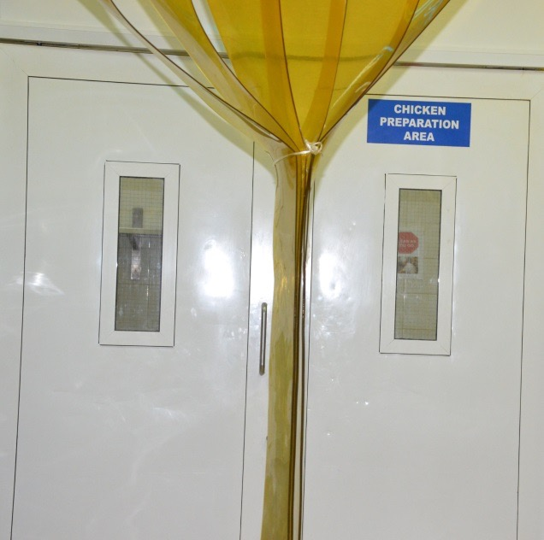
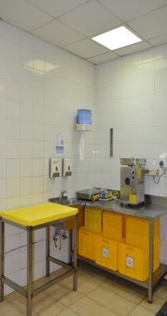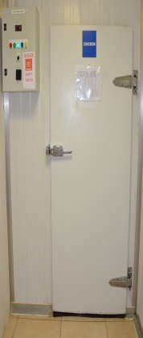
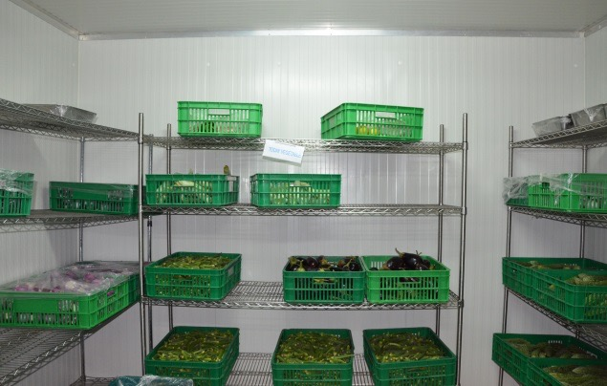

Our onsite facilities cleaning team always ensures that the kitchen and all operating areas and equipment meets the requirements and guidelines set by HACCP and the HSE inspector and operates in the most efficient and effective way to ensure that the kitchen is set and ready for the next meal production and next wave of diners!
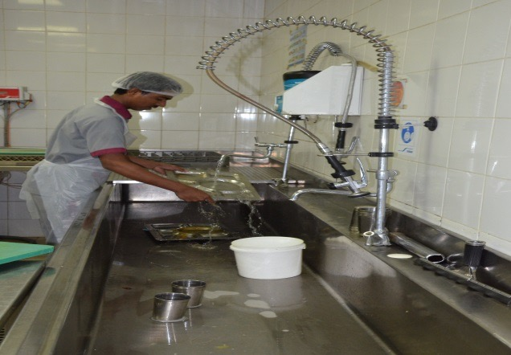
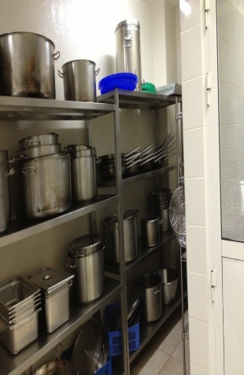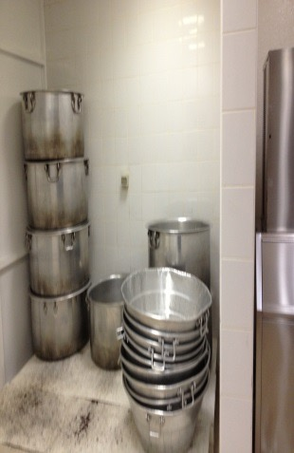
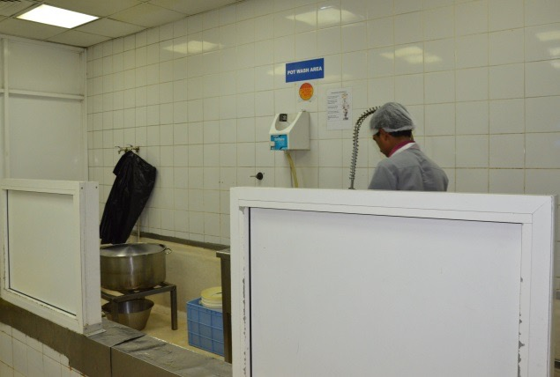

“Nutritionally, satisfying food delivered anywhere, to perfection, on time!”

Contact Us
We are always at hand to listen and cater to your requirements and would be more than glad to assist!


Commodore Services & Catering
PO Box 2023, Abu Dhabi, UAE
Tel: 02 565 6040
Fax: 02 565 6671
Email: hasan.omari@commodore.ae

