Web site Design
Scope for ‘Health & Nutrition’ Social Network

Contents
1. Fresh web design for a health social network 3
1.1 About PrestoVita 3
2 Web site requirements 3
2.1 Home Page 3
2.2 Dashboards 4
2.2.1 Health Professional Dashboard 4
2.2.2 End User Client Dashboard 5
2.3 Health Networks 5
2.4 Communities 6
2.5 Resources 9
2.7 Colour Scheme 10
2.8 Template Background Pattern 11
2.9 Website Background 11
2.10 Brand Communication 12
2.10.1 Target Audience: 12
2.10.2 Understanding the Brand 12
3 Additional important information 13

Fresh web design for a health social network
We are currently looking for a creative, fresh, vibrant, inspiring design for our new social network that is focused on bringing natural health to the masses. PrestoVita is an aggregator of content bringing together experts, such as nutritionists to support and educate users on major problem areas of health. The web site empowers global health experts to share their knowledge and help users to find natural solutions/ answers to their health problems/ questions. It will also empower end-users to share their health experiences in order to help others (encouraging a ‘pay it forward’ model).

About PrestoVita
PrestoVita shows people how they can have more energy and time in their life by simply having the right nutrition, having the right mind-set and exercising. PrestoVita’s social network health forum educates people on how they can prevent and overcome disease by leading a healthy, natural and mindful life.
In summary PrestoVita enables:
- Users to access free information that will improve their health, nutrition, energy, exercise levels and motivation via a personalized web portal
- Real world experiences and practical tools to keep users on track and achieve their goals.
- A portal for nutritional therapists to share their knowledge and engage end users who require health and nutritional advice via online consultations and group workshops. End users are able to share their experiences in order to make a difference in other people’s lives.
- Content providers to be positioned as thought leaders within the health, energy and nutrition marketplace. PrestoVita provides the most targeted platform for content providers to sell their health and energy products and service offerings.

Web site requirements

Home Page
- A short inspirational video/moving imagery for the homepage - an example can be seen at: https://healthunlocked.com/
- 5 changeable homepage images (pictures of people with no background) as per the home page of: http://themeforest.net/item/razor-cutting-edge-wordpress-theme/full_screen_preview/3822067 (the web site is built utilizing the razor word press theme). These images need to be aligned with the following captions:
- Share your story and support others
(picture of an attractive people/person sharing info for example)
- Improve your health; ask an expert
(picture of an Inspirational nutritionist for example)
- Tired of having no energy?
(picture of someone full of energy for example)
- Start your healthy habit now and prevent disease in the future
(picture of healthy happy children/ child for example)
- Why count calories? Count what matters – Nutrition!
(picture of attractive person who’s inspires others to lose weight for example)

Dashboards
There are two dashboards; one for health professionals and one for end user clients. Each dashboard will need its own template which will consist of a changeable dashboard banner image and changeable dashboard profile image, as per the figures below.

Health Professional Dashboard
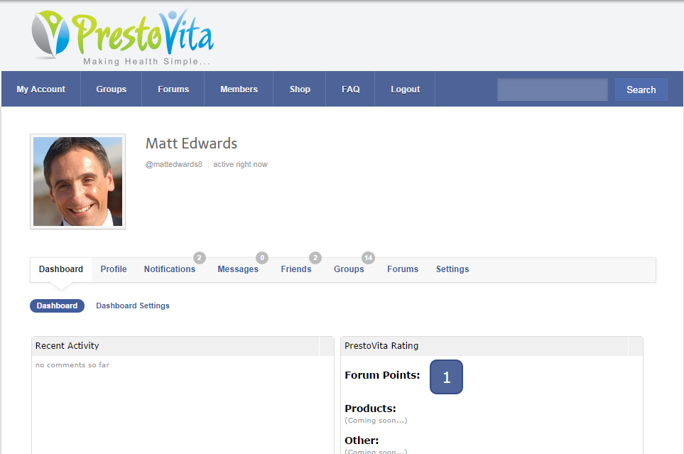
Changeable health professional dashboard image

End User Client Dashboard

Changeable end user client dashboard image

Health Networks
The website consists of 10 health networks as follows:
- Healthy Lifestyle
- Health Problem
- Weight Loss
- Pregnancy
- Female Health
- Male Health
- Child Health
- Senior Health
- Healthy Mind
- Sports Nutrition
The health network page (shown as communities) will require one banner image.

Communities
Each health network will have communities within them and each community will have multiple topics (discussions). Each individual community and its topics will need to use the same colour scheme/design elements to ensure continuity. Each community will also have a separate banner and profile image. Community banners will be used for incorporated topics and hence ‘topic banners’ do not need to be sourced.
PrestoVita will encourage ‘topic profile’ images to be supplied by end users however, in the meantime the website will require generic topic profile image(s). Health network, community and topic details are as follows:
- Healthy Lifestyle (e.g. Health Network)
  - Alkalinity (e.g. community)
  - Detoxification
  - Digestive Health
  - Exercise
  - Maintaining a Healthy life
  - Nutrition & Hydration
  - Starting a Healthy Life
  - Supplements
- Health Problem
  - Addictions
  - Allergies
    - Food Intolerances (e.g. topic)
    - Food Allergies
  - Anemia
    - Megaloblastic Anaemia
    - Iron Deficiency Anaemia
  - Asthma
  - Cancer
  - Chronic Fatigue Syndrome/ME
  - Coeliac Disease
  - Diabetes
  - Digestive Disease
    - Diarrhoea
    - Irritable Bowel Syndrome (IBS)
    - Constipation
    - Crohn’s Disease
  - Eating Disorders
    - Anorexia Nervosa
    - Bulimia Nervosa
    - Binge Eating Disorder
  - Headaches & Migraines
  - Heart Disease
    - Ischemic Heart Disease
    - Hypertension (High Blood Pressure)
    - High Cholesterol
  - Malnutrition
  - Obesity
  - Skin Health
    - Eczema
    - Psoriasis
    - Rosacea
  - Stroke
  - Thyroid Problems
    - Hypothyroidism (Underactive Thyroid)
    - Hyperthyroidism (Overactive Thyroid)
- Weight Loss
  - Blood/Sugar Imbalance
    - Controlling Cravings
  - Diabetes
  - Obesity
- Pregnancy
  - Preconception
    - Infertility (e.g. Topic)
  - Pregnancy
    - Pre-eclampsia
  - Post-Pregnancy
    - Breast Feeding
- Female Health
  - Breast Cancer
  - Endometriosis
  - Low Libido
  - Menopause
  - Polycystic Ovary Syndrome (PCOS)
  - Premenstrual Syndrome (PMS/PMT)
- Male Health
  - Prostate Cancer
  - Erectile Dysfunction
  - Low Libido
- Child Health
  - Infant Health
    - Infant Vaccinations
  - Schoolchildren Health
    - Schoolchildren Vaccinations
  - Teenage Health
    - Acne
- Senior Health
  - Ageing
  - Arthritis
  - Bone Heath
  - Dementia
    - Alzheimer’s
    - Osteoporosis
- Healthy Mind
  - Confidence &Self Esteem
  - Depression
  - Mood
  - Sleeping Disorders
    - Tiredness
  - Stress
- Sports Nutrition
  - Dietary Supplements
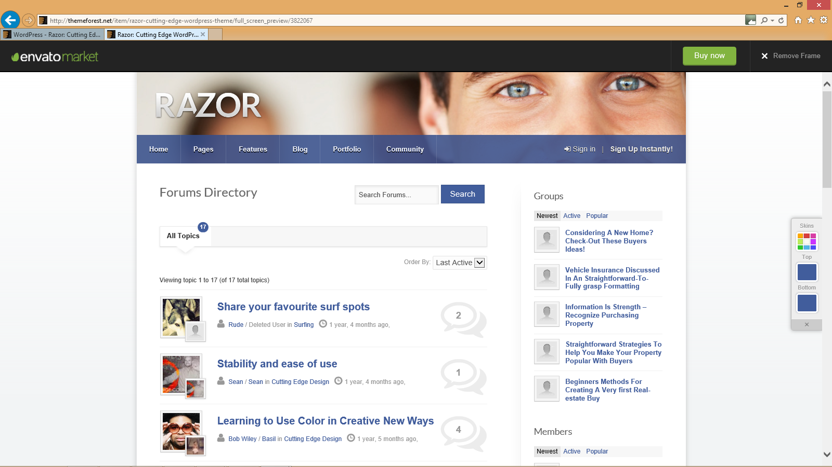
Each community will need its own template which will consist of a changeable community banner image and changeable community profile image, as per the figure below.

Changeable Community Banner Image

Changeable Community Profile Image

Resources
Each community and topic will have resources available on the right hand side of the page (see diagram below).
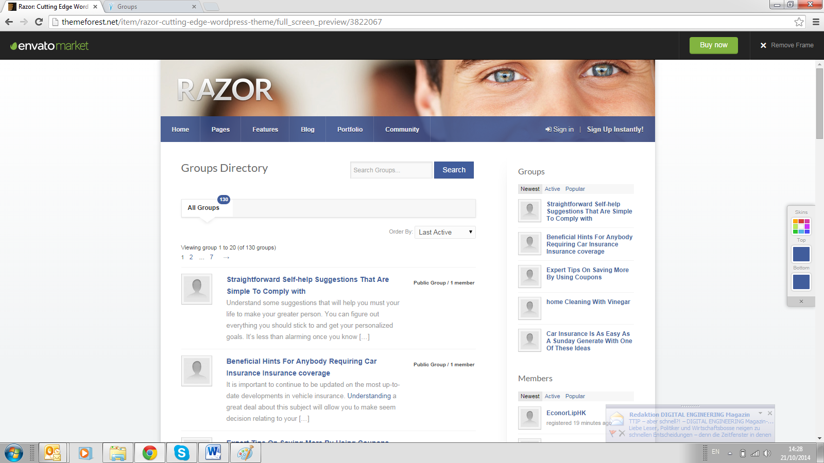
Available Resources
Resources available include:
- Information
- Recipes
- Webinars
- Workshops
Each resource will need its own template which will consist of a changeable resource banner image and changeable resource profile image, as per the figure below.

Colour Scheme
The colour schemes for the PrestoVita brand are listed in the PrestoVita Brand Guidelines and shown below. These colours should be used for menus, backgrounds, templates and anything associated with the PrestoVita brand.
However, please note we may be open to changes in brand colours for the right reason.
C100 M22 Y0 K0 R0 G147 B216

C0 M0 Y0 K85 R77 G77 B79

C30 M0 Y100 K0 R191 G215 B48

C67 M95 Y0 K8 R107 G48 B138

C0 M50 Y100 K8 R247 G148 B30

C100 M22 Y0 K0 C18 M5 Y0 K0

C52 M0 Y100 K0 C26 M0 Y100 K0

C0 M0 Y0 K60 C0 M0 Y0 K20


Template Background Pattern
The community template and the associated topic templates will have the same colour and background pattern. Background patterns should be different colours (probably watermarks) to signify a community or topic.

Template background pattern to signify you are either in a health network, community or topic

Website Background
The website background should be elegant and refreshing.

Website background should be refreshing (and potentially convey peaceful or inspiring energy)

Brand Communication
Top three things that the PrestoVita brand should communicate:
#1 - Thought leadership conveys trust, integrity and honesty
#2 - Central theme conveys health, energy, nutrition and exercise
#3 - Values convey fun, vitality, fresh, crisp, life fulfilment

Target Audience:
End users: all people who require more or want to maintain health and vitality in their lives - age group 15 to 65 in English speaking countries around the world.
Health professionals: global health experts, including nutritionists, functional medicine doctors that require a health community and environment that instils trust and enables them to

Understanding the Brand
The following chart describes the brand (and hence website design) characteristics in more detail…
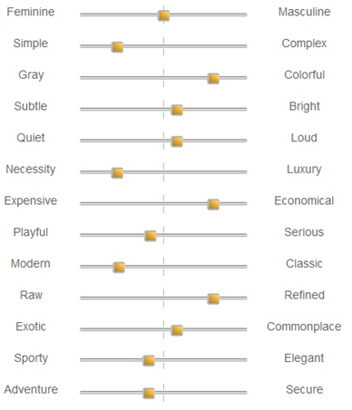

Additional important information
- The web site is under development and can be viewed here: http://beta.prestovita.com
- The web site is built utilizing the razor word press theme and hence the new design will need to work with this: http://themeforest.net/item/razor-cutting-edge-wordpress-theme/3822067?WT.mc_id=item_update_email
- Imagery must have a consistent/inter-related theme across all communities, topics and resources (examples exist in the PrestoVita Brand Guidelines; these should be used solely as a guide and/or incorporated if they fit the new design theme). 60+ licensed images required.
- Imagery and overall design elements will also need to be easily applicable to the entire web site including banners, and can be applied to literature, social networks, such as Facebook, twitter…
- Design will need to work with the current logo – see attached branding guidelines. The PrestoVita branding guidelines serve as a guide and should not limit the design; the guidelines can be developed further according to the new web design and imagery.
- We would like to see something fresh and unique in the imagery – to help engage our audience.
- The chosen design will need to be applied to create a PDF, PowerPoint and business card template.
- Please contact Matthew Edwards if you have questions or require additional information medwards@prestovita.com
- Deadline - Wednesday, November 06, 2014

