Certified Cash Register by ACLAS
A complete certified cash register system including fiscal printer
This complete solution exists of a cash drawer, register, display and printer in one device.
This complete solution is the most affordable solution available on Curaçao!
Advantages
- Complete certified solution in one device
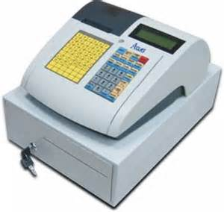
- PC programmable
- Handles barcodes
- Prints company name on receipt
- Up to 72 hours battery power

- Up to 12.000 products
- 120 quick keys available
Pricing
- ACLAS Cash register - 1995 ANG*
- Optional full package (installation and training) 799 ANG
- Optional installation fee (4 hour set-up) 599 ANG
- Optional training (2 hours) 299 ANG
- Service contract 1 ANG/day (24 hrs swap)

* Pricing as mentioned above are indicative. After an intake of Infotrans we can submit a proposal with all details, based on your specific situation and needs.

Certified Universal Bridge with fiscal printer
Fits any POS system!
Infotrans offers a universal bridge that connects any POS system to our certified fiscal printer.
Infotrans can take care of connection of your existing POS solution to the Bixolon thermal printer and can offer additional support to guarantee continuity of your cash income! This solution has been approved by BAB and prevents you from doing the certification process yourself.
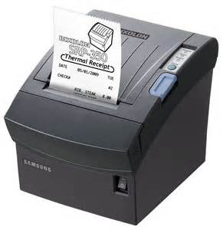
Advantages
- Keep your current POS system
- Lowest investment
- Continuity and insurance
- No certification at BAB necessary
Pricing
- Bixolon 350 fiscal printer – 949 ANG
- Universal bridge per printer - 1429 ANG*
- Implementation fee per printer – 499 ANG**
- Service contract 1 ANG/ day (24 hrs swap)
* The bridge has been connected to a series of POS systems yet, if your specific POS is not ready, an additional fee for adjustment needs to be charged. This varies between 500 and 2500 ANG.
** Pricing as mentioned above are indicative. After an intake of Infotrans we can submit a proposal with all details, based on your specific situation and needs.

Aloha and Microsoft RMS Complete POS solution
Infotrans is dealer of Aloha (NCR) POS systems and software. Aloha is ideal for hotels and restaurants. We have more than 15 years of experience in implementing and maintaining Aloha POS systems and have an installed base of more than 400 systems in the formal Dutch Caribbean.
For Retail Infotrans offers a complete POS system of Microsoft: Retail Management System (RMS). This complete system suits any retailer.
Please contact Infotrans if you are looking for complete certified POS system. Based on your requirements we can create a tailor made proposal with Aloha or RMS, combined with our certified Bixolon printers.

New Fiscal printing law
As of 1 January 2014 entrepreneurs that operate in certain sectors have to apply a new cash register system that has to meet specific requirements prescribed by law. The purpose of this cash register system is to record sales more accurately which, in turn is aimed at conducting more efficient and effective tax audits. The obligation was postponed several times with the most recent postponement being granted until 1 October 2014.
A cash register should only be installed, uninstalled, modified or repaired by a designated qualified installer such as Infotrans.
If you want to be a candidate for postponement until 1 January 2015, you must show the BAB that you are in negotiation with a qualified installer. Infotrans can help you with this process and has several solutions to help your business in getting certified to this new law. Please contact our sales department for information.
Infotrans Caribbean N.V.
Infotrans Caribbean is a SYSTEM INTEGRATOR, a full service Infrastructure, Communications and Technology company with its head office on the island of Curaçao and branches on Bonaire, Aruba, Sint Maarten and Surinam. Infotrans supplies major brands of equipment as well as turn-key solutions supported by the world’s leading technology partners, such as Microsoft, VMWare, Cisco, HP and NetApp.
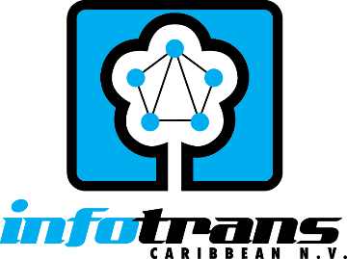
Infotrans Caribbean N.V.
Kaya Kooyman 22
Tel: 465-6345
sales@infotrans.cw
www.infotrans.cw

