The Milk & Honey Distillery
LOGO DESIGN BRIEF

Who is our target audience?
- Whisky fans worldwide, All ages (well, all over 18!), Men/Women
Who are our closest competitors?
- Premium Single-Malt Scotch/Irish Whisky, High-end Bourbon
What type of product do we offer?
- Premium artisan/craft whisky
What is our unique selling point?
- Holy land but its not a gimmick. We are about quality whisky!
What is the exact wording to be used in the logo?
- “Milk & Honey Distillery” [‘Distillery’ can be in a smaller font size]
Where will the logo be used?
- Bottles, General company communications, Website, Press releases, Facebook
Typographic preference?
- Does not have to feel old but try to capture:
- Strong/Solid (but friendly), Clear (but elegant), Proud, Honest
- Is it possible to have a hint of Hebrew looking fonts without being tacky?
Are there any specific images or icons we’d like to include in the logo?
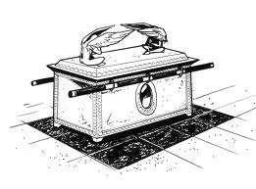
- Successful incorporation of a biblical element/character/person/thing is a plus but not at the expense of sense of quality/strength/pride/cool/authenticity e.g a whisky barrel carried on poles like the ark? But just a thought…
- Can the word ‘Distillery’ fill the bottom of the logo full width?
- Preference for a logo that is wider than it is tall
- Avoid anything that would make Christians or Jews uncomfortable
Are there any specific colours we may want to use?
- The logo should not use more than white plus max 2 other colours
- It should also work well in black and white.
- Surprise us!
Logos we like including what we like about them.
- Strong, clear, easy to read, easy to use different colours,
  - (But perhaps a little friendlier than some of these)
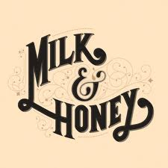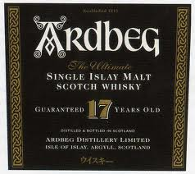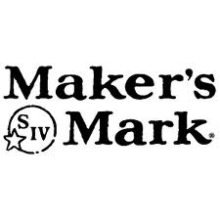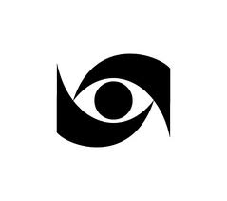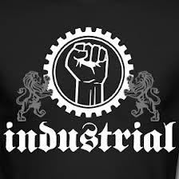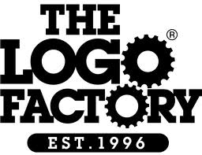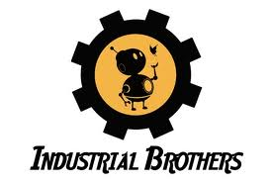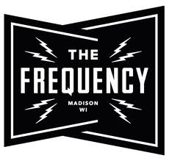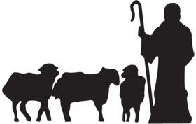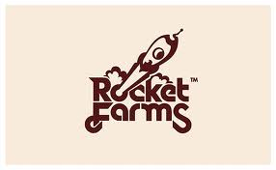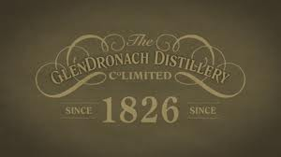

What decides who wins?
Fit with our brief and creative excellence will determine the winner.
Standard format e.g. jpeg (size limit 3MB per entry, multiple entries welcome)

