
LET’S GO GET THE VOTE OUT!
VOTE FOR BETTER TEACHER PAY!
VOTE FOR RAISES, INSTEAD OF BONUSES!
VOTE FOR BETTER HEALTH INSUANCE!
VOTE FOR YOUR 20 PERCENT TAX EXEMPTION!
VOTE FOR!




LET’S KICK CORRUPTION OUT OF OUR SCHOOL DISTRICT
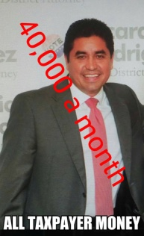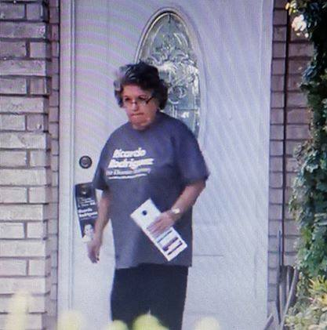
Renee Betancourt Rodriguez Fred Palacios Ricardo Rodriguez Carmen Gonzalez
LET’S ALSO KICK BULLYING AND INTIMIDATION OUT OF ECISD

 Edinburg school district trustees voted unanimously to award Superintendent Rene Gutierrez a raise of about 12 percent Tuesday, bumping his annual salary to $246,225. But board president Juan “Sonny” Palacios said trustees decided Tuesday that an increase was necessary to keep pace with the growth of school leaders’ salaries elsewhere in the Rio Grande Valley. “We don’t want somebody to take him, so to keep him in line with what everybody else is doing we thought was fair,” Palacios said.He added that he would have liked to at least pay Gutierrez on the same level per student as McAllen Superintendent James Ponce. That would entail an annual salary of more than $328,000.

THERE IS ONLY ONE TIME WHEN IT IS ESSENTIAL TO AWAKEN.
THE TIME IS NOW ! (Buddha)
VIVA LA REVOLUTION!

