 | Could place an image here or leave it blank – website colours should match the logo however please ensure the green isn’t does’t look brown (may need the alter the colour slightly)  Could add this wording…  Over 17 years floristry experience | Your local online flower shop  Auckland | North Island  0800 356 725  09 9721742

Home About Retail Wedding Consultation Galleries Gifts & Add-ons Specials Press FAQs Order Now Contact
Add gallery image here, options attached or choose a stock image of your choice  Text over image For artistic, modern & classic floral arrangements using only the freshest flowers choose flowers.org.nz  Also on the image add two buttons and nav links - ‘Order Now’ and ‘Call Us icon/badge  ‘Order now’ and ‘Give us a call…’  Note: the buttons on the left can go anywhere on the site, i.e. below the gallery, above it or on the left or right. Design must include the buttons! | Button with image and wording Wedding flowers 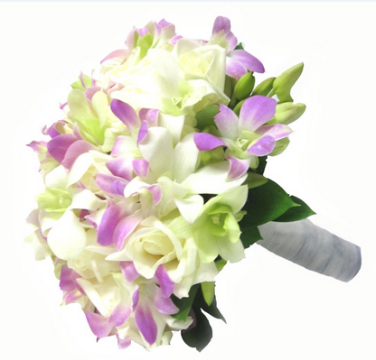
 | Button with image and wording Corsages 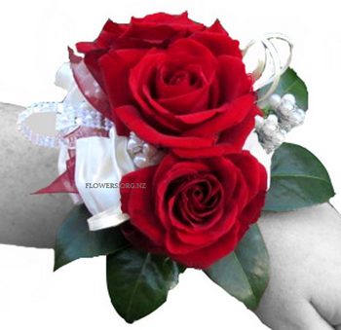
 | Button with image and wording Corporate arrangements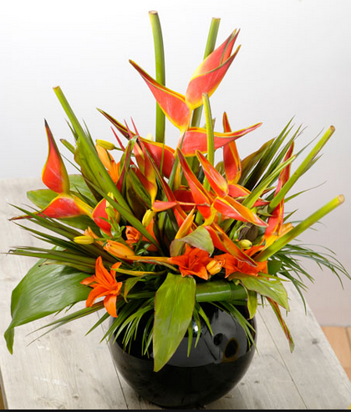
 | Button with image and wording Funeral flowers 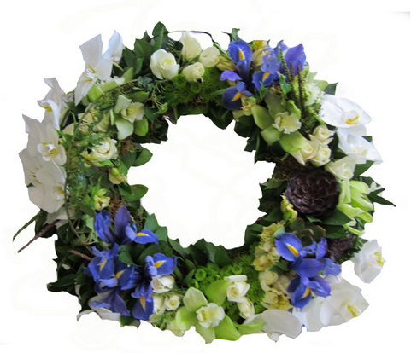
 | Button with image and wording Romantic flowers 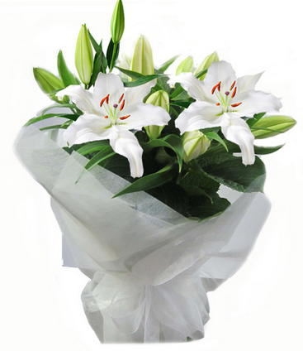
 | Button with image and wording Congratulation bunches 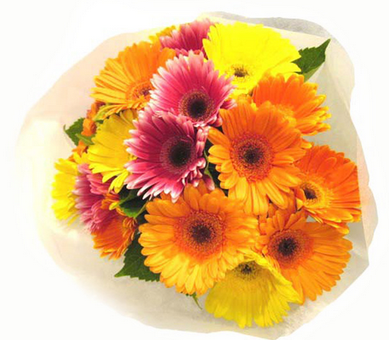
 | Button with image and wording Gifts & Add Ons 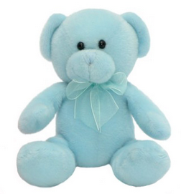or 
 | Button with image and wording Sympathy 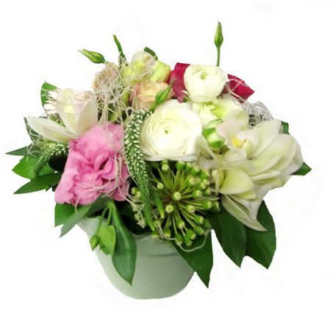

Free wedding flower consultation Auckland wide – We come to you  Flowers.org.nz offer a free wedding flower consultation service because they believe in creating beautiful flowers that represent you! Whether you’re after classic wedding flowers or unique unforgettable bridal flowers, Flower.org.nz can help. Our local Auckland florist also offers personal delivery and set up - even for Waiheke Island wedding flowers  Buttons  More Info | Want to freshen up your workplace - Get unique floral arrangements delivered weekly!  For fresh flowers that will brighten up your reception area or workplace - talk to Flowers.org.nz. Each of our corporate flower arrangements are unique and are hand crafted by our highly experienced florist, so you receive a great new look every week!  Buttons  More Info
Free flower delivery in Auckland and surrounding suburbs  As your local Auckland florist, Flowers.org.nz use local wholesalers and hand pick only the freshest flowers for you. Delivery is available the same, if you order before 10am.  For great flowers and free delivery in Auckland, order your flowers online now.  Buttons  More Info | Looking for tasteful, personally delivered funeral flowers in Auckland?  Our funeral flower selection at Flowers.org.nz is simply beautiful. Show all your love and deep sympathy in a time of bereavement, with one of our sympathy flowers arrangements, or for full funeral flowers Auckland wide call us and we can create and deliver everything from casket flowers to wreaths.  Buttons  More Info
Note: The four boxes below can be 1 X 4, 2 X 2 or however your wish to arrange them. Also you could add an image with each one
Footer:
Home  About Us  Retail  Wedding Consultation  Galleries  Gifts & Add Ons  Specials  Press  FAQs  Order Now  Contact | Flowers.org.nz’s guarantee to you...  Fresh flowers guaranteed! Or we’ll send you a replacement  Martine has been a florist in Auckland for over 17 years and sometimes visits the wholesalers market up to four times a day, for guaranteed freshness - Giving you get the best flowers available in Auckland.  Delivery available throughout the North Island  Flowers.org.nz offer overnight flower delivery throughout the North Island. And same day delivery is available Auckland wide, when orders are received before 10am.    Our delivery is Monday to Friday, or by prior arrangement on Saturdays for Wedding, Funeral or event deliveries. | Ask our florist…  Want to know what flowers are in season or what flowers are available in a certain colour?  Ask our local Auckland florist now and I’ll respond within 24hrs.      Check out our current specials

Note: Could use a green more like this:

