ICE HOCKEY JERSEY PROJECT
- This is for a Halloween costume for my son who will be dressing up as a ZOMBIE hockey player.
- The project requires design on the front and back of the jersey.
- The logo/design will be made into an “iron on” and then ironed onto a white jersey.
- The deliverable will be HIGH RESOLUTON files which can be printed. JPG/BMP at a resolution of 300dpi or higher as well as images in vector art format.
- We will need this ASAP so the jersey can be made in time for Halloween.

Design Mandatories - FRONT OF JERSEY
- Logo you design for “The Zombies” (which will be the team name)
- It should probably be a funny looking Zombie or group of zombies with a hockey stick or other hockey equipment with the name “The Zombies” somewhere on the front.
  - Creativity is strongly encouraged but one idea was to create a zombie type character or characters similar to the ones in the video game Plants vs Zombies (you’ll just want it to be a zombie looking hockey player or players with hockey stick(s)). This is NOT a design requirement but just one idea!
- You might want to use a fun font for the team name “The Zombies”.
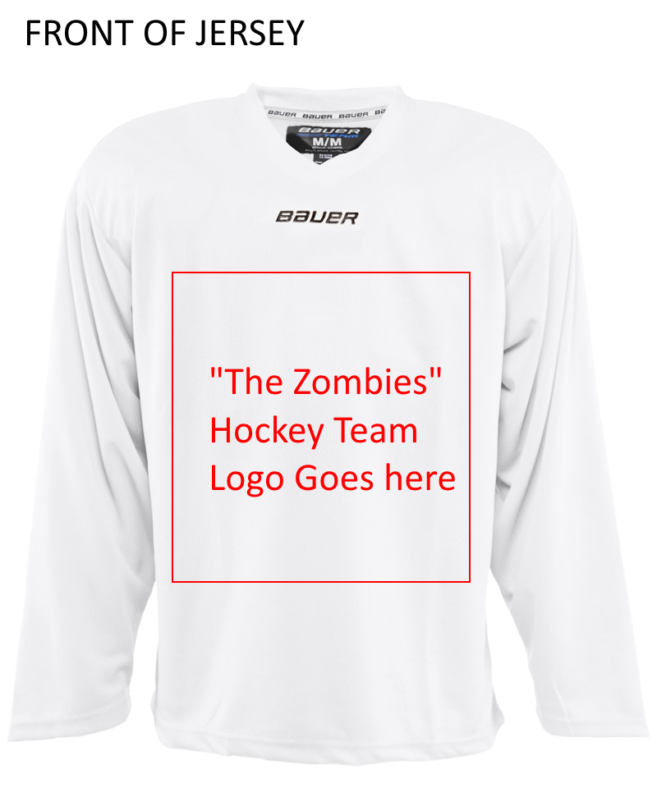
Design Mandatories – BACK OF JERSEY
- His last name at the top “ADELMANN”. You might want to use a fun font for this.
- His number which is “23”. Again, you might want to use a fun font for this.
- Note that IF you go with a Plants vs Zombies type design on the front (Again, this is NOT A REQUIREMENT), he thought a silly note similar to what you see in the “Plants vs Zombies” game (see example note below from the game) somewhere on the back. It should be large enough to read. The note should say:
Hello,
We are about to launch an all-out attack on your team.
Sincerely,
the Zombies
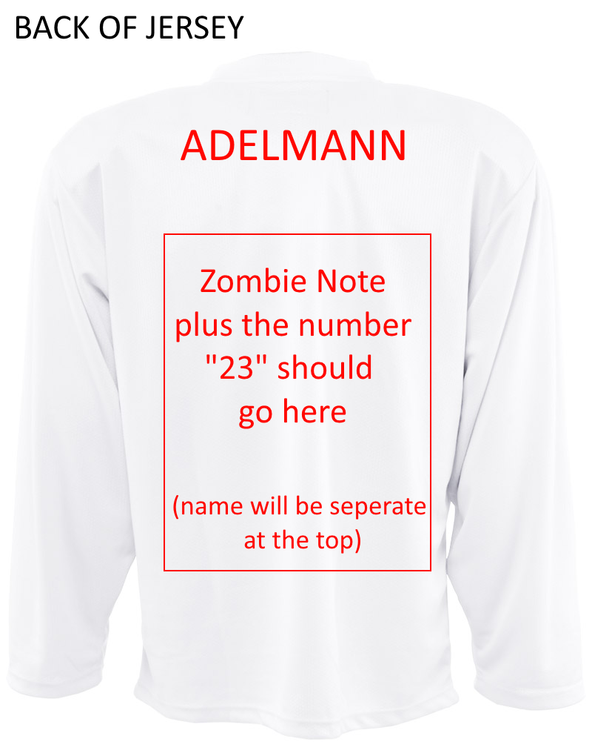
For reference, here is an example of a “note” (and the font / style) utilized in the Plants vs Zombies game:
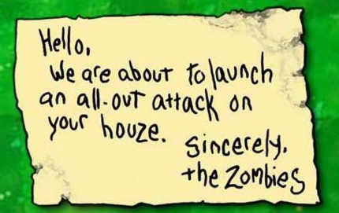

AGAIN – the plant vs zombie theme was just one idea he had but he is totally open to new / creative ideas. Another quick idea was to create a group of zombies similar to what is pictured below but add hockey sticks / gear to the design.
