

Pressure
Area
Care
A
Guide
For Patients

What is a Pressure Ulcer?
A pressure ulcer is an area of damage to the skin and underlying tissue.
They are sometimes known as pressure sores or bed sores.
What causes a Pressure Ulcer?
Pressure ulcers are caused by poor circulation to tissues due to a combination of the following factors:
Pressure
Body weight and some equipment (e.g. anti-thrombosis stockings) can squash the skin and other tissues where parts are under pressure. This reduces the blood supply to the area and can lead to tissue damage.
Shearing
Sliding or slumping down the bed/chair can damage the skin and deeper layers of tissue.
Friction
Poor moving and handling methods can remove the top layers of skin. Repeated friction can increase your risk.
Who is most at risk of Developing Pressure Ulcers?
You may be at risk of developing pressure ulcers for a number of reasons including the following:
Problems with Movement
If your ability to move is limited you don’t get enough oxygen to the parts under pressure

Poor Circulation
Vascular disease or smoking reduces your circulation
Moist Skin
You may be at increased risk if your skin is too damp, due to incontinence, sweat or a weeping wound. It is important that your skin is kept clean and healthy.
Lack of Sensitivity to Pain of Discomfort
Conditions such as Diabetes Stroke, Nerve, Muscle Disorders, etc. reduce the normal sensations that usually prompt you, or enable you to move. Some treatments (e.g. Epidural pain relief, medications, and operations) reduce your sensitivity to pain or discomfort so that you are not aware of the need to move.
Previous Tissue Damage
Scar tissue will have lost some of its previous strength and is more prone to breakdown.
Inadequate Diet of Fluid Intake
Lack of fluid may dehydrate your tissues. Weight gain or loss can affect the pressure distribution over bony points and healing.
Risk Assessment
To assess your risk of developing Pressure Ulcers, a member of your Health Care team will examine/assess you and ask you some questions. This will help to identify if you require specialised equipment or other forms of care, and will assist in providing for your individual needs.
What are the Early Signs of a Pressure Ulcer?
You will notice the following signs:
- Change in skin colour redder or darker
- Heat or cold
- Discomfort or pain
- Blistering
- Skin damage
Without appropriate intervention the damage may worsen, developing into hard black tissue or an open wound.
Common Locations of Pressure Ulcers
Laying on your back
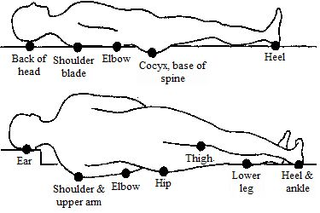
Laying on your side
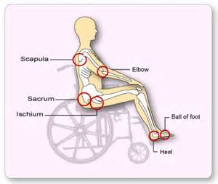
Sitting in a chair
What can I do to Avoid Pressure Ulcers?
There are several ways you can reduce the risk of pressure ulcers.
Keep Moving
Changing your position regularly helps keep blood flowing. If you have reduced movement the Health Care team looking after you will assist you with regular turns in addition to providing specialist mattresses, cushions, boots etc.
Look for signs of Damage
Check your skin for pressure damage at least once a day. Look for skin that doesn’t go back to its normal colour after you have taken the weight off it. Do not continue to lie on skin that is redder of darker than usual. Also watch out for blisters, dry patches or breaks in the skin.
Protect your Skin
Wash your skin using warm water of PH Neutral skin cleansers. Do not use heavily perfumed soap or talcum powder as these can soak up the skins natural oils leading to vulnerable dry areas. If you suffer from incontinence please inform your health care team as they can assess the best way to deal with the problems. Rubbing/massaging skin is bad for it.
Eat a Well-balanced Diet
Make sure you eat a healthy balanced diet and drink plenty of fluids. Extra protein may help.
What should I do if I suspect a pressure ulcer?
Tell your Doctor or Nurse as soon as possible and follow the advice they give you
Kevina Flynn Clinical Nurse Specialist Kevina.flynn@Cavendishstaffing.co.uk
October 2014

