your total health & sport solutions
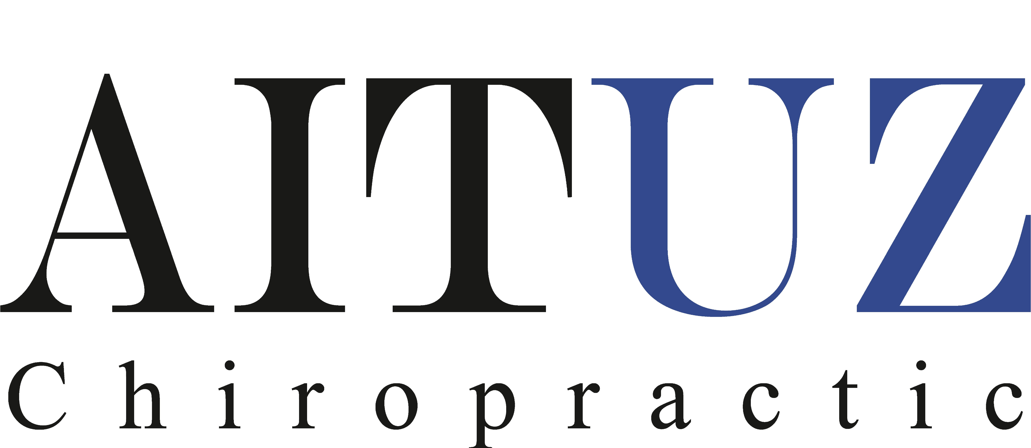
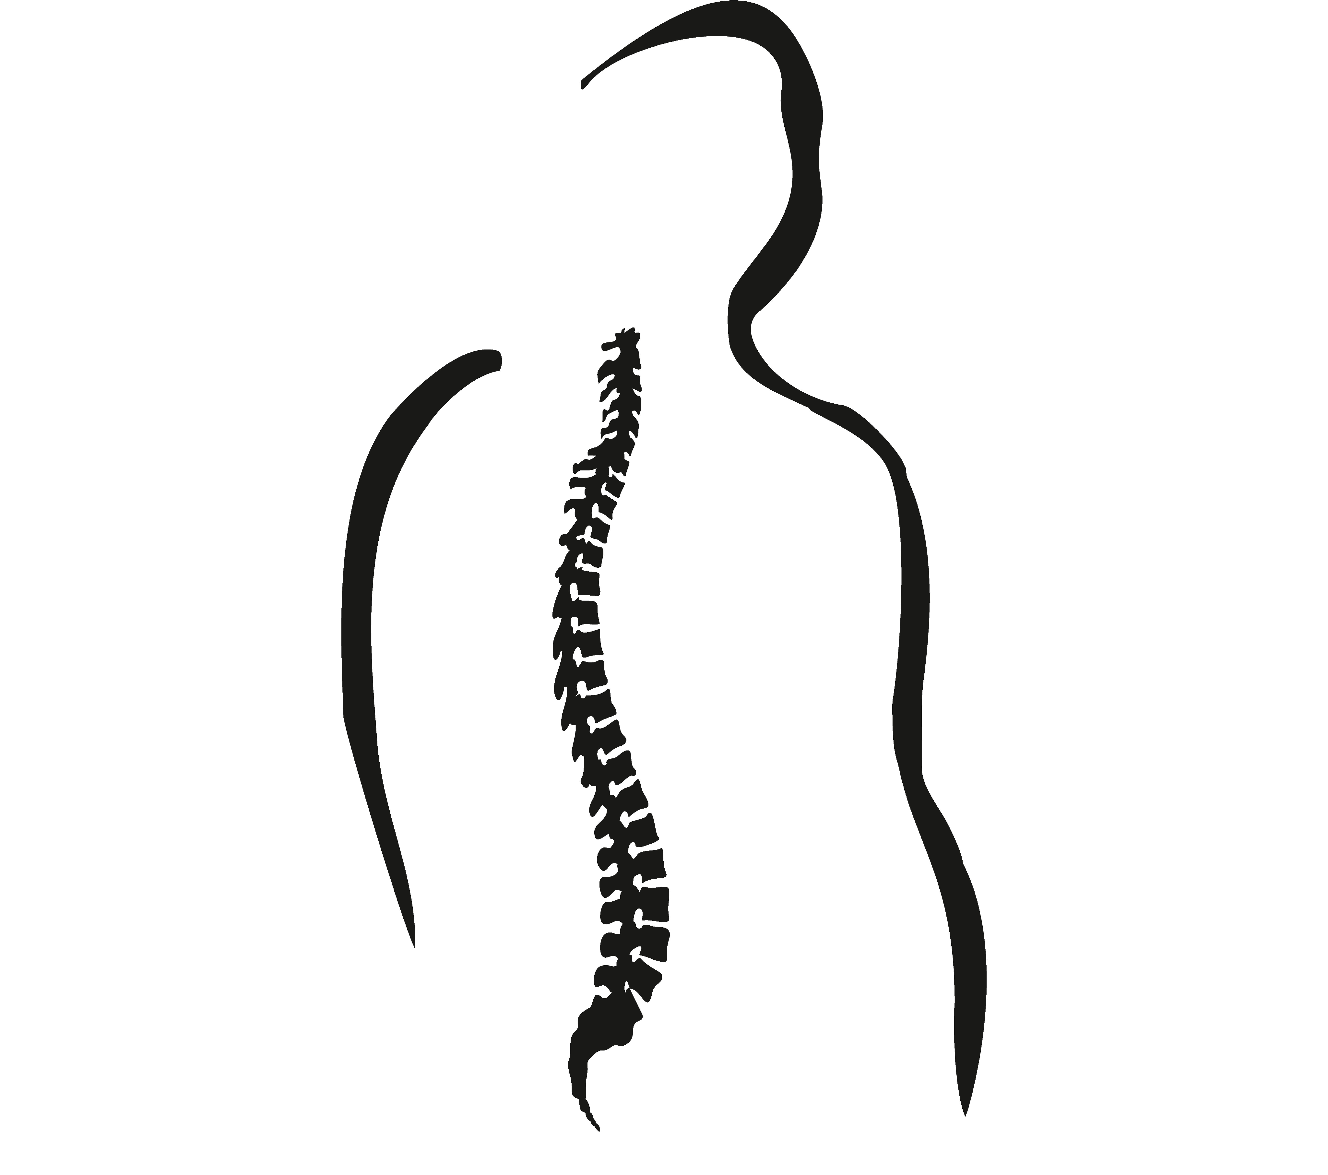
. sports chiropractic . applied kinesiology . total body modification . kinesio-taping .

0 7 8 5 5 3 0 6 0

