
Home Page Benefits Specifications Applications Packaging Contacts

Thermogard Gel-Ice Packs
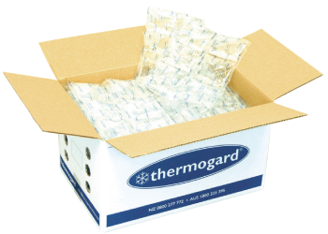

Why use Thermogard?
- Cost and time saving compared to flake ice
- Thermogard lasts longer & maintains more constant temperature
- Segmented pads provide excellent chill distribution
- High grade film is durable and puncture resistant
- Reuseable and food safe USFDA Approved
- Packaged ready for quick freezing
Thermogard Gel-Ice Packs are an effective and reliable ice replacement for chilling products during transit. They have been developed through extensive research and testing.

Keep your products chilled for longer
Thermogard Gel-Ice Packs are filled with a specially formulated gel that lasts longer than conventional ice packs. This provides assurance that your products are protected against unexpected delays during transit or air freight.

Versatile, reuseable and puncture resistant
Thermogard Gel-Ice Packs are segmented and flexible and packed into cartons with pop-out ends for faster freezing. The Thermogard transit chill system will keep your costs and temperatures down.

Thermogard Ice Packs are effective & reliable ice replacement products
Contact us or more information about Thermogard Gel-Ice Products
Copyright © 2013 Thermogard Products. All rights reserved.

