Stationary Specs for HighStreet

Font: Calibri
Pantone for Green: 370c
For more information on North American paper sizes – see http://www.designersinsights.com/designer-resources/north-american-paper-envelope-sizes

Content Information for Company:

14131 23rd Avenue NW
Edmonton, AB T6R 0G4

Phone: 790.431.1500
Fax: 790.431.1700
Toll Free: 895.425.3488

Email address: state@highstreetinsurance.com
Website: www.highstreetinsurance.com

#1 Business Card:
Design can be either vertical or horizontal

W: 3.5”
H: 2”

Card should include the following information:

Stuart Tate, BA, CRM
President & CEO

14131 23rd Avenue NW
Edmonton, AB T6R 0G4

Phone: 790.431.1500
Direct: 790.431.9999
Fax: 790.431.1700
Toll Free: 895.425.3488

Email address: state@highstreetinsurance.com
Website: www.highstreetinsurance.com

#2: Letterhead

Letter size 8.5” x 11”H
Letter head should include the following information:

14131 23rd Avenue NW
Edmonton, AB T6R 0G4

Phone: 790.431.1500
Fax: 790.431.1700
Toll Free: 895.425.3488

Website: www.highstreetinsurance.com

#3: Cover and Back Page for proposals

Page size 8.5” W x 11” H (per page)

Front Cover should include the following copy
(sample from old company below. Do NOT use the apples & oranges image).

HighStreet Logo
Client Name (in sample it is Rehabtronics Inc)
2014-2015

Company Information (address, phone and website)
Space for 2 peoples contact information (in sample it is Kelly & Stuart)

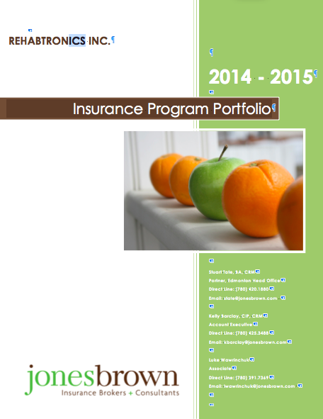

Back Cover should include the following information
14131 23rd Avenue NW
Edmonton, AB T6R 0G4

Phone: 790.431.1500
Fax: 790.431.1700
Toll Free: 895.425.3488

Website: www.highstreetinsurance.com

#4: Envelopes
Commercial flap style only

Commercial Flap: 3.875” x 8.875”

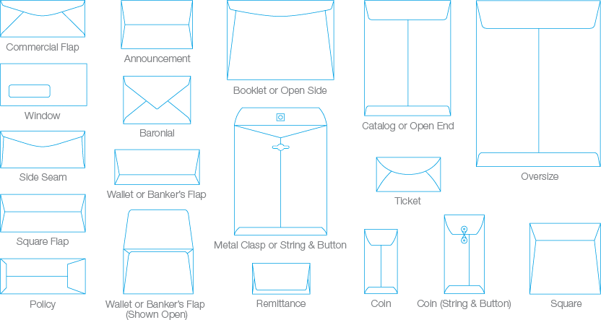

#5: Thank You Card + Envelope

10.5 cm x 15 cm

#6 Presentation Folder
Standard 9” x 12” Folder

- Location of Pockets: Left, Right
- Number of Panels: 2

#7 Email Signature

Sample :

