Logo Design – SaveTime Solutions

SaveTime Solutions is a time management/concierge company for busy professionals. Our clients are high level executives, CEOs and small business entrepreneurs. We are a luxury brand. What we want to capture in the logo design is elegance, class, color, reliability, professionalism, simplicity and modern.

Please stay away from using the cheap looking clocks and other “time” related clichés. Most of the clock logos I’ve seen look extremely cheesy and cheap. Having said that, if it’s done in an abstract manner, however, it might work

I’ve been flirting with idea of having STS in big letters and SaveTime Solutions in small letters - Just a thought.

As far as color goes, I’m fairly open to what works. I like vibrant colors and modern, soft tones. A simple black and white logo could work too. Let your imagination run free here. in other words, really colorful or plain black and white.

Below are some examples of logos that I liked. I’ve also included reasons why I like them:

- Plain
- Elegant
- Sophisticated
- modern
- use of white space

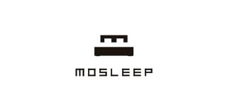

- Colorful and playfulness of the bird
- Plain and legible letters
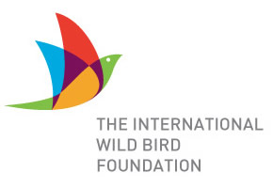

______________________________________________________________________________

- Claming colors
- Layout
- Different size fonts
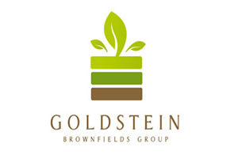

______________________________________________________________________________

- Simplicity
- Color scheme
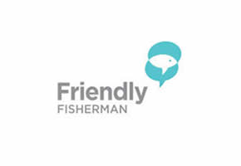

- Use of negative space

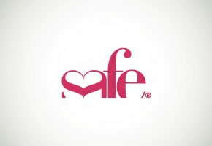

___________________________________________________________________________

- Clean
- Bold
- Colors
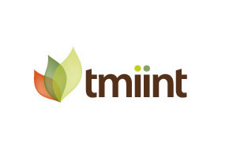
______________________________________________________________________________

- Use of different fonts
- Layout




